UNITED STATES
SECURITIES AND EXCHANGE COMMISSION
WASHINGTON, D.C. 20549
FORM 8-K
CURRENT REPORT

Pursuant to Section 13 or 15(d)
of the Securities Exchange Act of 1934
Date of Report (Date of earliest event reported): August 12, 2026

Acumen Pharmaceuticals, Inc.
(Exact name of Registrant as Specified in Its Charter)
____________________________
Delaware |  |  | 001-40551 |  |  | 36-4108129
(State or Other Jurisdiction  of Incorporation) |  |  | (Commission  File Number) |  |  | (IRS Employer  Identification No.)
1210-1220 Washington Street, Suite 210  Newton, Massachusetts |  |  | 02465
(Address of Principal Executive Offices) |  |  | (Zip Code)
Registrant’s Telephone Number, Including Area Code: (617) 344-4190

(Former Name or Former Address, if Changed Since Last Report)

Check the appropriate box below if the Form 8-K filing is intended to simultaneously satisfy the filing obligation of the registrant under any of the following provisions (see General Instructions A.2. below):
o |  |  | Written communications pursuant to Rule 425 under the Securities Act (17 CFR 230.425)
o |  |  | Soliciting material pursuant to Rule 14a-12 under the Exchange Act (17 CFR 240.14a-12)
o |  |  | Pre-commencement communications pursuant to Rule 14d-2(b) under the Exchange Act (17 CFR 240.14d-2(b))
o |  |  | Pre-commencement communications pursuant to Rule 13e-4(c) under the Exchange Act (17 CFR 240.13e-4(c))
Securities registered pursuant to Section 12(b) of the Act:
Title of each class |  |  |  |  |  | Trading  Symbol(s) |  |  |  |  |  | Name of each exchange  on which registered
Common Stock, $0.0001 par value |  |  |  |  |  | ABOS |  |  |  |  |  | The Nasdaq Global Select Market
Indicate by check mark whether the registrant is an emerging growth company as defined in Rule 405 of the Securities Act of 1933 (§230.405 of this chapter) or Rule 12b-2 of the Securities Exchange Act of 1934 (§240.12b-2 of this chapter).
Emerging growth company x
If an emerging growth company, indicate by check mark if the registrant has elected not to use the extended transition period for complying with any new or revised financial accounting standards provided pursuant to Section 13(a) of the Exchange Act. o

Item 2.02 Results of Operations and Financial Condition.
On August 12, 2026, Acumen Pharmaceuticals, Inc. (the “Company”) reported financial results and business highlights for the quarter ended June 30, 2026. A copy of this press release (the “Earnings Press Release”) is furnished as Exhibit 99.1 to this Current Report on Form 8-K (this “Report”) and is incorporated by reference.
The information in this Item 2.02 of this Report (including Exhibit 99.1) is being furnished and shall not be deemed “filed” for purposes of Section 18 of the Securities Exchange Act of 1934, as amended (the “Exchange Act”), or otherwise subject to the liabilities of that Section, nor shall it be deemed incorporated by reference in any filing under the Securities Act of 1933, as amended (the “Securities Act”), or the Exchange Act, except as expressly set forth by specific reference in such a filing.

Item 7.01 Regulation FD Disclosure.
On August 12, 2026, the Company posted an updated corporate presentation to its website at https://investors.acumenpharm.com/news-events/presentations, which the Company may use from time to time in communications or conferences. The corporate presentation was updated to reflect the Company’s cash, cash equivalents and marketable securities balance as of June 30, 2026. A copy of the corporate presentation is attached as Exhibit 99.2 to this Report.

The information in this Item 7.01 of this Report (including Exhibit 99.2), is being furnished and shall not be deemed “filed” for purposes of Section 18 of the Exchange Act, or otherwise subject to the liabilities of that Section, nor shall it be deemed incorporated by reference in any filing under the Securities Act or the Exchange Act, except as expressly set forth by specific reference in such filing. The Company’s submission of this Report shall not be deemed an admission as to the materiality of any information required to be disclosed solely to satisfy the requirements of Regulation FD.

Item 9.01 Financial Statements and Exhibits.
(d).Exhibits

Exhibit No. |  |  |  |  |  | Description
99.1 |  |  |  |  |  | Earnings Press Release, dated August 12, 2026
99.2 |  |  |  |  |  | Corporate Presentation, dated August 12, 2026
104 |  |  |  |  |  | Cover Page Interactive Data File (embedded within the Inline XBRL document)

SIGNATURES
Pursuant to the requirements of the Securities Exchange Act of 1934, as amended, the Company has duly caused this report to be signed on its behalf by the undersigned hereunto duly authorized.
 |  |  | Acumen Pharmaceuticals, Inc.
Dated: August 12, 2026 |  |  | By: |  |  | /s/ Matthew Zuga
Matthew Zuga
Chief Financial Officer and Chief Business Officer

Exhibit 99.1



Acumen Pharmaceuticals Reports Second Quarter 2026 Financial Results
and Business Highlights

•Expect to report topline results for ALTITUDE-AD, a Phase 2 study to investigate sabirnetug (ACU193) for the treatment of early Alzheimer’s disease, in late 2026

•Two candidates nominated for development in Acumen’s Enhanced Brain Delivery™ (EBD™) program; lead clinical candidate IND filing for the EBD program targeted for mid-2027
•Cash, cash equivalents and marketable securities of $110.2 million as of June 30, 2026, expected to support current clinical and operational activities into early 2027
•Company to host conference call and webcast today at 8:00 a.m. ET

NEWTON, Mass., Aug. 12, 2026 – Acumen Pharmaceuticals, Inc. (NASDAQ: ABOS) (“Acumen” or the “Company”), a clinical-stage biopharmaceutical company developing novel therapeutics that target toxic soluble amyloid beta oligomers (AβOs) for the treatment of Alzheimer’s disease (AD), today reported financial results for the second quarter of 2026 and provided a business update.
“This quarter we have been laser-focused on the readout preparations for our ALTITUDE-AD Phase 2 study investigating the efficacy, safety and tolerability of sabirnetug for the treatment of early AD, with topline results expected later this year. We are excited about the potential for sabirnetug to emerge as a potential treatment of choice with a differentiated benefit-to-risk profile given its unique product attributes as an anti-AβO, IgG2 monoclonal,” said Daniel O’Connell, Chief Executive Officer of Acumen. “In the second quarter, we also announced the nomination of two Enhanced Brain Delivery™ candidates for the treatment of Alzheimer’s Disease, representing the only program combining a validated blood-brain barrier-penetrating technology with an AβO-selective therapeutic antibody. We continue to advance IND-enabling activities toward a mid-2027 IND submission for a lead candidate, and are excited about the optionality this innovative product approach adds to our pipeline and the potential it holds to deliver a next-generation treatment for AD.”

Recent Highlights

•In June 2026, the Company announced the nomination of two EBD™ development candidates for the treatment of AD.

◦ACU301 and ACU401 were nominated in the EBD program as part of the exercise of Acumen’s option under its license agreement with JCR Pharmaceuticals.



◦Acumen’s EBD candidates are designed to achieve higher brain penetration with potential for improved safety compared to native antibodies and delivered in a stable, low volume subcutaneous administration format.

•In July 2026, the Company announced EBD program data and early AD insights at the Alzheimer’s Association International Conference (AAIC®) 2026.

◦EBD bispecific antibodies targeting both AβOs and hTfR (human transferrin receptor) showed improved brain penetration compared to the native anti-AβO antibodies, which may enable administration with a low-volume delivery device and reduce the delivered dose required for efficacy.

◦EBD candidate ACU401 achieves up to 40-fold greater frontal cortex exposure in non-human primates and significant increase in exposures in deep brain regions.

◦No hematological safety signals, including no effects on reticulocytes, were observed in non-human primates, demonstrating low potential for anemia.

◦ALTITUDE-AD patient experience data highlight unmet need in early Alzheimer's disease.

◦To access the material, please visit the Publications section of the Acumen website.
Anticipated Milestones
•The Company expects topline results from ALTITUDE-AD in late 2026. ALTITUDE-AD is a Phase 2 study investigating sabirnetug in 542 participants (N=180 per cohort) for the treatment of early Alzheimer’s disease.

◦ALTITUDE-AD includes two active doses (35 mg/kg, 50 mg/kg, IV Q4W) vs. placebo over an 18-month double-blinded period.

◦Topline results are expected to include iADRS (Integrated Alzheimer’s Disease Rating Scale), our primary clinical efficacy endpoint, as well as key secondary endpoints, such as CDR-SB (Clinical Dementia Rating – Sum of the Boxes), certain safety measures such as adverse event rates, including ARIA rates, and key biomarkers.

•The Company is targeting the submission of an IND filing with respect to a lead clinical candidate in its EBD program in mid-2027.
Second Quarter 2026 Financial Results
•Cash Balance. As of June 30, 2026, cash, cash equivalents and marketable securities totaled $110.2 million compared to cash, cash equivalents and marketable securities of $128.4 million as of March 31, 2026. Cash is expected to support current clinical and operational activities into early 2027.

2
•Research and Development (R&D) Expenses. R&D expenses were $27.8 million for the quarter ended June 30, 2026, compared to $37.1 million for the quarter ended June 30, 2025. The decrease was primarily due to reductions in manufacturing and materials costs, and CRO costs, which are both associated with our ALTITUDE-AD clinical trial.

•General and Administrative (G&A) Expenses. G&A expenses were $4.7 million for the quarter ended June 30, 2026, compared to $4.6 million for the quarter ended June 30, 2025.
•Loss from Operations. Loss from operations was $32.6 million for the quarter ended June 30, 2026, compared to $41.8 million for the quarter ended June 30, 2025. This decrease was due to the decreased R&D expenses over the prior year period.
•Net Loss. Net loss was $32.7 million for the quarter ended June 30, 2026, compared to $41.0 million for the quarter ended June 30, 2025.
Conference Call Details
Acumen will host a conference call and live audio webcast today, August 12, 2026, at 8:00 a.m. ET.
To participate in the live conference call, please register using this link. After registration, you will be informed of the dial-in numbers including PIN. Please register at least one day in advance.

The webcast audio will be available via this link.

An archived version of the webcast will be available for at least 30 days in the Investors section of the Company’s website at www.acumenpharm.com.
About Sabirnetug (ACU193)

Sabirnetug (ACU193) is a humanized monoclonal antibody (mAb) discovered and developed based on its selectivity for soluble amyloid beta oligomers (AβOs), which are a highly toxic and pathogenic form of Aβ, relative to Aβ monomers and amyloid plaques. Soluble AβOs have been observed to be potent neurotoxins that bind to neurons, inhibit synaptic function and induce neurodegeneration. By selectively targeting toxic soluble AβOs, sabirnetug aims to address the hypothesis that soluble AβOs are an early and persistent underlying cause of the neurodegenerative process in Alzheimer’s disease (AD). Sabirnetug has been granted Fast Track designation for the treatment of early AD by the U.S. Food and Drug Administration and is currently being evaluated in a Phase 2 study in patients with early AD.
About ALTITUDE-AD (Phase 2)

Initiated in 2024, ALTITUDE-AD is a Phase 2, multi-center, randomized, double-blind, placebo-controlled clinical trial designed to evaluate the efficacy and safety of sabirnetug (ACU193)
3
infusions administered once every four weeks in slowing cognitive and functional decline as compared to placebo in participants with early Alzheimer's disease. The study has enrolled 542 individuals with early Alzheimer’s disease (mild cognitive impairment or mild dementia due to AD) at multiple investigative sites located in the United States, Canada, the European Union and the United Kingdom. Topline results are expected in late 2026. More information can be found on www.clinicaltrials.gov, NCT identifier NCT06335173.
About Acumen Pharmaceuticals, Inc.

Acumen Pharmaceuticals is a clinical-stage biopharmaceutical company developing novel therapeutics that target toxic soluble amyloid beta oligomers (AβOs) for the treatment of Alzheimer’s disease (AD). Acumen’s scientific founders pioneered research on AβOs, which a growing body of evidence indicates are early and persistent triggers of Alzheimer’s disease pathology. Acumen is currently focused on advancing its lead investigational product candidate, sabirnetug (ACU193), a humanized monoclonal antibody that selectively targets toxic soluble AβOs, in its ongoing Phase 2 clinical trial ALTITUDE-AD (NCT06335173) in early symptomatic Alzheimer’s disease patients, following positive results in its Phase 1 trial INTERCEPT-AD. Acumen is also investigating a subcutaneous formulation of sabirnetug using Halozyme’s proprietary ENHANZE® drug delivery technology. Acumen is also collaborating with JCR Pharmaceuticals to develop an Enhanced Brain Delivery™ (EBD™) therapy for Alzheimer’s disease utilizing a transferrin-receptor-targeting blood-brain barrier-penetrating technology. The company is headquartered in Newton, Mass. For more information, visit www.acumenpharm.com.

Forward-Looking Statements

This press release contains forward-looking statements within the meaning of The Private Securities Litigation Reform Act of 1995. Any statement describing Acumen’s goals, expectations, financial or other projections, intentions or beliefs is a forward-looking statement and should be considered an at-risk statement. Words such as “believes,” “expects,” “anticipates,” “could,” “should,” “would,” “seeks,” “aims,” “plans,” “potential,” “will,” “milestone” and similar expressions are intended to identify forward-looking statements, although not all forward-looking statements contain these identifying words. Forward-looking statements include statements concerning Acumen’s business, and Acumen’s ability to achieve its strategic and financial goals, including its projected use of cash, cash equivalents and marketable securities and the expected sufficiency of its cash resources into early 2027, the therapeutic potential of Acumen’s product candidate, sabirnetug (ACU193), including against other antibodies, the timing of anticipated topline results of ALTITUDE-AD, Acumen's plans to develop a candidate to treat Alzheimer's Disease utilizing EBD technology, including its expectations with respect to timing for the submission of an IND, the potential of its EBD candidates and the potential for developing a best-in-class therapeutic candidate for people living with Alzheimer’s Disease. These statements are based upon the current beliefs and expectations of Acumen management, and are subject to certain factors, risks and uncertainties, particularly those inherent in the process of discovering, developing and commercializing safe and effective human therapeutics. Such risks may be amplified by the impacts of geopolitical events and macroeconomic conditions, such as rising inflation and interest rates, supply disruptions and uncertainty of credit and financial markets. These and other risks concerning Acumen’s programs are described in additional detail in Acumen’s filings
4
with the Securities and Exchange Commission (“SEC”), including in Acumen’s most recent Annual Report on Form 10-K, and in subsequent filings with the SEC. Copies of these and other documents are available from Acumen. Additional information will be made available in other filings that Acumen makes from time to time with the SEC. These forward-looking statements speak only as of the date hereof, and Acumen expressly disclaims any obligation to update or revise any forward-looking statement, except as otherwise required by law, whether, as a result of new information, future events or otherwise.

CONTACTS:

Investors:
Alex Braun
abraun@acumenpharm.com
Media:
ICR Healthcare
AcumenPR@icrhealthcare.com

5
Acumen Pharmaceuticals, Inc.
Condensed Balance Sheets
(in thousands, except share and per share data)
 |  |  | June 30, |  |  |  |  |  | December 31,
 |  |  | 2026 |  |  |  |  |  | 2025
 |  |  | (unaudited)
ASSETS
Current assets
Cash and cash equivalents |  |  | $ | 59,443 |  |  |  |  | $ | 53,989
Marketable securities |  |  | 50,754 |  |  |  |  |  | 62,876
Prepaid expenses and other current assets |  |  | 5,316 |  |  |  |  |  | 5,387
Total current assets |  |  | 115,513 |  |  |  |  |  | 122,252
Restricted cash |  |  | 231 |  |  |  |  |  | 231
Other assets, long-term |  |  | 263 |  |  |  |  |  | 350
Total assets |  |  | $ | 116,007 |  |  |  |  | $ | 122,833
LIABILITIES AND STOCKHOLDERS’ EQUITY
Current liabilities
Accounts payable |  |  | $ | 13,379 |  |  |  |  | $ | 554
Accrued clinical trial expenses |  |  | 6,263 |  |  |  |  |  | 10,616
Accrued expenses and other current liabilities |  |  | 7,533 |  |  |  |  |  | 10,072
Debt, short-term |  |  | 19,673 |  |  |  |  |  | 8,765
Total current liabilities |  |  | 46,848 |  |  |  |  |  | 30,007
Debt, long-term |  |  | 11,896 |  |  |  |  |  | 22,396
Total liabilities |  |  | 58,744 |  |  |  |  |  | 52,403
Commitments and contingencies
Stockholders’ equity
Preferred stock, $0.0001 par value; 10,000,000 shares authorized and no shares issued and outstanding as of June 30, 2026 and December 31, 2025 |  |  | — |  |  |  |  |  | —
Common stock, $0.0001 par value; 300,000,000 shares authorized as of June 30, 2026 and December 31, 2025; 72,314,714 and 60,575,369 shares issued and outstanding as of June 30, 2026 and December 31, 2025, respectively |  |  | 7 |  |  |  |  |  | 6
Additional paid-in capital |  |  | 557,186 |  |  |  |  |  | 516,803
Accumulated deficit |  |  | (499,917) |  |  |  |  |  | (446,462)
Accumulated other comprehensive (loss) income |  |  | (13) |  |  |  |  |  | 83
Total stockholders’ equity |  |  | 57,263 |  |  |  |  |  | 70,430
Total liabilities and stockholders’ equity |  |  | $ | 116,007 |  |  |  |  | $ | 122,833

6
Acumen Pharmaceuticals, Inc.
Condensed Statements of Operations and Comprehensive Loss
(in thousands, except share and per share data)
(unaudited)
 |  |  | Three Months Ended June 30, |  |  |  |  |  |  |  |  |  |  |  | Six Months Ended June 30,
 |  |  | 2026 |  |  |  |  |  | 2025 |  |  |  |  |  | 2026 |  |  |  |  |  | 2025
Operating expenses
Research and development |  |  | $ | 27,809 |  |  |  |  | $ | 37,125 |  |  |  |  | $ | 44,293 |  |  |  |  | $ | 62,391
General and administrative |  |  | 4,747 |  |  |  |  |  | 4,625 |  |  |  |  |  | 9,412 |  |  |  |  |  | 9,729
Total operating expenses |  |  | 32,556 |  |  |  |  |  | 41,750 |  |  |  |  |  | 53,705 |  |  |  |  |  | 72,120
Loss from operations |  |  | (32,556) |  |  |  |  |  | (41,750) |  |  |  |  |  | (53,705) |  |  |  |  |  | (72,120)
Other income (expense)
Interest income |  |  | 1,111 |  |  |  |  |  | 2,015 |  |  |  |  |  | 2,175 |  |  |  |  |  | 4,486
Interest expense |  |  | (1,094) |  |  |  |  |  | (1,046) |  |  |  |  |  | (2,163) |  |  |  |  |  | (2,069)
Change in fair value of embedded derivatives |  |  | (160) |  |  |  |  |  | (40) |  |  |  |  |  | 300 |  |  |  |  |  | 150
Other expense, net |  |  | (19) |  |  |  |  |  | (129) |  |  |  |  |  | (62) |  |  |  |  |  | (193)
Total other (expense) income |  |  | (162) |  |  |  |  |  | 800 |  |  |  |  |  | 250 |  |  |  |  |  | 2,374
Net loss |  |  | (32,718) |  |  |  |  |  | (40,950) |  |  |  |  |  | (53,455) |  |  |  |  |  | (69,746)
Other comprehensive gain (loss)
Unrealized (loss) gain on marketable securities |  |  | (34) |  |  |  |  |  | 8 |  |  |  |  |  | (96) |  |  |  |  |  | 71
Comprehensive loss |  |  | $ | (32,752) |  |  |  |  | $ | (40,942) |  |  |  |  | $ | (53,551) |  |  |  |  | $ | (69,675)
Net loss per common share, basic and diluted |  |  | $ | (0.45) |  |  |  |  | $ | (0.68) |  |  |  |  | $ | (0.79) |  |  |  |  | $ | (1.15)
Weighted-average shares outstanding, basic and diluted |  |  | 72,250,694 |  |  |  |  |  | 60,573,425 |  |  |  |  |  | 67,759,940 |  |  |  |  |  | 60,549,658

7
Acumen Pharmaceuticals, Inc.
Condensed Statements of Cash Flows
(in thousands)
(unaudited)
 |  |  | Six Months Ended June 30,
 |  |  | 2026 |  |  |  |  |  | 2025
Cash flows from operating activities
Net loss |  |  | $ | (53,455) |  |  |  |  | $ | (69,746)
Adjustments to reconcile net loss to net cash used in operating activities:
Depreciation |  |  | 23 |  |  |  |  |  | 31
Stock-based compensation expense |  |  | 4,920 |  |  |  |  |  | 4,972
Amortization of premiums and accretion of discounts on marketable securities, net |  |  | (161) |  |  |  |  |  | (644)
Change in fair value of embedded derivatives |  |  | (300) |  |  |  |  |  | (150)
Amortization of right-of-use asset |  |  | 68 |  |  |  |  |  | 61
Realized gain on marketable securities |  |  | (6) |  |  |  |  |  | (3)
Noncash interest expense |  |  | 708 |  |  |  |  |  | 613
Changes in operating assets and liabilities:
Prepaid expenses and other current assets |  |  | 71 |  |  |  |  |  | 1,714
Other long-term assets |  |  | (4) |  |  |  |  |  | 18
Accounts payable |  |  | 12,825 |  |  |  |  |  | (3,545)
Accrued clinical trial expenses |  |  | (4,353) |  |  |  |  |  | (4,236)
Accrued expenses and other liabilities |  |  | (2,539) |  |  |  |  |  | 4,962
Net cash used in operating activities |  |  | (42,203) |  |  |  |  |  | (65,953)
Cash flows from investing activities
Purchases of marketable securities |  |  | (40,823) |  |  |  |  |  | (38,056)
Proceeds from maturities and sales of marketable securities |  |  | 53,016 |  |  |  |  |  | 105,316
Purchases of property and equipment |  |  | — |  |  |  |  |  | (88)
Net cash provided by investing activities |  |  | 12,193 |  |  |  |  |  | 67,172
Cash flows from financing activities
Proceeds from private placement, net of offering costs |  |  | 35,441 |  |  |  |  |  | —
Proceeds from exercise of stock options |  |  | 172 |  |  |  |  |  | 37
Repurchase of common shares to pay employee withholding taxes |  |  | (149) |  |  |  |  |  | (73)
Net cash provided by (used in) financing activities |  |  | 35,464 |  |  |  |  |  | (36)
Net change in cash and cash equivalents and restricted cash |  |  | 5,454 |  |  |  |  |  | 1,183
Cash and cash equivalents and restricted cash at the beginning of the period |  |  | 54,220 |  |  |  |  |  | 35,859
Cash and cash equivalents and restricted cash at the end of the period |  |  | $ | 59,674 |  |  |  |  | $ | 37,042

8
Corporate Presentation August 2026 1

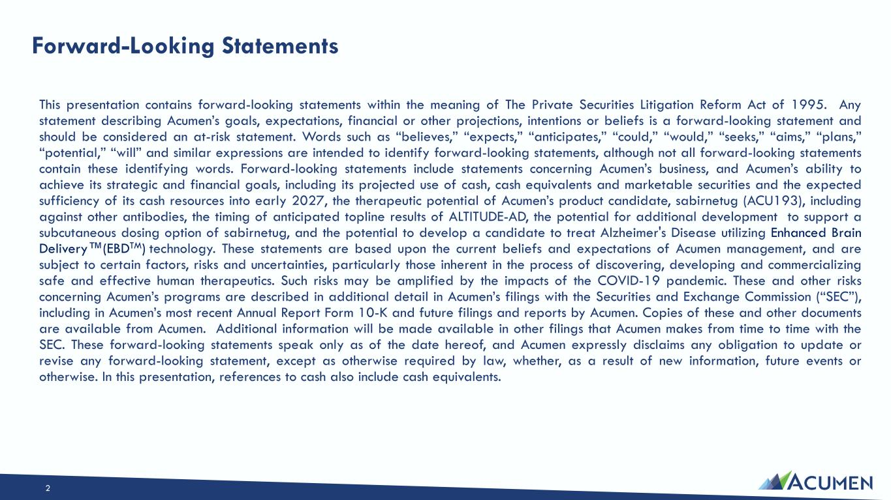
Forward-Looking Statements 2 This presentation contains forward-looking statements within the meaning of The Private Securities Litigation Reform Act of 1995. Any statement describing Acumen’s goals, expectations, financial or other projections, intentions or beliefs is a forward-looking statement and should be considered an at-risk statement. Words such as “believes,” “expects,” “anticipates,” “could,” “would,” “seeks,” “aims,” “plans,” “potential,” “will” and similar expressions are intended to identify forward-looking statements, although not all forward-looking statements contain these identifying words. Forward-looking statements include statements concerning Acumen’s business, and Acumen’s ability to achieve its strategic and financial goals, including its projected use of cash, cash equivalents and marketable securities and the expected sufficiency of its cash resources into early 2027, the therapeutic potential of Acumen’s product candidate, sabirnetug (ACU193), including against other antibodies, the timing of anticipated topline results of ALTITUDE-AD, the potential for additional development to support a subcutaneous dosing option of sabirnetug, and the potential to develop a candidate to treat Alzheimer's Disease utilizing Enhanced Brain Delivery (EBDTM) technology. These statements are based upon the current beliefs and expectations of Acumen management, and are subject to certain factors, risks and uncertainties, particularly those inherent in the process of discovering, developing and commercializing safe and effective human therapeutics. Such risks may be amplified by the impacts of the COVID-19 pandemic. These and other risks concerning Acumen’s programs are described in additional detail in Acumen’s filings with the Securities and Exchange Commission (“SEC”), including in Acumen’s most recent Annual Report Form 10-K and future filings and reports by Acumen. Copies of these and other documents are available from Acumen. Additional information will be made available in other filings that Acumen makes from time to time with the SEC. These forward-looking statements speak only as of the date hereof, and Acumen expressly disclaims any obligation to update or revise any forward-looking statement, except as otherwise required by law, whether, as a result of new information, future events or otherwise. In this presentation, references to cash also include cash equivalents.

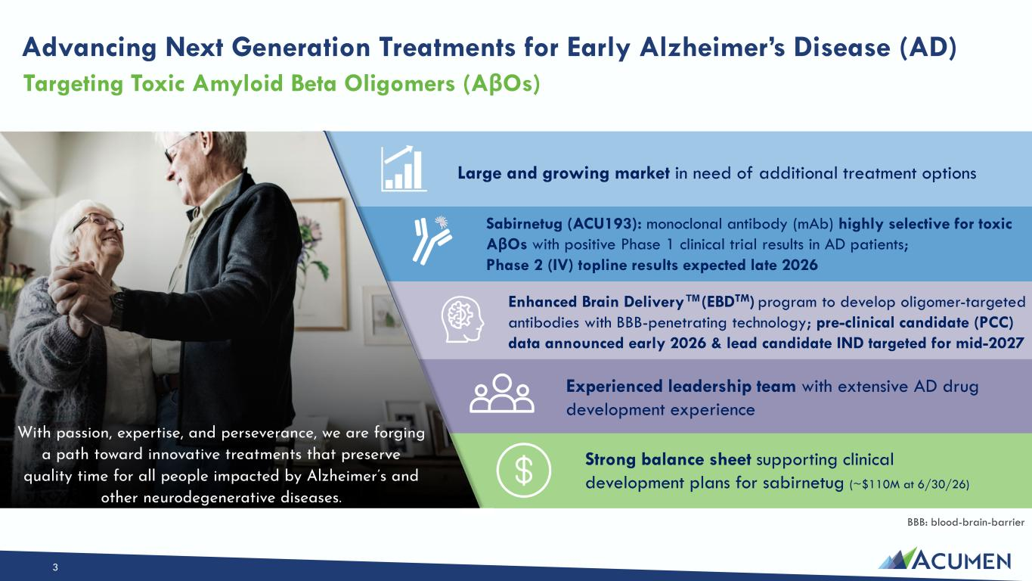
3 Large and growing market in need of additional treatment options Sabirnetug (ACU193): monoclonal antibody (mAb) highly selective for toxic AβOs with positive Phase 1 clinical trial results in AD patients; Phase 2 (IV) topline results expected late 2026 Enhanced Brain Delivery (EBDTM) program to develop oligomer-targeted antibodies with BBB-penetrating technology; pre-clinical candidate (PCC) data announced early 2026 & lead candidate IND targeted for mid-2027 Experienced leadership team with extensive AD drug development experience Strong balance sheet supporting clinical development plans for sabirnetug (~$110M at 6/30/26) BBB: blood-brain-barrier Advancing Next Generation Treatments for Early Alzheimer’s Disease (AD) Targeting Toxic Amyloid Beta Oligomers (AβOs)

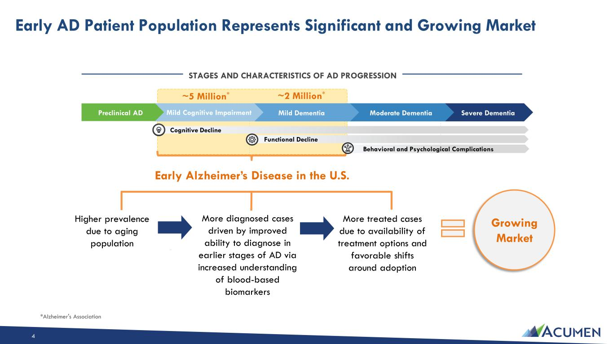
Early AD Patient Population Represents Significant and Growing Market STAGES AND CHARACTERISTICS OF AD PROGRESSION Severe DementiaModerate DementiaMild DementiaMild Cognitive ImpairmentPreclinical AD ~5 Million* ~2 Million* Early Alzheimer’s Disease in the U.S. Cognitive Decline Behavioral and Psychological Complications Functional Decline Growing Market Higher prevalence due to aging population More diagnosed cases driven by improved ability to diagnose in earlier stages of AD via increased understanding of blood-based biomarkers More treated cases due to availability of treatment options and favorable shifts around adoption *Alzheimer's Association 4

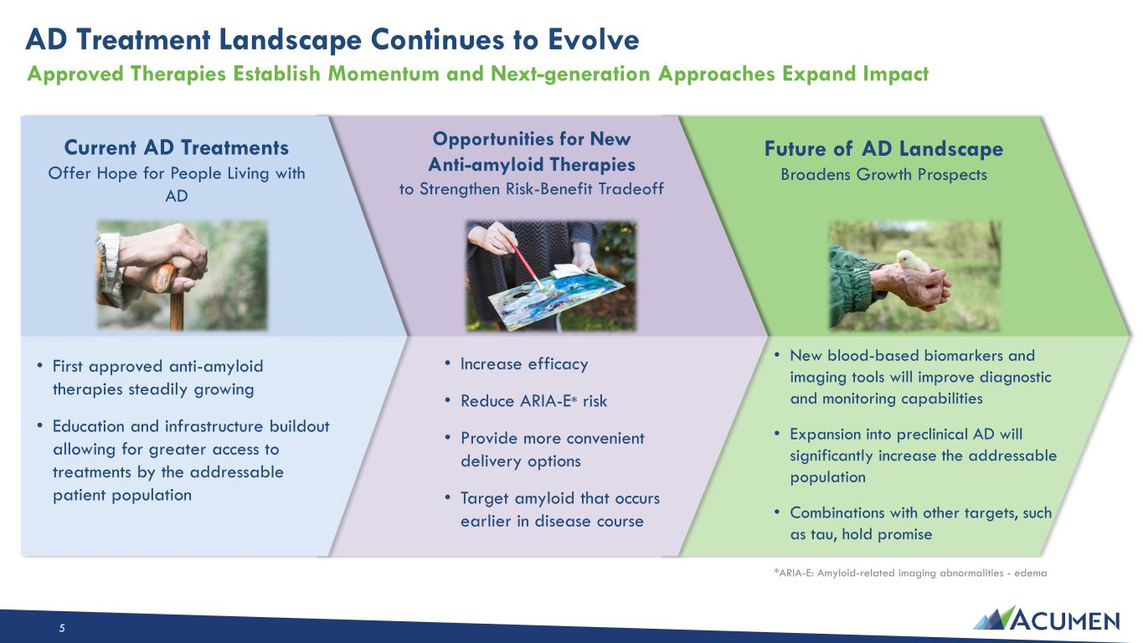
5 *ARIA-E: Amyloid-related imaging abnormalities - edema AD Treatment Landscape Continues to Evolve Approved Therapies Establish Momentum and Next-generation Approaches Expand Impact Future of AD Landscape Broadens Growth Prospects • New blood-based biomarkers and imaging tools will improve diagnostic and monitoring capabilities • Expansion into preclinical AD will significantly increase the addressable population • Combinations with other targets, such as tau, hold promise Current AD Treatments Offer Hope for People Living with AD • First approved anti-amyloid therapies steadily growing • Education and infrastructure buildout allowing for greater access to treatments by the addressable patient population • Increase efficacy • Reduce ARIA-E* risk • Provide more convenient delivery options • Target amyloid that occurs earlier in disease course Opportunities for New Anti-amyloid Therapies to Strengthen Risk-Benefit Tradeoff

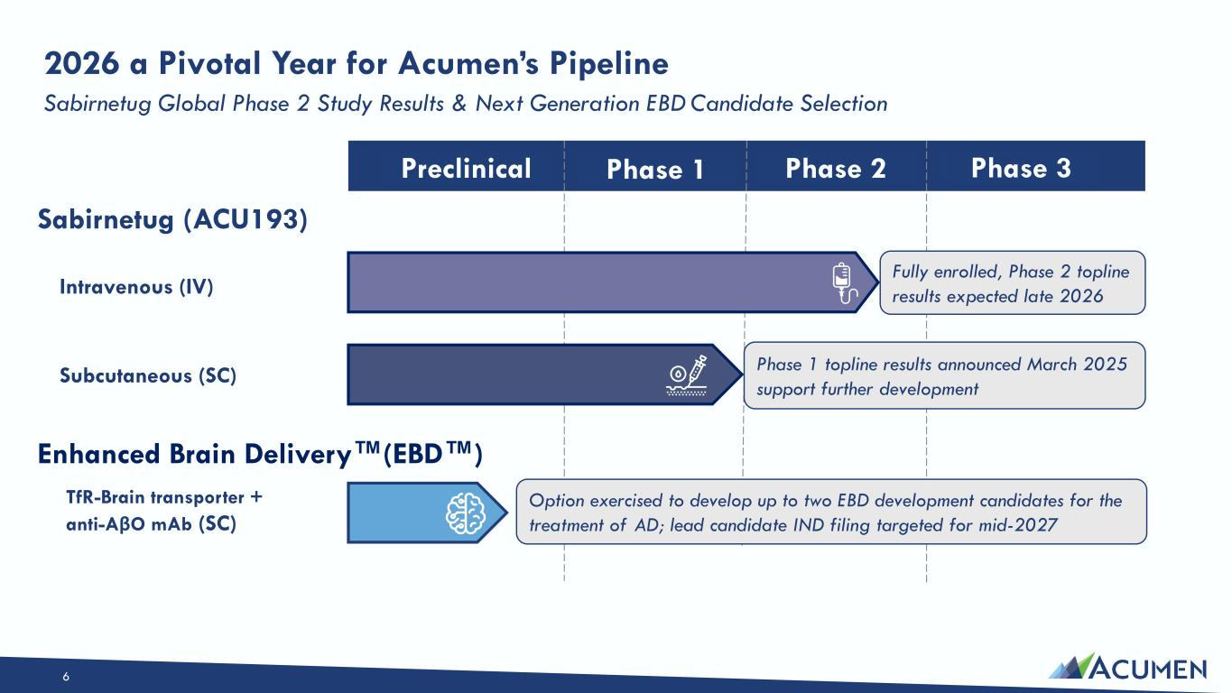
6 Phase 1 Phase 2 Phase 3Preclinical Intravenous (IV) Subcutaneous (SC) Fully enrolled, Phase 2 topline results expected late 2026 Phase 1 topline results announced March 2025 support further development TfR-Brain transporter + anti-AβO mAb (SC) Option exercised to develop up to two EBD development candidates for the treatment of AD; lead candidate IND filing targeted for mid-2027 Sabirnetug (ACU193) Enhanced Brain Delivery (EBD ) 2026 a Pivotal Year for Acumen’s Pipeline Sabirnetug Global Phase 2 Study Results & Next Generation EBD Candidate Selection

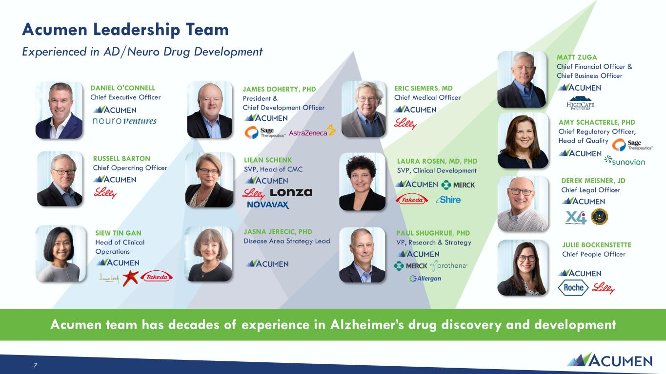
Acumen Leadership Team Experienced in AD/Neuro Drug Development Acumen team has decades of experience in Alzheimer’s drug discovery and development AMY SCHACTERLE, PHD Chief Regulatory Officer, Head of Quality PAUL SHUGHRUE, PHD VP, Research & Strategy JASNA JERECIC, PHD Disease Area Strategy Lead ERIC SIEMERS, MD Chief Medical Officer MATT ZUGA Chief Financial Officer & Chief Business Officer RUSSELL BARTON Chief Operating Officer DANIEL O'CONNELL Chief Executive Officer SIEW TIN GAN Head of Clinical Operations 7 JULIE BOCKENSTETTE Chief People Officer JAMES DOHERTY, PHD President & Chief Development Officer LIEAN SCHENK SVP, Head of CMC LAURA ROSEN, MD, PHD SVP, Clinical Development DEREK MEISNER, JD Chief Legal Officer

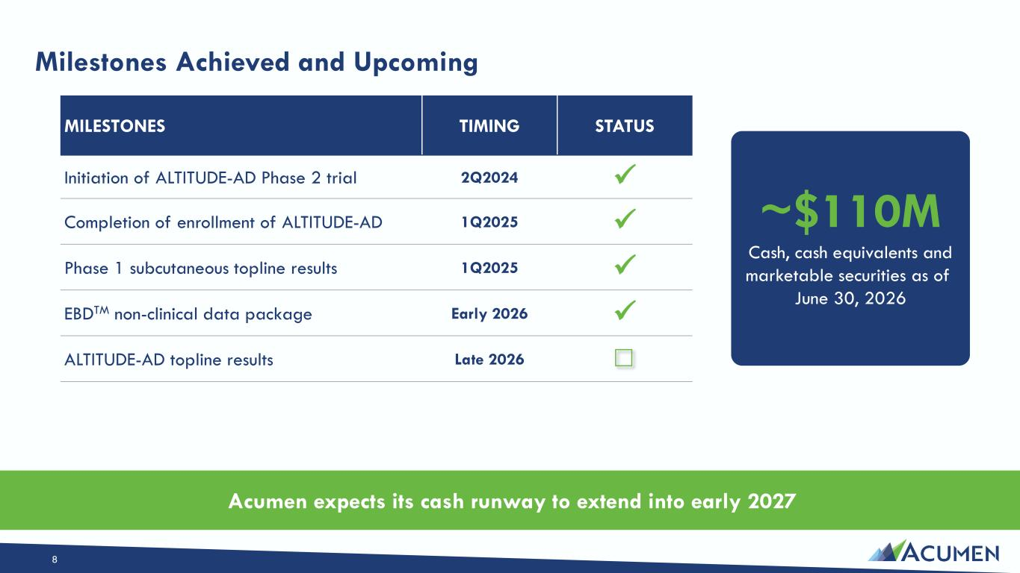
Milestones Achieved and Upcoming ~$110M Cash, cash equivalents and marketable securities as of June 30, 2026 8 MILESTONES TIMING STATUS Initiation of ALTITUDE-AD Phase 2 trial 2Q2024 ✓ Completion of enrollment of ALTITUDE-AD 1Q2025 ✓ Phase 1 subcutaneous topline results 1Q2025 ✓ EBDTM non-clinical data package Early 2026 ✓ ALTITUDE-AD topline results Late 2026 Acumen expects its cash runway to extend into early 2027

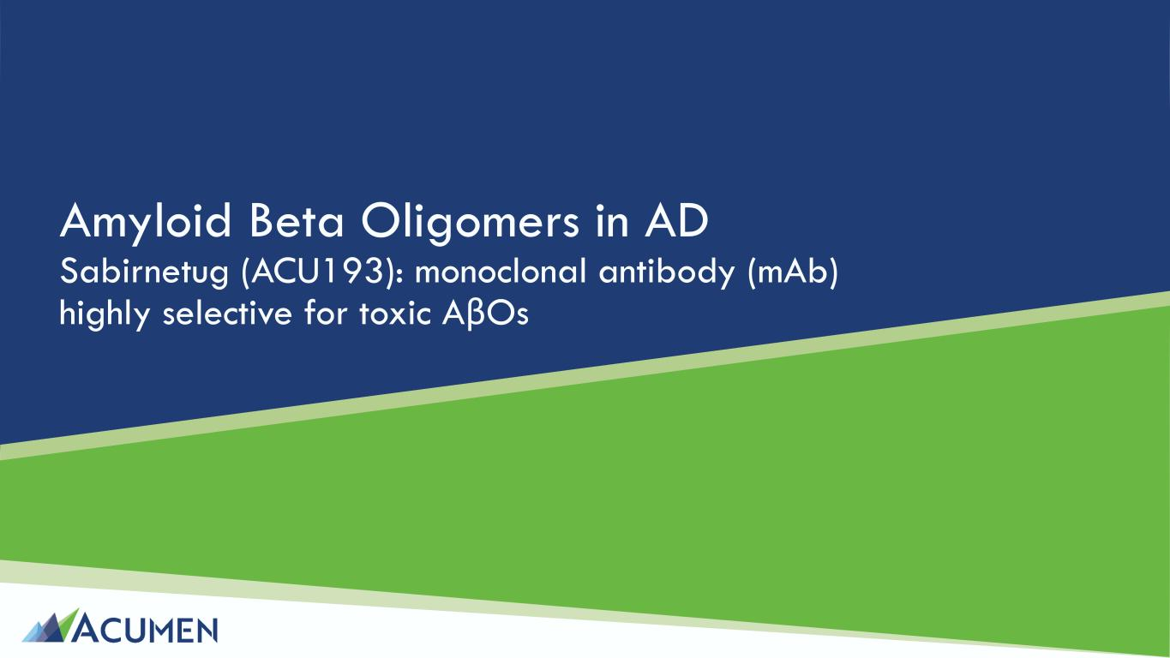
Amyloid Beta Oligomers in AD Sabirnetug (ACU193): monoclonal antibody (mAb) highly selective for toxic AβOs

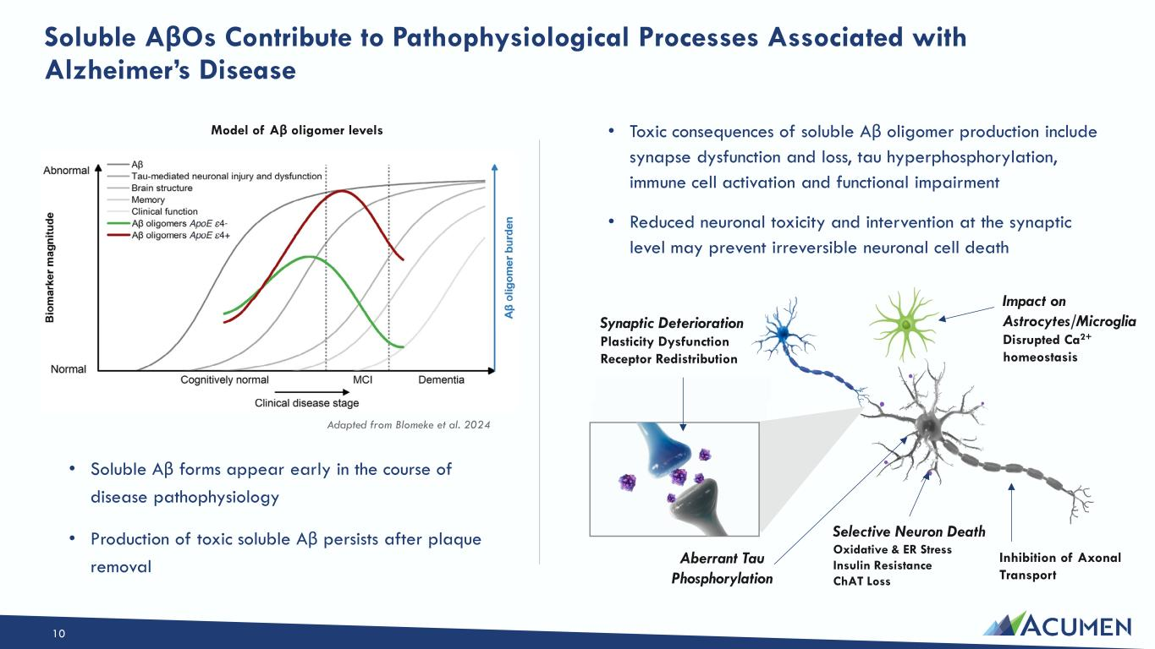
Soluble AβOs Contribute to Pathophysiological Processes Associated with Alzheimer’s Disease • Toxic consequences of soluble Aβ oligomer production include synapse dysfunction and loss, tau hyperphosphorylation, immune cell activation and functional impairment • Reduced neuronal toxicity and intervention at the synaptic level may prevent irreversible neuronal cell death Aberrant Tau Phosphorylation Selective Neuron Death Oxidative & ER Stress Insulin Resistance ChAT Loss Synaptic Deterioration Plasticity Dysfunction Receptor Redistribution Impact on Astrocytes/Microglia Disrupted Ca2+ homeostasis Inhibition of Axonal Transport 10 Adapted from Blomeke et al. 2024 Model of Aβ oligomer levels • Soluble Aβ forms appear early in the course of disease pathophysiology • Production of toxic soluble Aβ persists after plaque removal

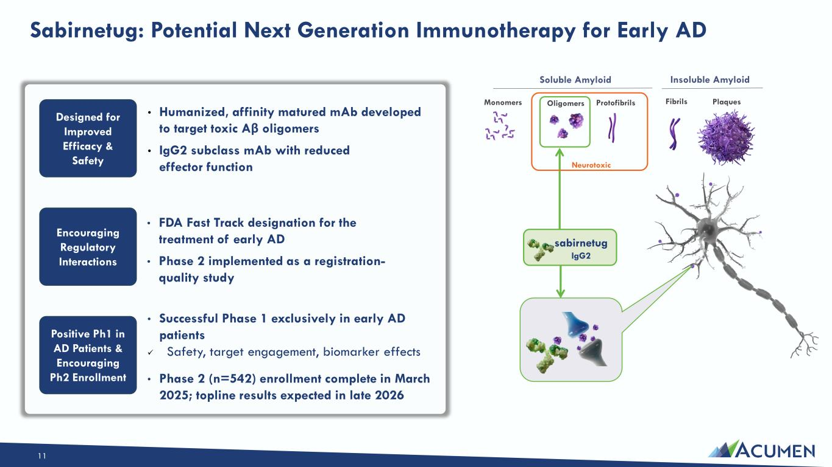
Sabirnetug: Potential Next Generation Immunotherapy for Early AD 11 • Humanized, affinity matured mAb developed to target toxic Aβ oligomers • IgG2 subclass mAb with reduced effector function Designed for Improved Efficacy & Safety Encouraging Regulatory Interactions • FDA Fast Track designation for the treatment of early AD • Phase 2 implemented as a registration- quality study Positive Ph1 in AD Patients & Encouraging Ph2 Enrollment • Successful Phase 1 exclusively in early AD patients ✓ Safety, target engagement, biomarker effects • Phase 2 (n=542) enrollment complete in March 2025; topline results expected in late 2026 Monomers Oligomers Protofibrils Fibrils Plaques Soluble Amyloid Insoluble Amyloid sabirnetug IgG2 Neurotoxic


Sabirnetug

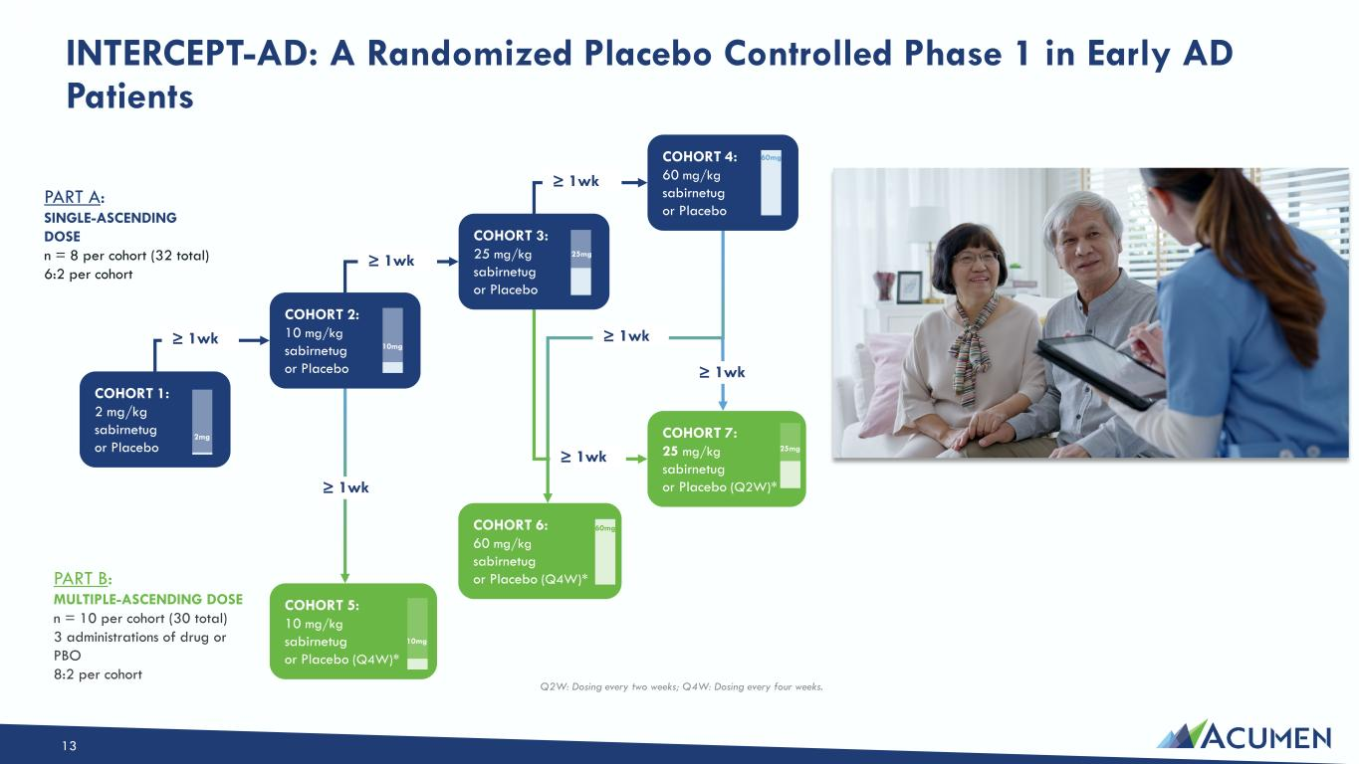
Q2W: Dosing every two weeks; Q4W: Dosing every four weeks. PART A: SINGLE-ASCENDING DOSE n = 8 per cohort (32 total) 6:2 per cohort PART B: MULTIPLE-ASCENDING DOSE n = 10 per cohort (30 total) 3 administrations of drug or PBO 8:2 per cohort COHORT 1: 2 mg/kg sabirnetug or Placebo 2mg COHORT 2: 10 mg/kg sabirnetug or Placebo 10mg COHORT 3: 25 mg/kg sabirnetug or Placebo 25mg COHORT 4: 60 mg/kg sabirnetug or Placebo 60mg COHORT 5: 10 mg/kg sabirnetug or Placebo (Q4W)* 10mg COHORT 6: 60 mg/kg sabirnetug or Placebo (Q4W)* 60mg COHORT 7: 25 mg/kg sabirnetug or Placebo (Q2W)* ≥ 1wk ≥ 1wk ≥ 1wk ≥ 1wk ≥ 1wk ≥ 1wk 25mg ≥ 1wk INTERCEPT-AD: A Randomized Placebo Controlled Phase 1 in Early AD Patients 13

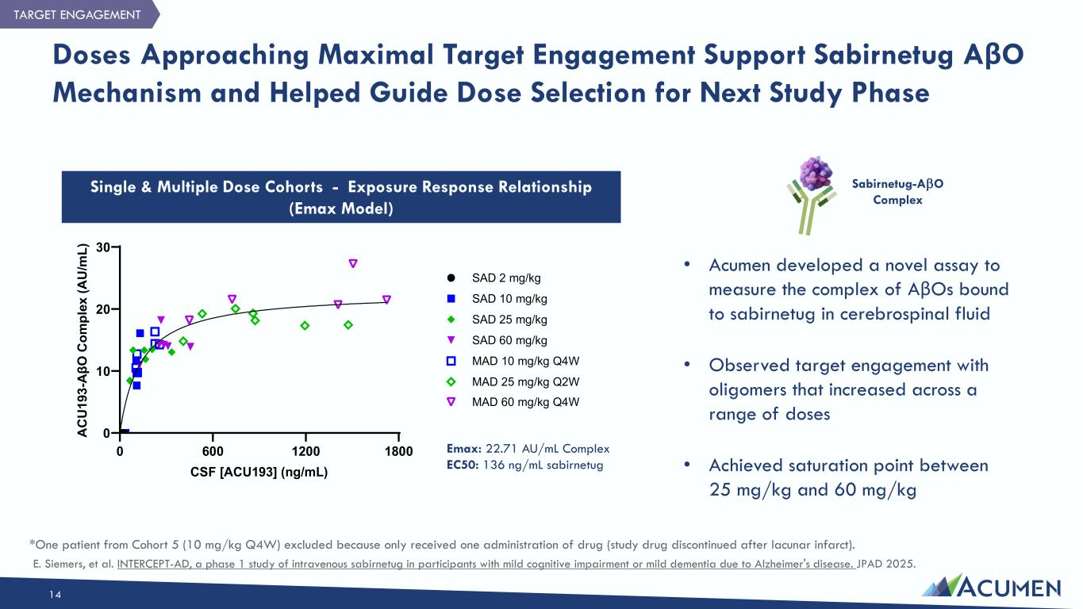
Doses Approaching Maximal Target Engagement Support Sabirnetug AβO Mechanism and Helped Guide Dose Selection for Next Study Phase 14 Single & Multiple Dose Cohorts - Exposure Response Relationship (Emax Model) Emax: 22.71 AU/mL Complex EC50: 136 ng/mL sabirnetug 0 600 1200 1800 0 10 20 30 CSF [ACU193] (ng/mL) A C U 19 3- A βO C om pl ex (A U /m L) SAD 2 mg/kg SAD 10 mg/kg SAD 25 mg/kg SAD 60 mg/kg MAD 10 mg/kg Q4W MAD 60 mg/kg Q4W MAD 25 mg/kg Q2W Sabirnetug-AβO Complex TARGET ENGAGEMENT *One patient from Cohort 5 (10 mg/kg Q4W) excluded because only received one administration of drug (study drug discontinued after lacunar infarct). E. Siemers, et al. INTERCEPT-AD, a phase 1 study of intravenous sabirnetug in participants with mild cognitive impairment or mild dementia due to Alzheimer's disease. JPAD 2025. • Acumen developed a novel assay to measure the complex of AβOs bound to sabirnetug in cerebrospinal fluid • Observed target engagement with oligomers that increased across a range of doses • Achieved saturation point between 25 mg/kg and 60 mg/kg

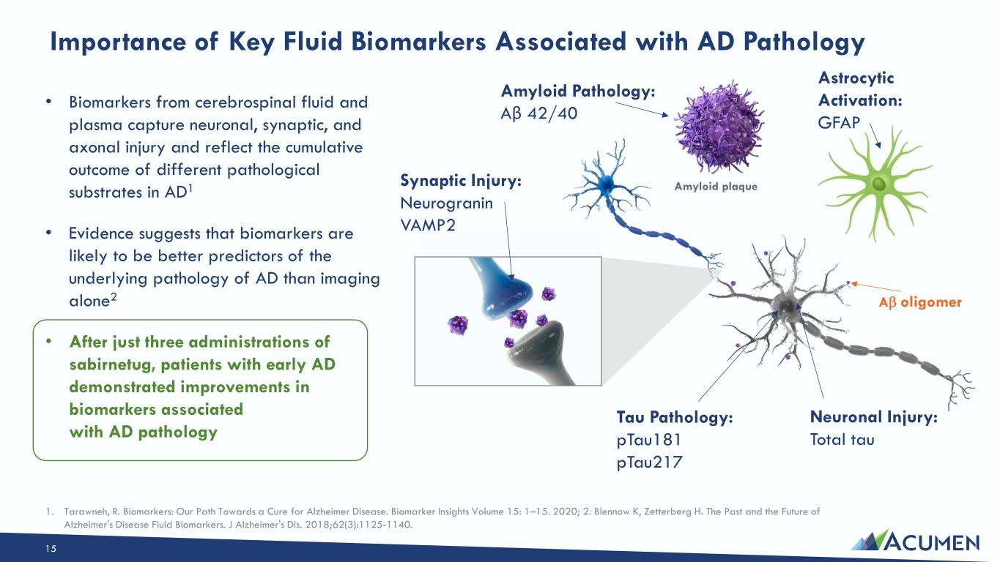
Importance of Key Fluid Biomarkers Associated with AD Pathology 15 Tau Pathology: pTau181 pTau217 Neuronal Injury: Total tau Synaptic Injury: Neurogranin VAMP2 Amyloid Pathology: Aβ 42/40 Astrocytic Activation: GFAP • Biomarkers from cerebrospinal fluid and plasma capture neuronal, synaptic, and axonal injury and reflect the cumulative outcome of different pathological substrates in AD1 • Evidence suggests that biomarkers are likely to be better predictors of the underlying pathology of AD than imaging alone2 • After just three administrations of sabirnetug, patients with early AD demonstrated improvements in biomarkers associated with AD pathology 1. Tarawneh, R. Biomarkers: Our Path Towards a Cure for Alzheimer Disease. Biomarker Insights Volume 15: 1–15. 2020; 2. Blennow K, Zetterberg H. The Past and the Future of Alzheimer's Disease Fluid Biomarkers. J Alzheimer's Dis. 2018;62(3):1125-1140. Aβ oligomer Amyloid plaque

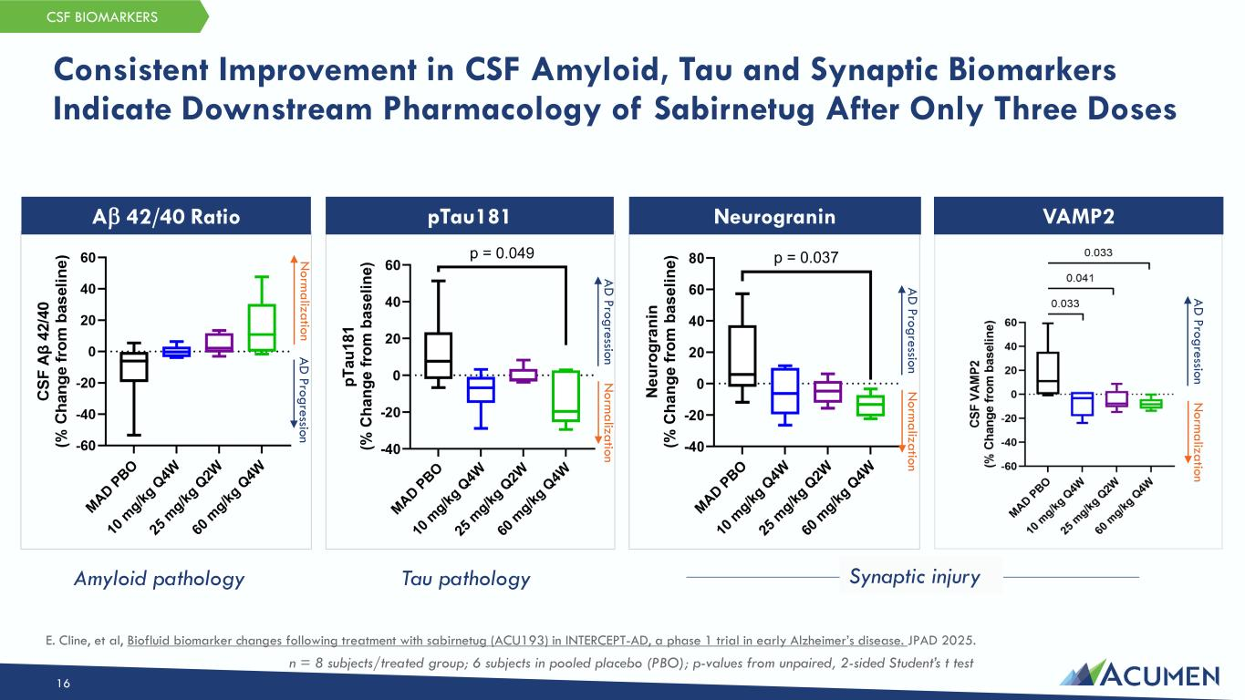
Consistent Improvement in CSF Amyloid, Tau and Synaptic Biomarkers Indicate Downstream Pharmacology of Sabirnetug After Only Three Doses 16 CSF BIOMARKERS pTau181 NeurograninAβ 42/40 Ratio VAMP2 Tau pathologyAmyloid pathology Synaptic injury n = 8 subjects/treated group; 6 subjects in pooled placebo (PBO); p-values from unpaired, 2-sided Student’s t test N orm alization A D Progression N orm alization A D Progression N orm alization A D Progression N orm alization A D Progression E. Cline, et al, Biofluid biomarker changes following treatment with sabirnetug (ACU193) in INTERCEPT-AD, a phase 1 trial in early Alzheimer’s disease. JPAD 2025.

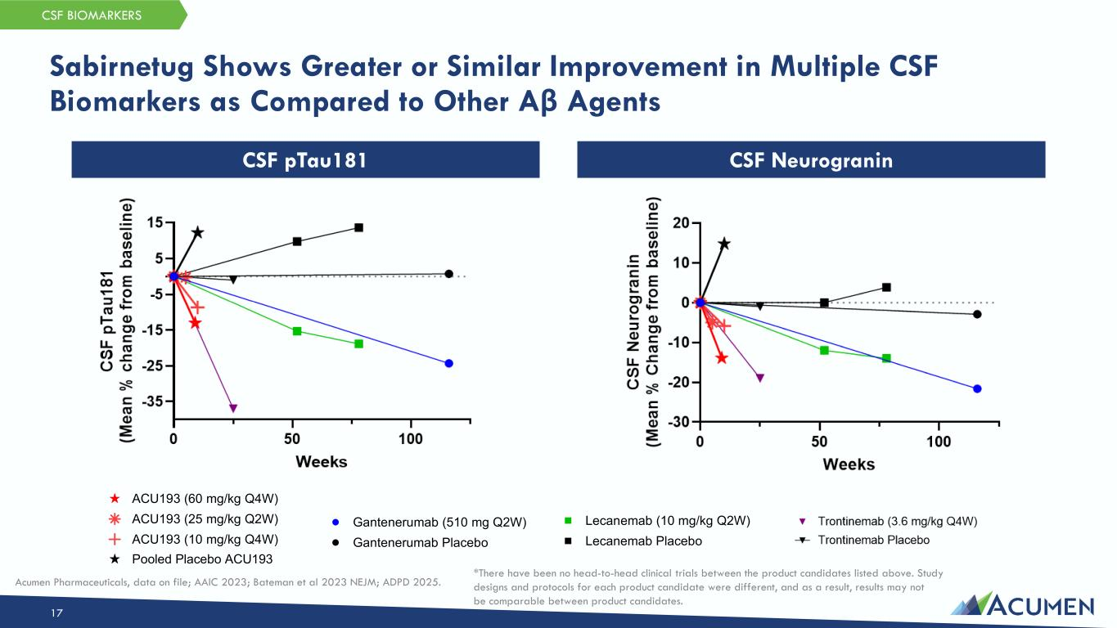
Sabirnetug Shows Greater or Similar Improvement in Multiple CSF Biomarkers as Compared to Other Aβ Agents 17 CSF BIOMARKERS CSF NeurograninCSF pTau181 ACU193 (60 mg/kg Q4W) ACU193 (25 mg/kg Q2W) ACU193 (10 mg/kg Q4W) Pooled Placebo ACU193 Gantenerumab (510 mg Q2W) Gantenerumab Placebo Lecanemab (10 mg/kg Q2W) Lecanemab Placebo *There have been no head-to-head clinical trials between the product candidates listed above. Study designs and protocols for each product candidate were different, and as a result, results may not be comparable between product candidates. Acumen Pharmaceuticals, data on file; AAIC 2023; Bateman et al 2023 NEJM; ADPD 2025.

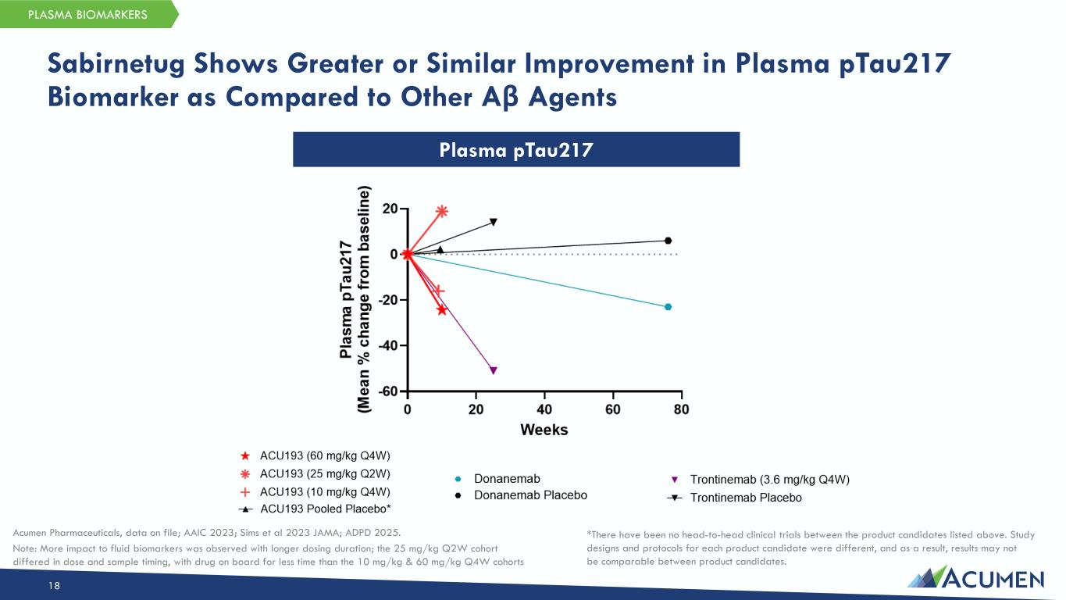
Sabirnetug Shows Greater or Similar Improvement in Plasma pTau217 Biomarker as Compared to Other Aβ Agents 18 PLASMA BIOMARKERS Plasma pTau217 *There have been no head-to-head clinical trials between the product candidates listed above. Study designs and protocols for each product candidate were different, and as a result, results may not be comparable between product candidates. Acumen Pharmaceuticals, data on file; AAIC 2023; Sims et al 2023 JAMA; ADPD 2025. Note: More impact to fluid biomarkers was observed with longer dosing duration; the 25 mg/kg Q2W cohort differed in dose and sample timing, with drug on board for less time than the 10 mg/kg & 60 mg/kg Q4W cohorts

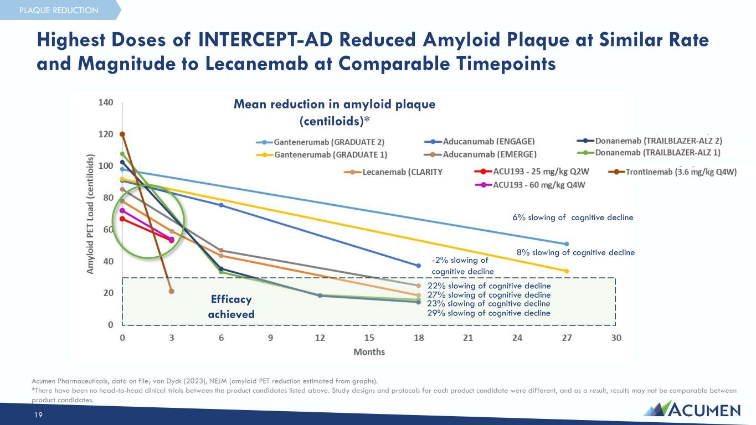
Highest Doses of INTERCEPT-AD Reduced Amyloid Plaque at Similar Rate and Magnitude to Lecanemab at Comparable Timepoints 6% slowing of cognitive decline 8% slowing of cognitive decline -2% slowing of cognitive decline 22% slowing of cognitive decline 27% slowing of cognitive decline 23% slowing of cognitive decline 29% slowing of cognitive decline Efficacy achieved Mean reduction in amyloid plaque (centiloids)* Acumen Pharmaceuticals, data on file; van Dyck (2023), NEJM (amyloid PET reduction estimated from graphs). *There have been no head-to-head clinical trials between the product candidates listed above. Study designs and protocols for each product candidate were different, and as a result, results may not be comparable between product candidates. 19 PLAQUE REDUCTION

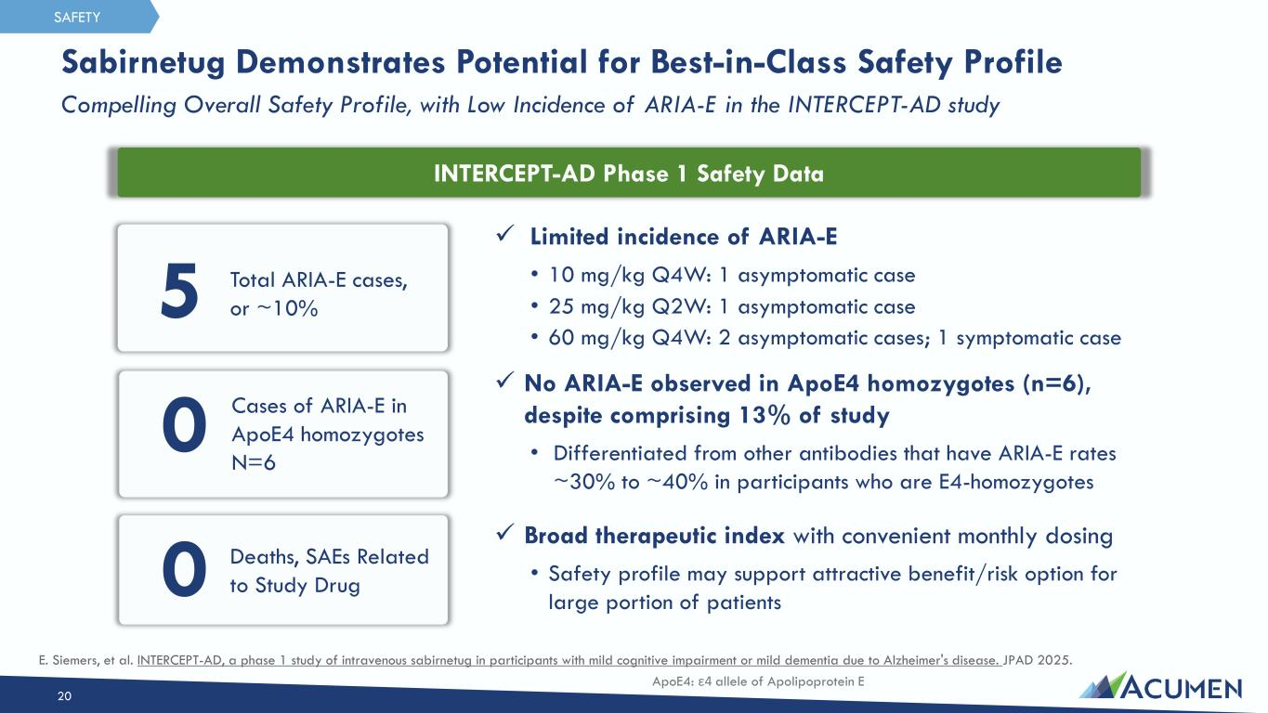
Sabirnetug Demonstrates Potential for Best-in-Class Safety Profile Compelling Overall Safety Profile, with Low Incidence of ARIA-E in the INTERCEPT-AD study 20 SAFETY ✓ Limited incidence of ARIA-E • 10 mg/kg Q4W: 1 asymptomatic case • 25 mg/kg Q2W: 1 asymptomatic case • 60 mg/kg Q4W: 2 asymptomatic cases; 1 symptomatic case ✓ No ARIA-E observed in ApoE4 homozygotes (n=6), despite comprising 13% of study • Differentiated from other antibodies that have ARIA-E rates ~30% to ~40% in participants who are E4-homozygotes ✓ Broad therapeutic index with convenient monthly dosing • Safety profile may support attractive benefit/risk option for large portion of patients 5 0 Total ARIA-E cases, or ~10% Cases of ARIA-E in ApoE4 homozygotes N=6 0 Deaths, SAEs Related to Study Drug INTERCEPT-AD Phase 1 Safety Data E. Siemers, et al. INTERCEPT-AD, a phase 1 study of intravenous sabirnetug in participants with mild cognitive impairment or mild dementia due to Alzheimer's disease. JPAD 2025. ApoE4: ε4 allele of Apolipoprotein E

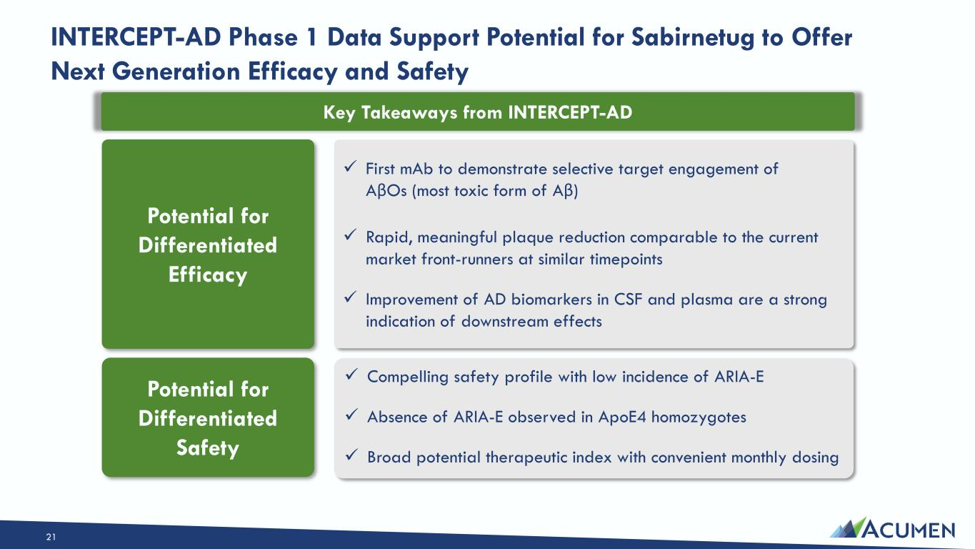
Potential for Differentiated Efficacy Potential for Differentiated Safety INTERCEPT-AD Phase 1 Data Support Potential for Sabirnetug to Offer Next Generation Efficacy and Safety 21 ✓ Compelling safety profile with low incidence of ARIA-E ✓ Absence of ARIA-E observed in ApoE4 homozygotes ✓ Broad potential therapeutic index with convenient monthly dosing ✓ First mAb to demonstrate selective target engagement of AβOs (most toxic form of Aβ) ✓ Rapid, meaningful plaque reduction comparable to the current market front-runners at similar timepoints ✓ Improvement of AD biomarkers in CSF and plasma are a strong indication of downstream effects Key Takeaways from INTERCEPT-AD

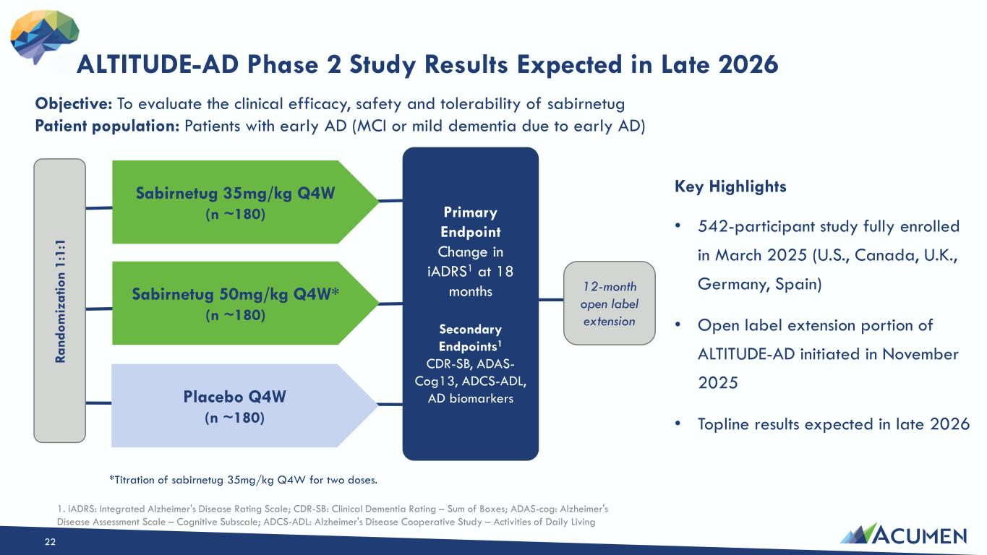
Ra nd om iz at io n 1: 1: 1 Sabirnetug 35mg/kg Q4W (n ~180) Sabirnetug 50mg/kg Q4W* (n ~180) Placebo Q4W (n ~180) Primary Endpoint Change in iADRS1 at 18 months Secondary Endpoints1 CDR-SB, ADAS- Cog13, ADCS-ADL, AD biomarkers 12-month open label extension Objective: To evaluate the clinical efficacy, safety and tolerability of sabirnetug Patient population: Patients with early AD (MCI or mild dementia due to early AD) ALTITUDE-AD Phase 2 Study Results Expected in Late 2026 1. iADRS: Integrated Alzheimer's Disease Rating Scale; CDR-SB: Clinical Dementia Rating – Sum of Boxes; ADAS-cog: Alzheimer's Disease Assessment Scale – Cognitive Subscale; ADCS-ADL: Alzheimer's Disease Cooperative Study – Activities of Daily Living 22 *Titration of sabirnetug 35mg/kg Q4W for two doses. • 542-participant study fully enrolled in March 2025 (U.S., Canada, U.K., Germany, Spain) • Open label extension portion of ALTITUDE-AD initiated in November 2025 • Topline results expected in late 2026 Key Highlights

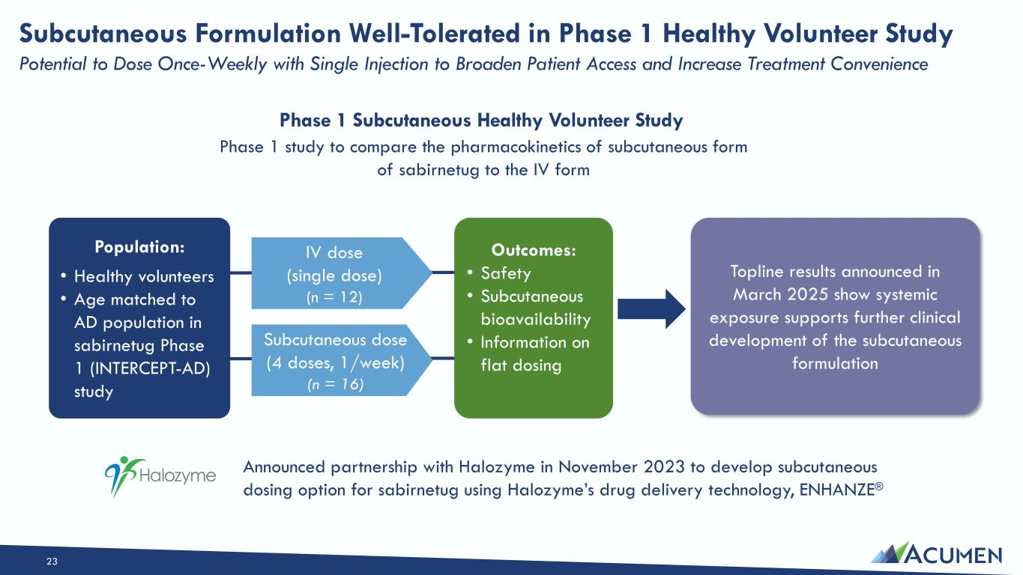
Subcutaneous Formulation Well-Tolerated in Phase 1 Healthy Volunteer Study Potential to Dose Once-Weekly with Single Injection to Broaden Patient Access and Increase Treatment Convenience Topline results announced in March 2025 show systemic exposure supports further clinical development of the subcutaneous formulation 23 Phase 1 study to compare the pharmacokinetics of subcutaneous form of sabirnetug to the IV form Outcomes: • Safety • Subcutaneous bioavailability • Information on flat dosing Population: • Healthy volunteers • Age matched to AD population in sabirnetug Phase 1 (INTERCEPT-AD) study IV dose (single dose) (n = 12) Subcutaneous dose (4 doses, 1/week) (n = 16) Phase 1 Subcutaneous Healthy Volunteer Study Announced partnership with Halozyme in November 2023 to develop subcutaneous dosing option for sabirnetug using Halozyme’s drug delivery technology, ENHANZE®

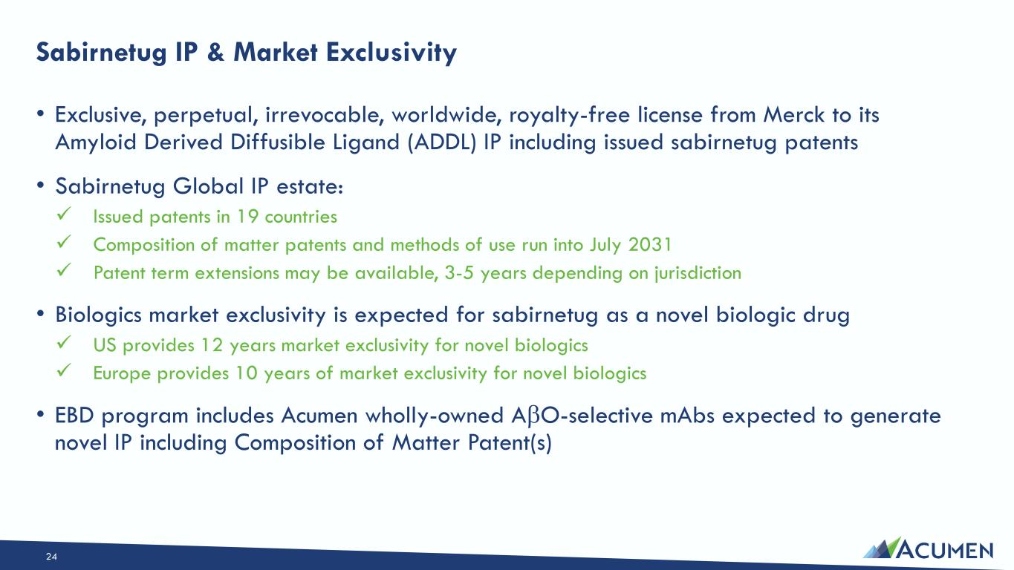
Sabirnetug IP & Market Exclusivity • Exclusive, perpetual, irrevocable, worldwide, royalty-free license from Merck to its Amyloid Derived Diffusible Ligand (ADDL) IP including issued sabirnetug patents • Sabirnetug Global IP estate: ✓ Issued patents in 19 countries ✓ Composition of matter patents and methods of use run into July 2031 ✓ Patent term extensions may be available, 3-5 years depending on jurisdiction • Biologics market exclusivity is expected for sabirnetug as a novel biologic drug ✓ US provides 12 years market exclusivity for novel biologics ✓ Europe provides 10 years of market exclusivity for novel biologics • EBD program includes Acumen wholly-owned AβO-selective mAbs expected to generate novel IP including Composition of Matter Patent(s) 24

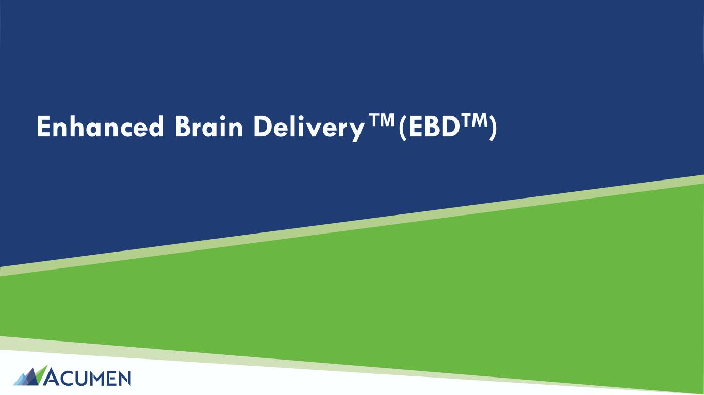
Enhanced Brain Delivery (EBDTM)

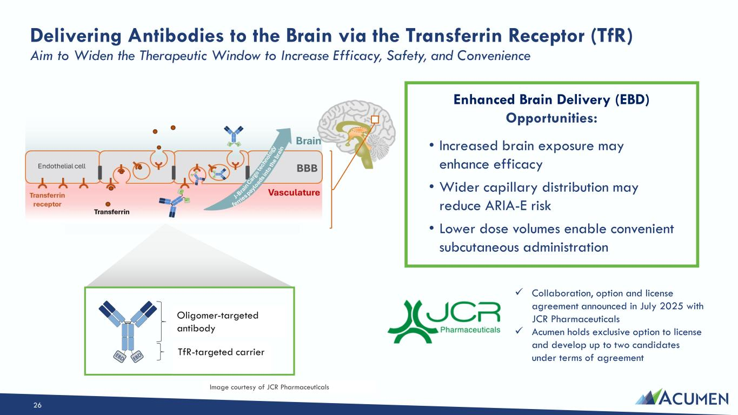
26 Delivering Antibodies to the Brain via the Transferrin Receptor (TfR) Aim to Widen the Therapeutic Window to Increase Efficacy, Safety, and Convenience • Increased brain exposure may enhance efficacy • Wider capillary distribution may reduce ARIA-E risk • Lower dose volumes enable convenient subcutaneous administration Enhanced Brain Delivery (EBD) Opportunities: Oligomer-targeted antibody TfR-targeted carrier ✓ Collaboration, option and license agreement announced in July 2025 with JCR Pharmaceuticals ✓ Acumen holds exclusive option to license and develop up to two candidates under terms of agreement Image courtesy of JCR Pharmaceuticals

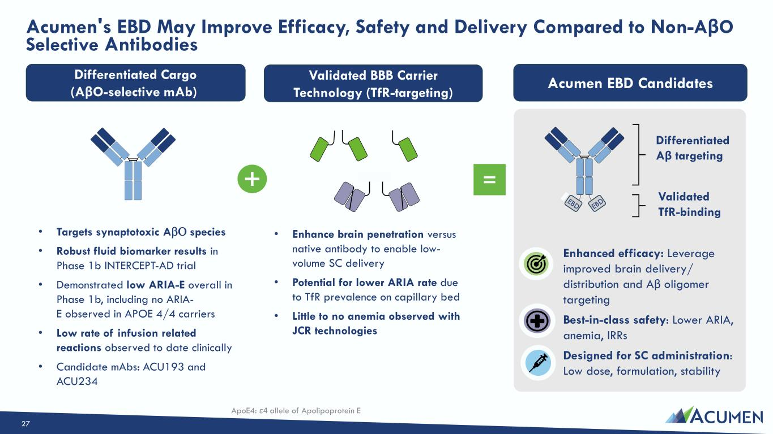
Acumen's EBD May Improve Efficacy, Safety and Delivery Compared to Non-AβO Selective Antibodies Differentiated Cargo (AβO-selective mAb) 27 Differentiated Aβ targeting Validated TfR-binding Validated BBB Carrier Technology (TfR-targeting) Acumen EBD Candidates • Targets synaptotoxic AβΟ species • Robust fluid biomarker results in Phase 1b INTERCEPT-AD trial • Demonstrated low ARIA-E overall in Phase 1b, including no ARIA- E observed in APOE 4/4 carriers • Low rate of infusion related reactions observed to date clinically • Candidate mAbs: ACU193 and ACU234 • Enhance brain penetration versus native antibody to enable low- volume SC delivery • Potential for lower ARIA rate due to TfR prevalence on capillary bed • Little to no anemia observed with JCR technologies = Enhanced efficacy: Leverage improved brain delivery/ distribution and Aβ oligomer targeting Best-in-class safety: Lower ARIA, anemia, IRRs Designed for SC administration: Low dose, formulation, stability ApoE4: ε4 allele of Apolipoprotein E

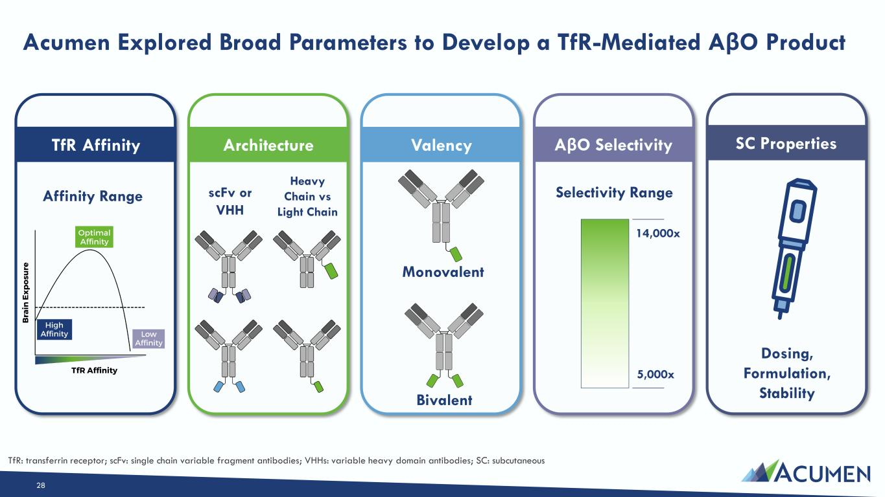
Acumen Explored Broad Parameters to Develop a TfR-Mediated AβO Product 28 TfR Affinity Architecture Valency AβO Selectivity scFv or VHH Heavy Chain vs Light Chain Monovalent Bivalent Affinity Range Selectivity Range SC Properties 14,000x 5,000x Dosing, Formulation, Stability TfR: transferrin receptor; scFv: single chain variable fragment antibodies; VHHs: variable heavy domain antibodies; SC: subcutaneous

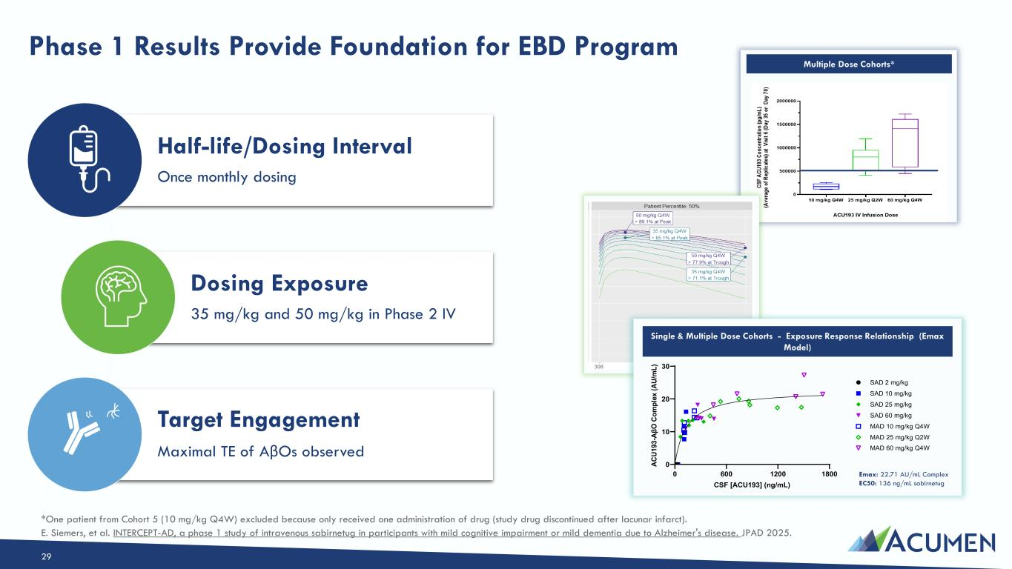
Multiple Dose Cohorts* Half-life/Dosing Interval Once monthly dosing Dosing Exposure 35 mg/kg and 50 mg/kg in Phase 2 IV Target Engagement Maximal TE of AβOs observed Phase 1 Results Provide Foundation for EBD Program 29 Single & Multiple Dose Cohorts - Exposure Response Relationship (Emax Model) Emax: 22.71 AU/mL Complex EC50: 136 ng/mL sabirnetug 0 600 1200 1800 0 10 20 30 CSF [ACU193] (ng/mL) AC U1 93 -A βO C om pl ex (A U/ m L) SAD 2 mg/kg SAD 10 mg/kg SAD 25 mg/kg SAD 60 mg/kg MAD 10 mg/kg Q4W MAD 60 mg/kg Q4W MAD 25 mg/kg Q2W *One patient from Cohort 5 (10 mg/kg Q4W) excluded because only received one administration of drug (study drug discontinued after lacunar infarct). E. Siemers, et al. INTERCEPT-AD, a phase 1 study of intravenous sabirnetug in participants with mild cognitive impairment or mild dementia due to Alzheimer's disease. JPAD 2025.

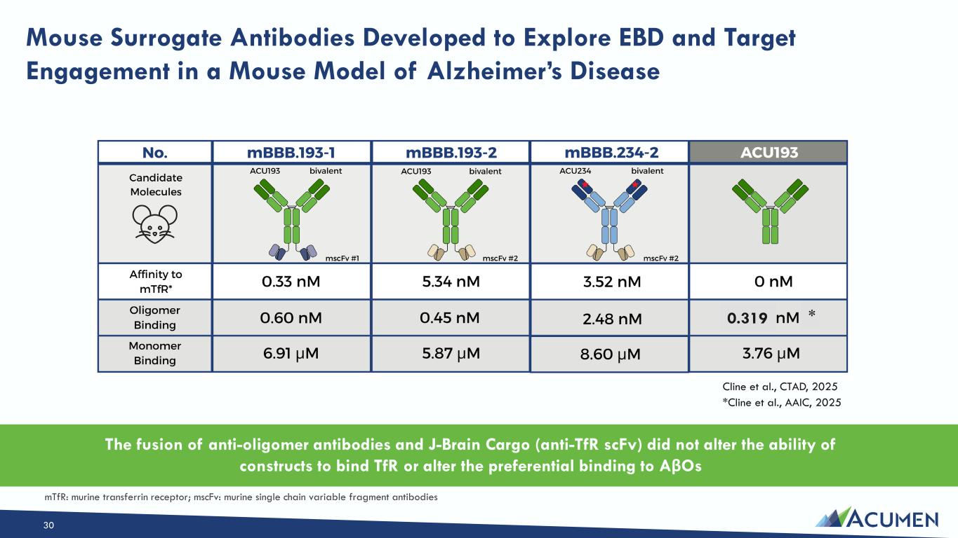
Mouse Surrogate Antibodies Developed to Explore EBD and Target Engagement in a Mouse Model of Alzheimer’s Disease 30 The fusion of anti-oligomer antibodies and J-Brain Cargo (anti-TfR scFv) did not alter the ability of constructs to bind TfR or alter the preferential binding to AβOs Cline et al., CTAD, 2025 234 0 nM Oligomer Binding Monomer Binding 2.182 nM 3.761 µM ACU193 0.33 nM 5.34 nM 3.52 nM 0.595 nM 0.448 nM 2.475 nM 6.914 µM 5.871 µM 8.6 µM mTfR: murine transferrin receptor; mscFv: murine single chain variable fragment antibodies 0.319 * *Cline et al., AAIC, 2025

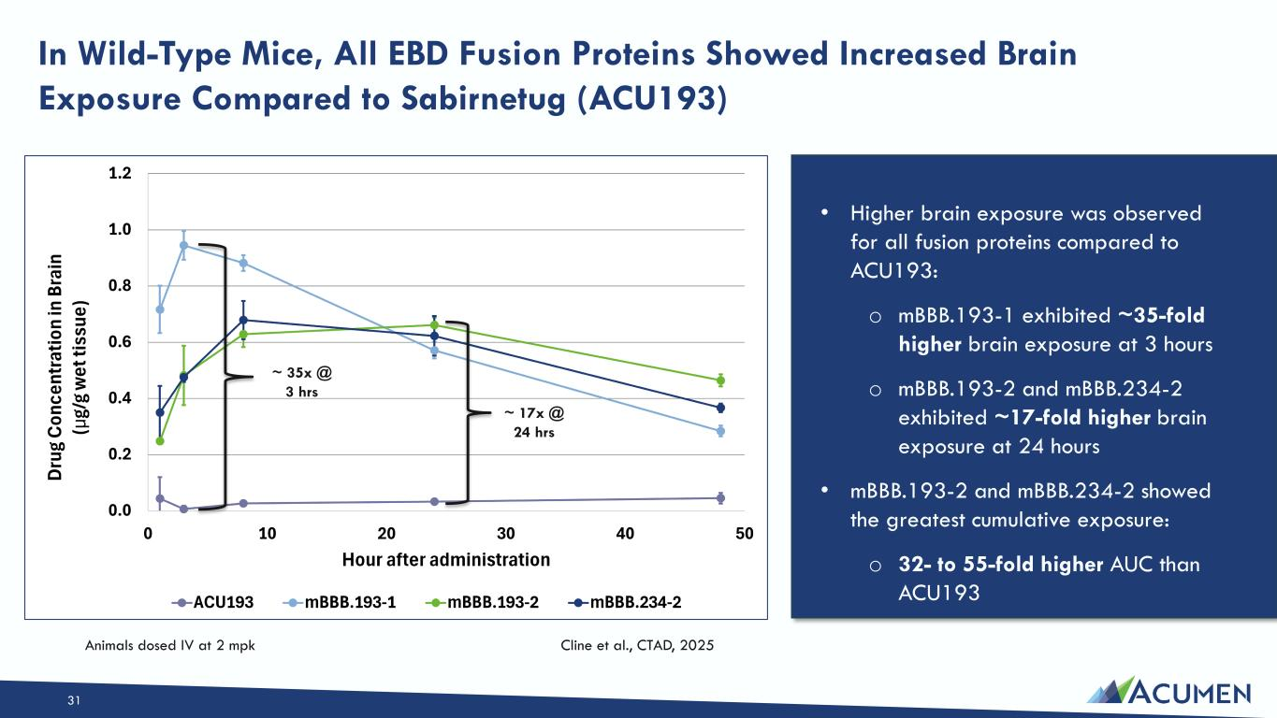
Animals dosed IV at 2 mpk Cline et al., CTAD, 2025 • Higher brain exposure was observed for all fusion proteins compared to ACU193: o mBBB.193-1 exhibited ~35-fold higher brain exposure at 3 hours o mBBB.193-2 and mBBB.234-2 exhibited ~17-fold higher brain exposure at 24 hours • mBBB.193-2 and mBBB.234-2 showed the greatest cumulative exposure: o 32- to 55-fold higher AUC than ACU193 In Wild-Type Mice, All EBD Fusion Proteins Showed Increased Brain Exposure Compared to Sabirnetug (ACU193) ~ 35x @ 3 hrs ~ 17x @ 24 hrs 31

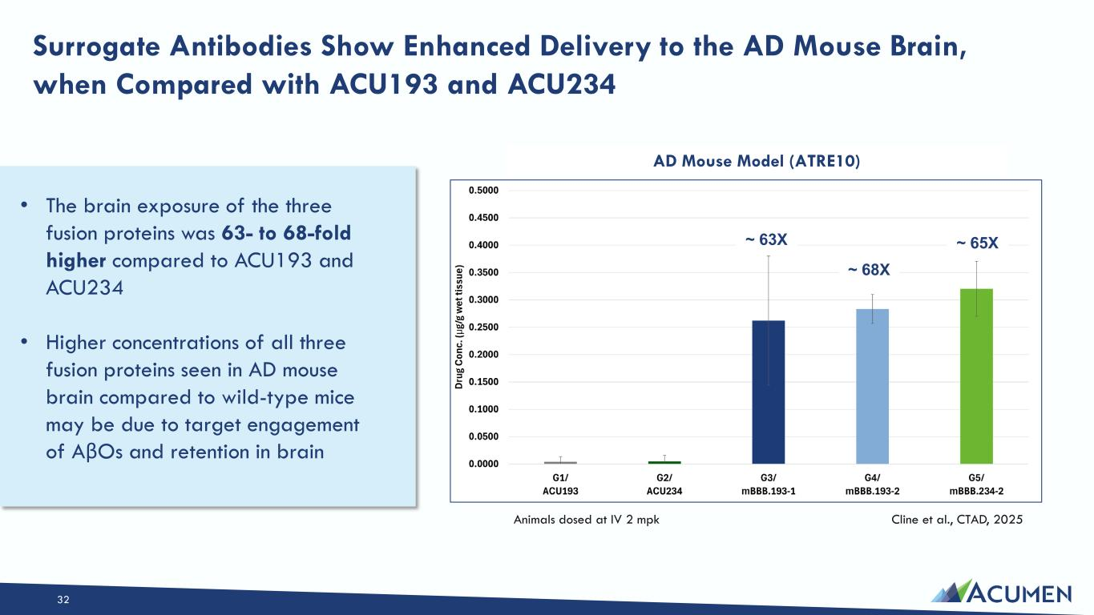
Surrogate Antibodies Show Enhanced Delivery to the AD Mouse Brain, when Compared with ACU193 and ACU234 AD Mouse Model (ATRE10) Animals dosed at IV 2 mpk Cline et al., CTAD, 2025 ~ 63X ~ 68X ~ 65X 32 • The brain exposure of the three fusion proteins was 63- to 68-fold higher compared to ACU193 and ACU234 • Higher concentrations of all three fusion proteins seen in AD mouse brain compared to wild-type mice may be due to target engagement of AβOs and retention in brain

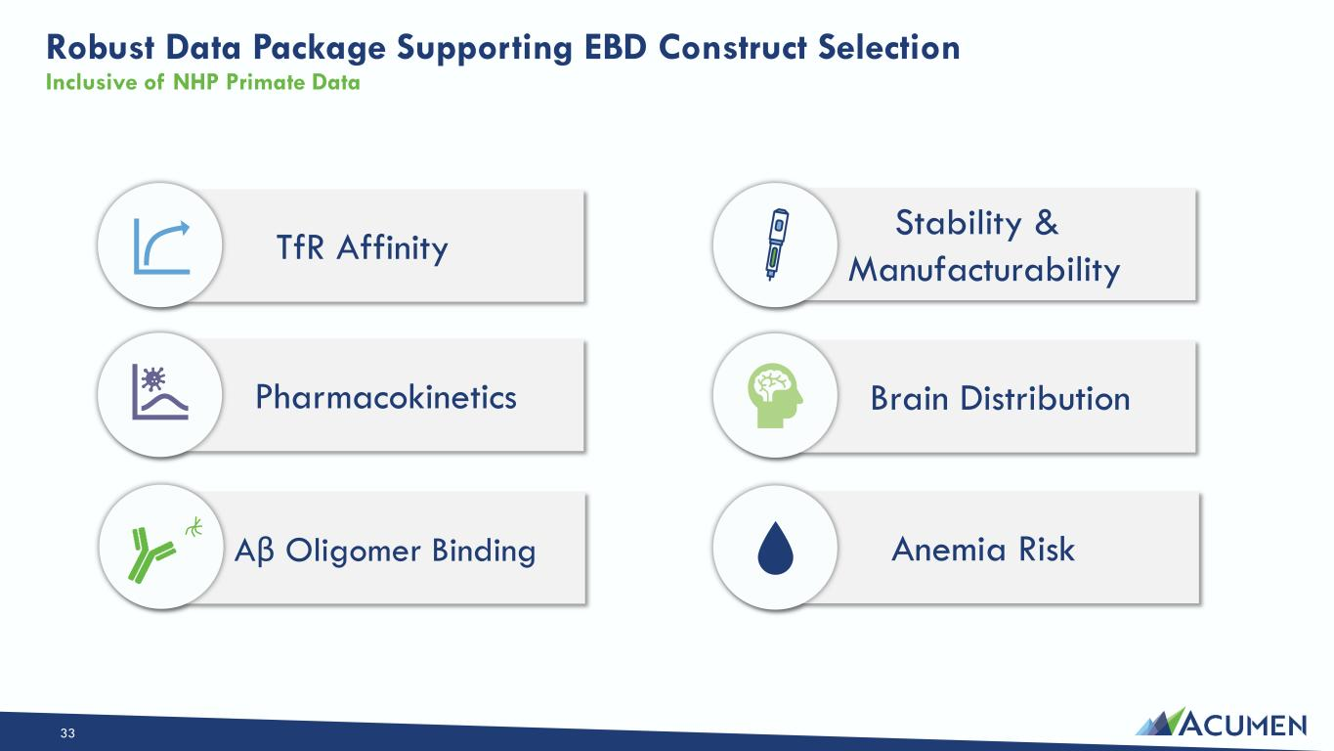
Robust Data Package Supporting EBD Construct Selection Inclusive of NHP Primate Data Anemia Risk Brain Distribution Stability & Manufacturability Pharmacokinetics TfR Affinity 33 Aβ Oligomer Binding

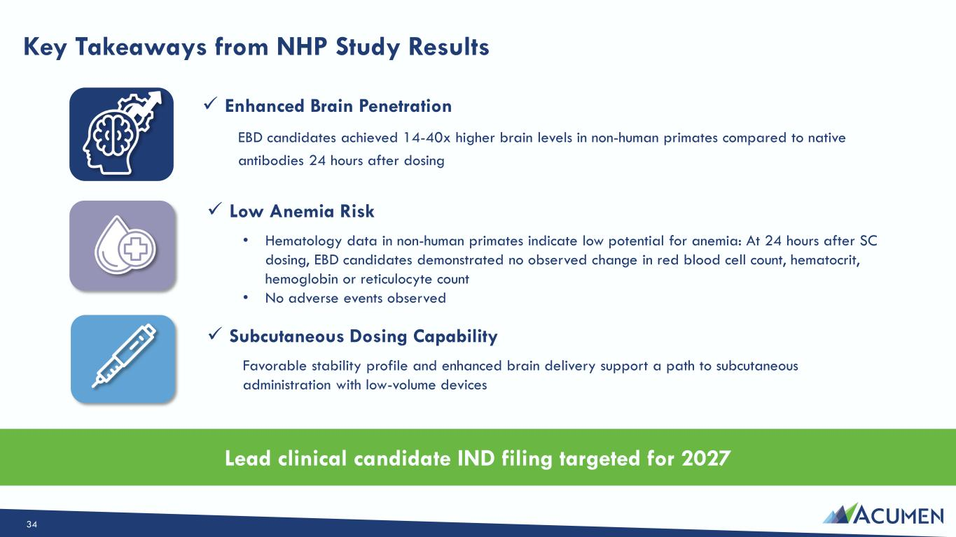
Key Takeaways from NHP Study Results 34 ✓ Enhanced Brain Penetration EBD candidates achieved 14-40x higher brain levels in non-human primates compared to native antibodies 24 hours after dosing Lead clinical candidate IND filing targeted for 2027 ✓ Subcutaneous Dosing Capability Favorable stability profile and enhanced brain delivery support a path to subcutaneous administration with low-volume devices ✓ Low Anemia Risk • Hematology data in non-human primates indicate low potential for anemia: At 24 hours after SC dosing, EBD candidates demonstrated no observed change in red blood cell count, hematocrit, hemoglobin or reticulocyte count • No adverse events observed

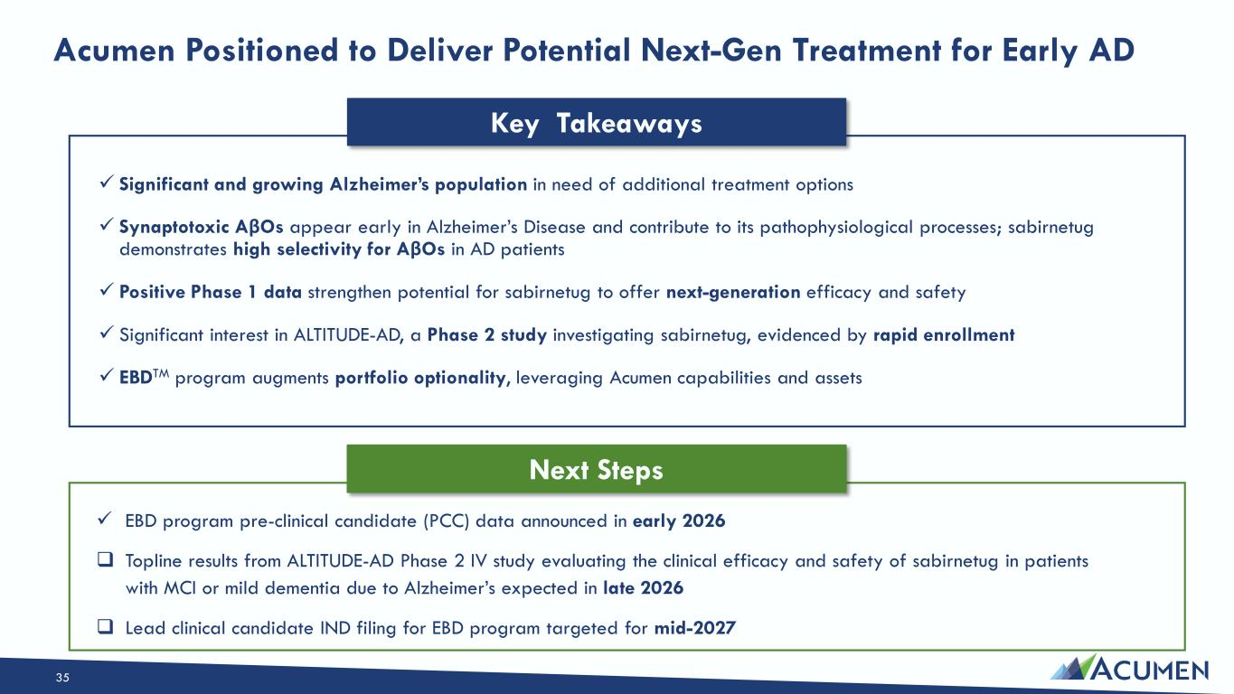
✓ Significant and growing Alzheimer’s population in need of additional treatment options ✓ Synaptotoxic AβOs appear early in Alzheimer’s Disease and contribute to its pathophysiological processes; sabirnetug demonstrates high selectivity for AβOs in AD patients ✓ Positive Phase 1 data strengthen potential for sabirnetug to offer next-generation efficacy and safety ✓ Significant interest in ALTITUDE-AD, a Phase 2 study investigating sabirnetug, evidenced by rapid enrollment ✓ EBDTM program augments portfolio optionality, leveraging Acumen capabilities and assets Acumen Positioned to Deliver Potential Next-Gen Treatment for Early AD 35 Key Takeaways Next Steps ✓ EBD program pre-clinical candidate (PCC) data announced in early 2026  Topline results from ALTITUDE-AD Phase 2 IV study evaluating the clinical efficacy and safety of sabirnetug in patients with MCI or mild dementia due to Alzheimer’s expected in late 2026  Lead clinical candidate IND filing for EBD program targeted for mid-2027

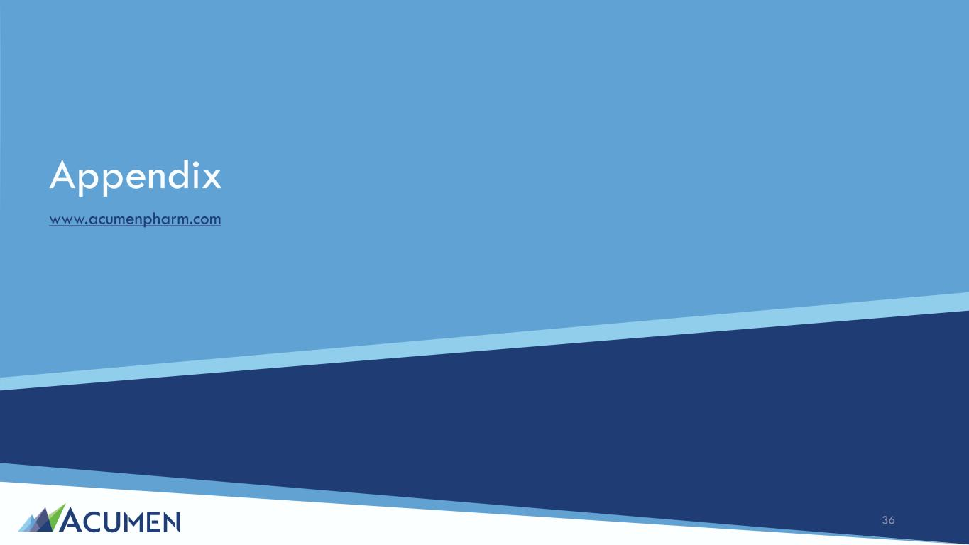
Appendix www.acumenpharm.com 36

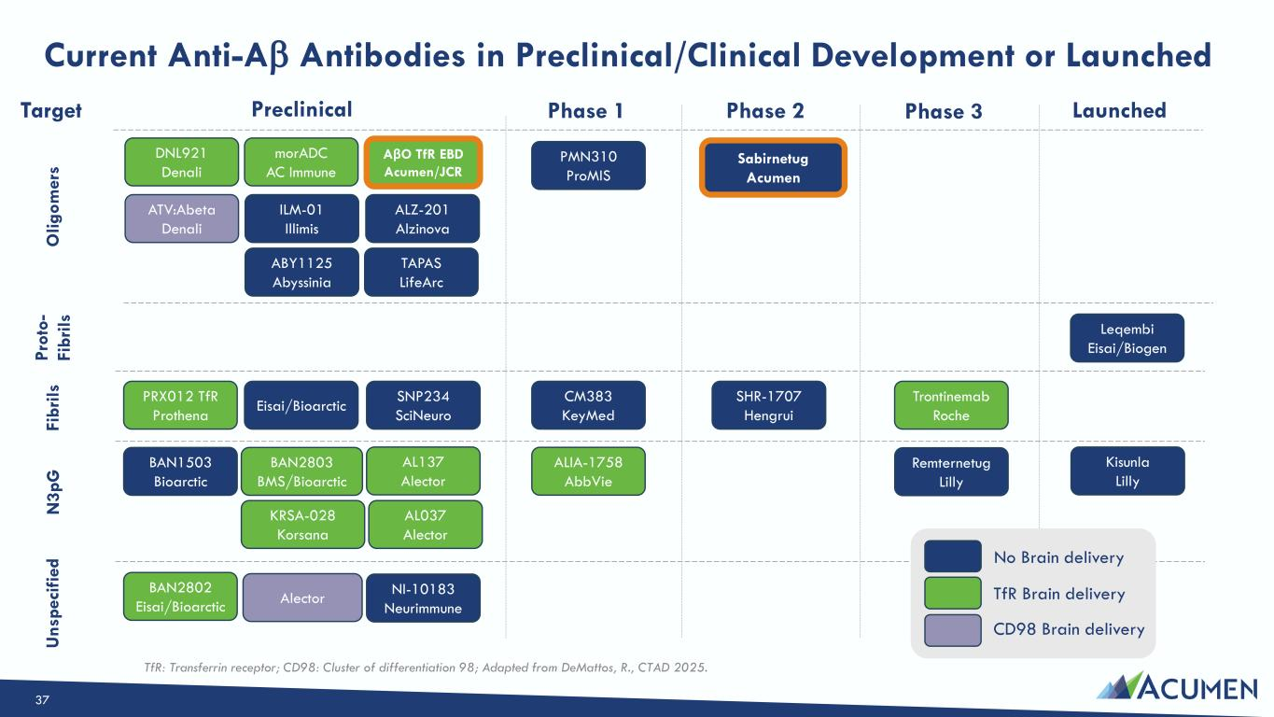
Current Anti-Aβ Antibodies in Preclinical/Clinical Development or Launched O lig om er s Target Preclinical Phase 1 Phase 2 Phase 3 Launched Sabirnetug Acumen PMN310 ProMIS CM383 KeyMed Trontinemab Roche Leqembi Eisai/Biogen Kisunla Lilly Remternetug Lilly ALIA-1758 AbbVie TAPAS LifeArc ILM-01 Illimis ABY1125 Abyssinia AβO TfR EBD Acumen/JCR ALZ-201 Alzinova morADC AC Immune DNL921 Denali ATV:Abeta Denali BAN2802 Eisai/Bioarctic SNP234 SciNeuro BAN1503 Bioarctic AL137 Alector AL037 Alector Eisai/Bioarctic PRX012 TfR Prothena BAN2803 BMS/Bioarctic TfR Brain deliveryAlector CD98 Brain delivery TfR: Transferrin receptor; CD98: Cluster of differentiation 98; Adapted from DeMattos, R., CTAD 2025. Fi br ils N 3p G U ns pe ci fie d SHR-1707 Hengrui NI-10183 Neurimmune No Brain delivery Pr ot o- Fi br ils KRSA-028 Korsana 37

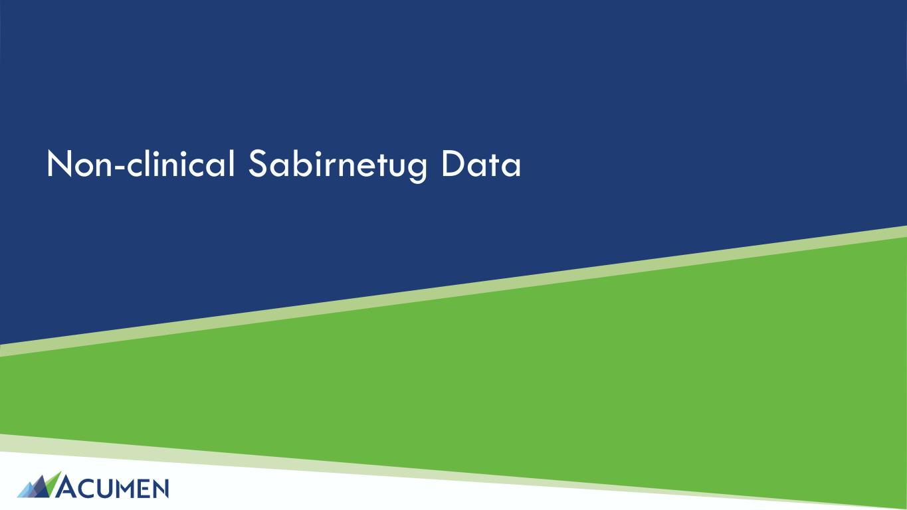
Non-clinical Sabirnetug Data

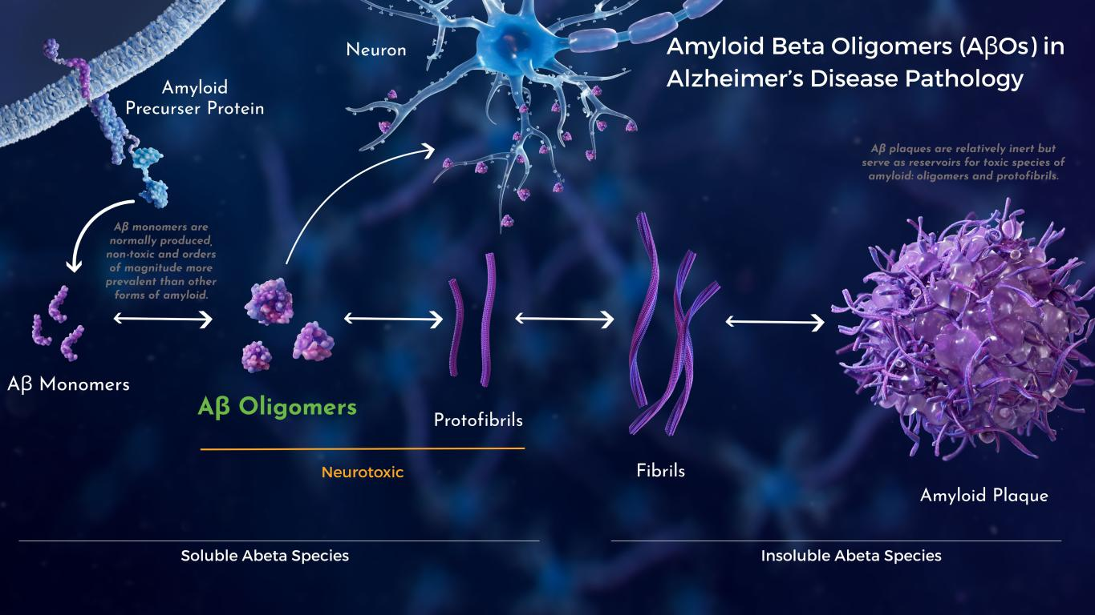
Amyloid Beta Oligomers (AβOs) in Alzheimer’s Disease Pathology Aβ monomers are normally produced, non- toxic and orders of magnitude more prevalent than other forms of amyloid. Aβ plaques are relatively inert but serve as reservoirs for toxic species of amyloid: oligomers and protofibrils. Neurotoxic Soluble Amyloid Insoluble Amyloid

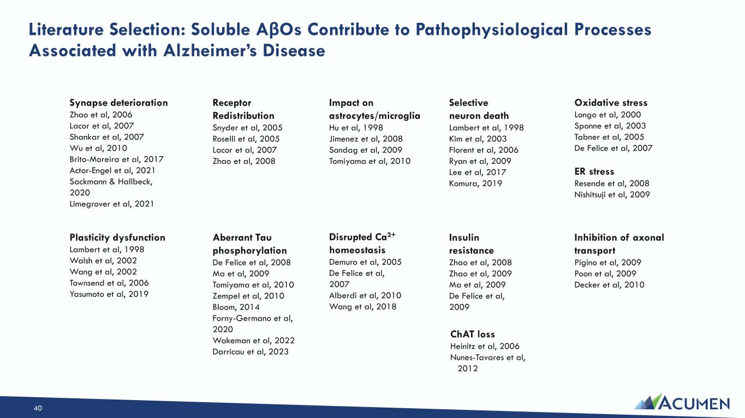
Literature Selection: Soluble AβOs Contribute to Pathophysiological Processes Associated with Alzheimer’s Disease Disrupted Ca2+ homeostasis Demuro et al, 2005 De Felice et al, 2007 Alberdi et al, 2010 Wang et al, 2018 ChAT loss Heinitz et al, 2006 Nunes-Tavares et al, 2012 Inhibition of axonal transport Pigino et al, 2009 Poon et al, 2009 Decker et al, 2010 Oxidative stress Longo et al, 2000 Sponne et al, 2003 Tabner et al, 2005 De Felice et al, 2007 ER stress Resende et al, 2008 Nishitsuji et al, 2009 Insulin resistance Zhao et al, 2008 Zhao et al, 2009 Ma et al, 2009 De Felice et al, 2009 Impact on astrocytes/microglia Hu et al, 1998 Jimenez et al, 2008 Sondag et al, 2009 Tomiyama et al, 2010 Aberrant Tau phosphorylation De Felice et al, 2008 Ma et al, 2009 Tomiyama et al, 2010 Zempel et al, 2010 Bloom, 2014 Forny-Germano et al, 2020 Wakeman et al, 2022 Darricau et al, 2023 Selective neuron death Lambert et al, 1998 Kim et al, 2003 Florent et al, 2006 Ryan et al, 2009 Lee et al, 2017 Komura, 2019 Plasticity dysfunction Lambert et al, 1998 Walsh et al, 2002 Wang et al, 2002 Townsend et al, 2006 Yasumoto et al, 2019 Synapse deterioration Zhao et al, 2006 Lacor et al, 2007 Shankar et al, 2007 Wu et al, 2010 Brito-Moreira et al, 2017 Actor-Engel et al, 2021 Sackmann & Hallbeck, 2020 Limegrover et al, 2021 Receptor Redistribution Snyder et al, 2005 Roselli et al, 2005 Lacor et al, 2007 Zhao et al, 2008 40

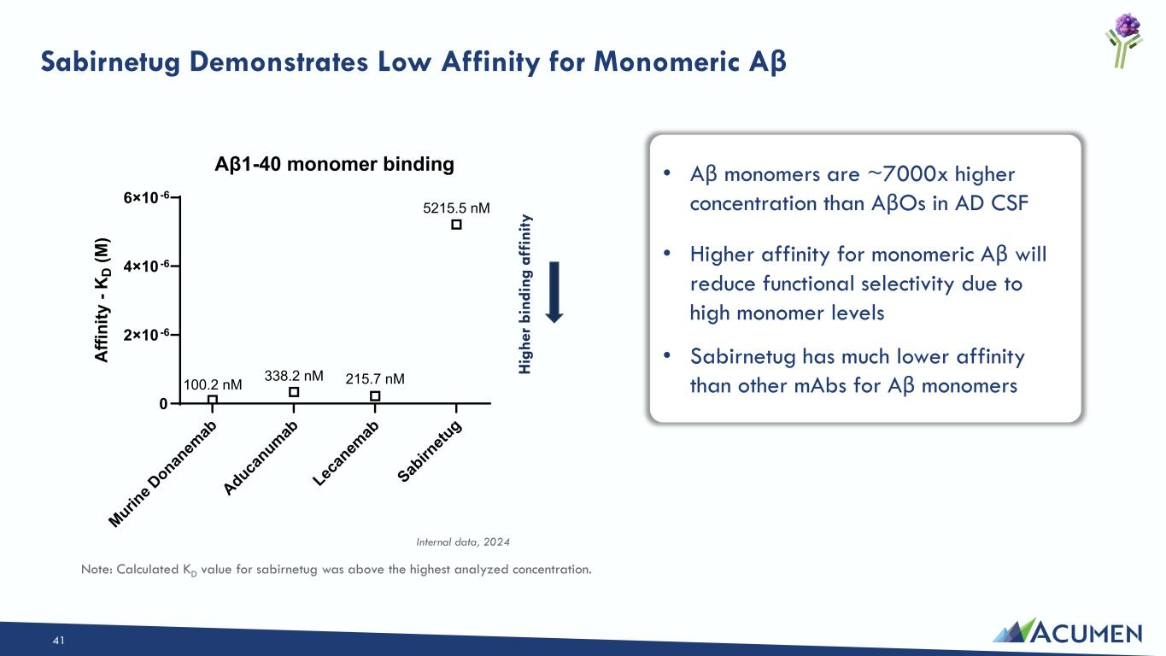
• Aβ monomers are ~7000x higher concentration than AβOs in AD CSF • Higher affinity for monomeric Aβ will reduce functional selectivity due to high monomer levels • Sabirnetug has much lower affinity than other mAbs for Aβ monomers Sabirnetug Demonstrates Low Affinity for Monomeric Aβ 41 Murin e D onan em ab Aduca numab Lec an em ab Sab irn etu g 0 2×10-6 4×10-6 6×10-6 Aβ1-40 monomer binding A ffi ni ty - K D (M ) 100.2 nM 338.2 nM 215.7 nM 5215.5 nM H ig he r b in di ng a ff in ity Internal data, 2024 Note: Calculated KD value for sabirnetug was above the highest analyzed concentration.

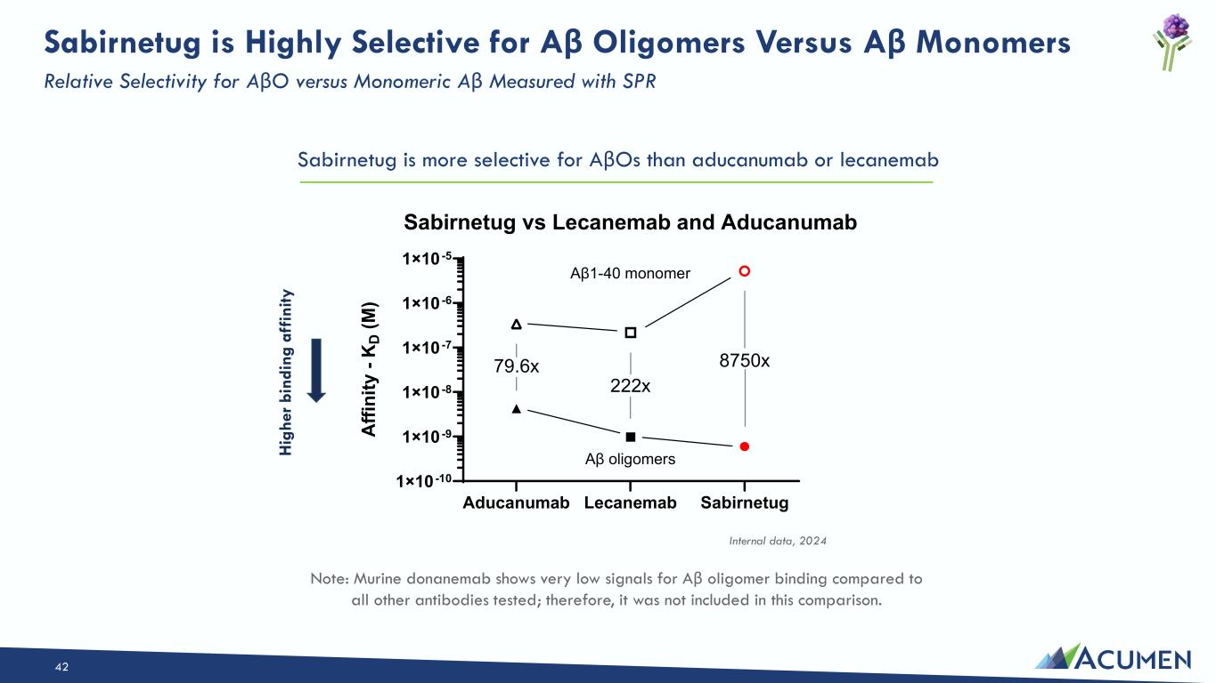
Sabirnetug is Highly Selective for Aβ Oligomers Versus Aβ Monomers Relative Selectivity for AβO versus Monomeric Aβ Measured with SPR 42 Sabirnetug is more selective for AβOs than aducanumab or lecanemab Aducanumab Lecanemab Sabirnetug 1×10-10 1×10-9 1×10-8 1×10-7 1×10-6 1×10-5 Sabirnetug vs Lecanemab and Aducanumab A ffi ni ty - K D (M ) Aβ1-40 monomer Aβ oligomers 8750x 222x 79.6x H ig he r b in di ng a ff in ity Internal data, 2024 Note: Murine donanemab shows very low signals for Aβ oligomer binding compared to all other antibodies tested; therefore, it was not included in this comparison.

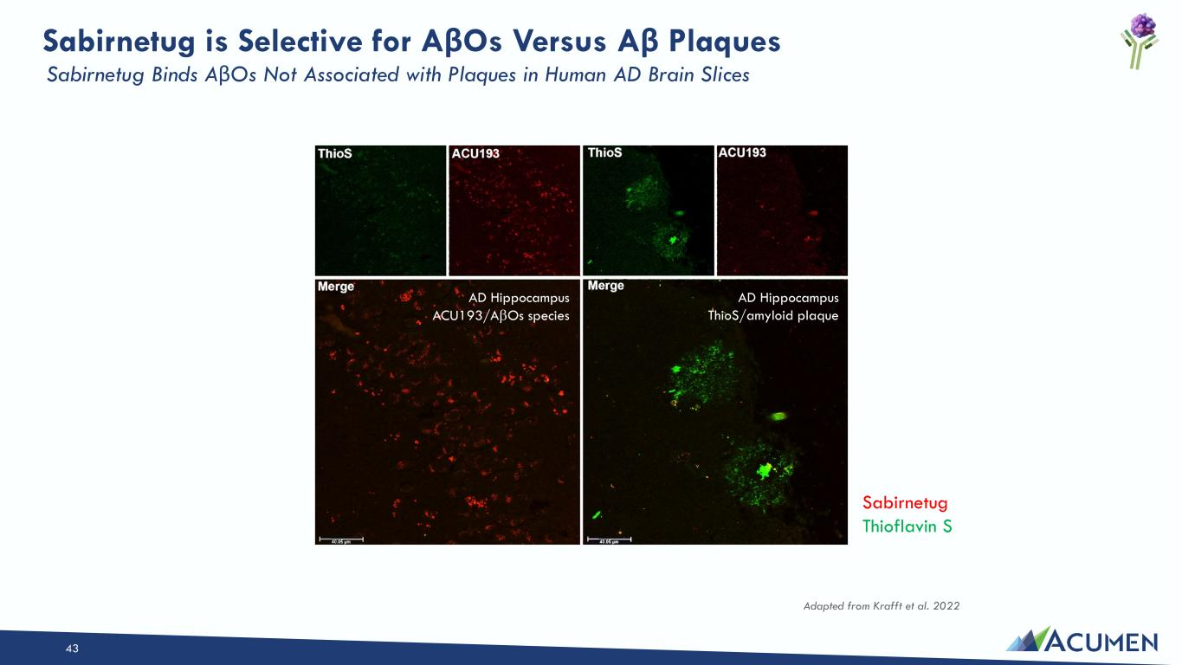
43 AD Hippocampus ThioS/amyloid plaque AD Hippocampus ACU193/AβOs species Sabirnetug is Selective for AβOs Versus Aβ Plaques Sabirnetug Thioflavin S Sabirnetug Binds AβOs Not Associated with Plaques in Human AD Brain Slices Adapted from Krafft et al. 2022

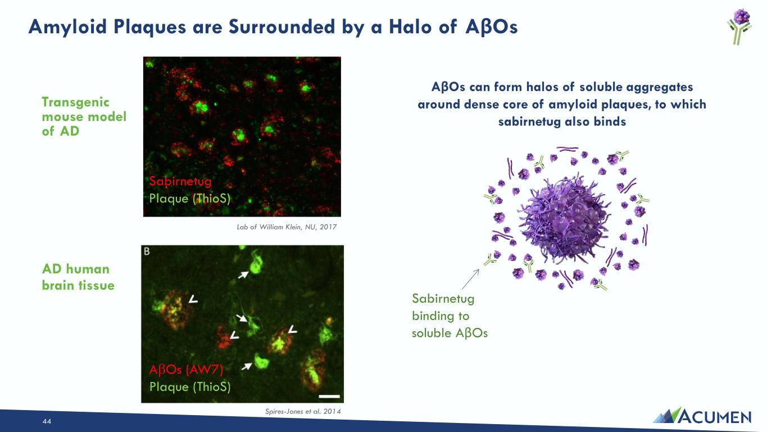
44 Amyloid Plaques are Surrounded by a Halo of AβOs Transgenic mouse model of AD AβOs can form halos of soluble aggregates around dense core of amyloid plaques, to which sabirnetug also binds Sabirnetug binding to soluble AβOs Sabirnetug Plaque (ThioS) Spires-Jones et al. 2014 AβOs (AW7) Plaque (ThioS) AD human brain tissue Lab of William Klein, NU, 2017

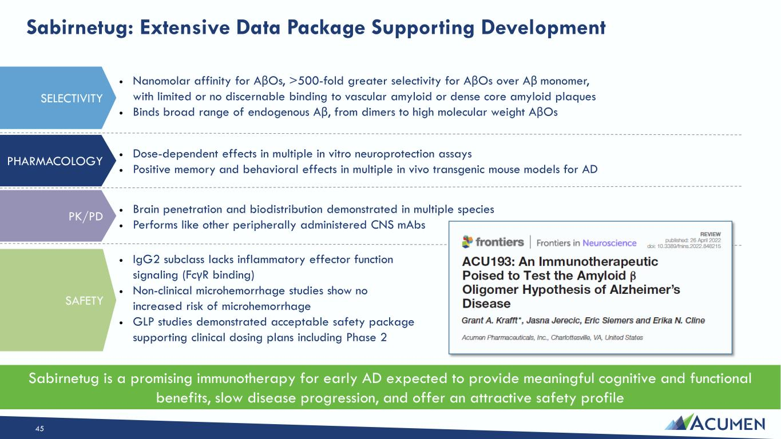
Sabirnetug: Extensive Data Package Supporting Development Sabirnetug is a promising immunotherapy for early AD expected to provide meaningful cognitive and functional benefits, slow disease progression, and offer an attractive safety profile  Nanomolar affinity for AβOs, >500-fold greater selectivity for AβOs over Aβ monomer, with limited or no discernable binding to vascular amyloid or dense core amyloid plaques  Binds broad range of endogenous Aβ, from dimers to high molecular weight AβOs  Brain penetration and biodistribution demonstrated in multiple species  Performs like other peripherally administered CNS mAbs  Dose-dependent effects in multiple in vitro neuroprotection assays  Positive memory and behavioral effects in multiple in vivo transgenic mouse models for AD  IgG2 subclass lacks inflammatory effector function signaling (FcγR binding)  Non-clinical microhemorrhage studies show no increased risk of microhemorrhage  GLP studies demonstrated acceptable safety package supporting clinical dosing plans including Phase 2 SELECTIVITY PHARMACOLOGY PK/PD SAFETY 45

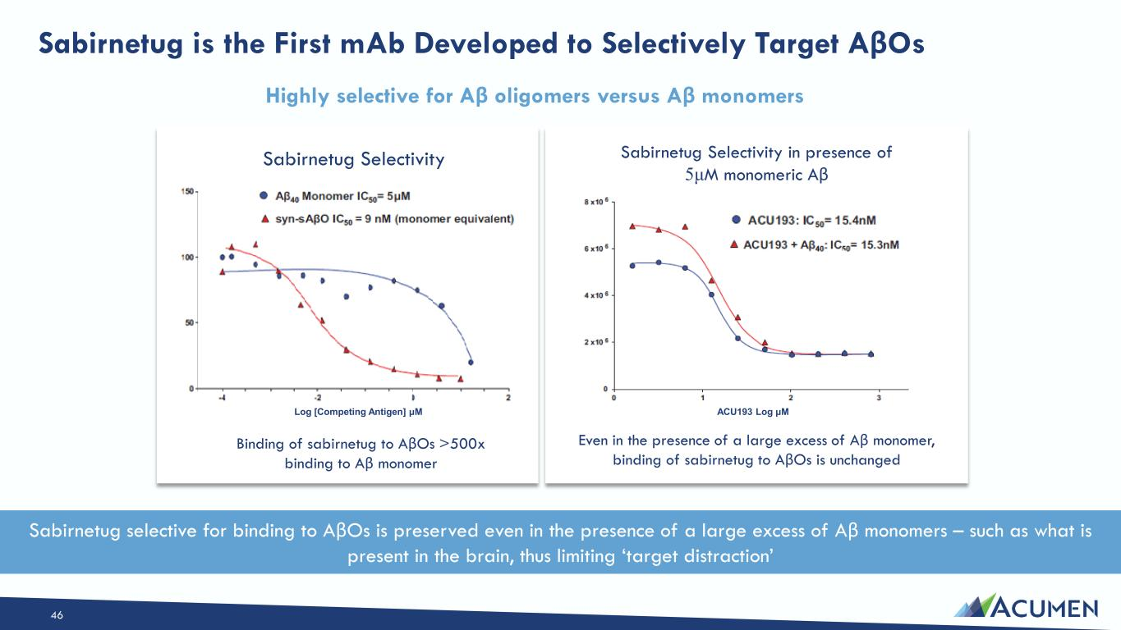
Highly selective for Aβ oligomers versus Aβ monomers Even in the presence of a large excess of Aβ monomer, binding of sabirnetug to AβOs is unchanged Binding of sabirnetug to AβOs >500x binding to Aβ monomer Log [Competing Antigen] μM Sabirnetug Selectivity Sabirnetug Selectivity in presence of 5μM monomeric Aβ ACU193 Log μM Sabirnetug is the First mAb Developed to Selectively Target AβOs Sabirnetug selective for binding to AβOs is preserved even in the presence of a large excess of Aβ monomers – such as what is present in the brain, thus limiting ‘target distraction’ 46

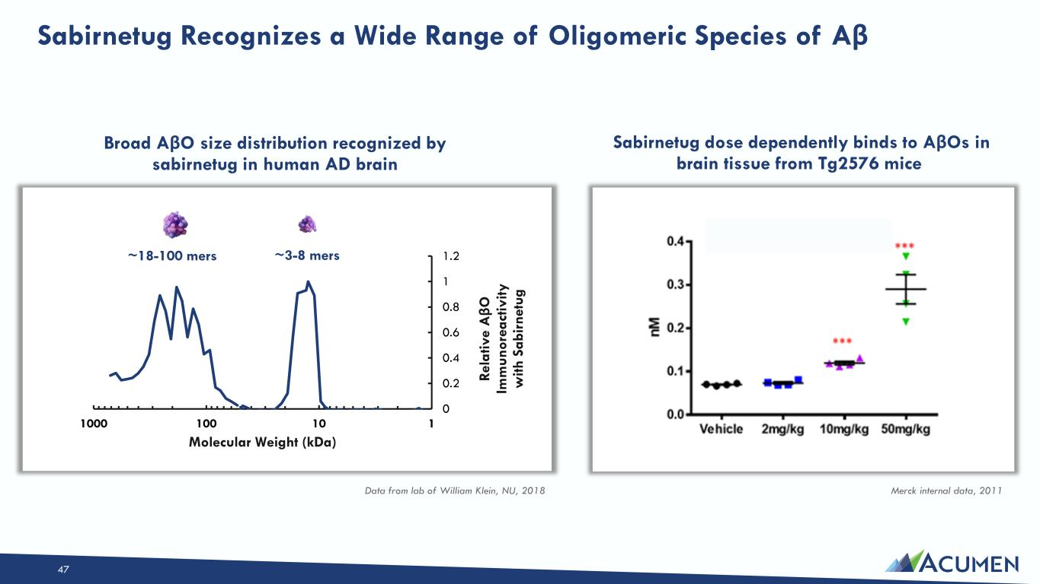
47 Sabirnetug Recognizes a Wide Range of Oligomeric Species of Aβ Broad AβO size distribution recognized by sabirnetug in human AD brain Sabirnetug dose dependently binds to AβOs in brain tissue from Tg2576 mice Data from lab of William Klein, NU, 2018 Merck internal data, 2011 0 0.2 0.4 0.6 0.8 1 1.2 1101001000 Re la tiv e A βO Im m un or ea ct iv ity w ith S ab ir ne tu g Molecular Weight (kDa) ~3-8 mers~18-100 mers

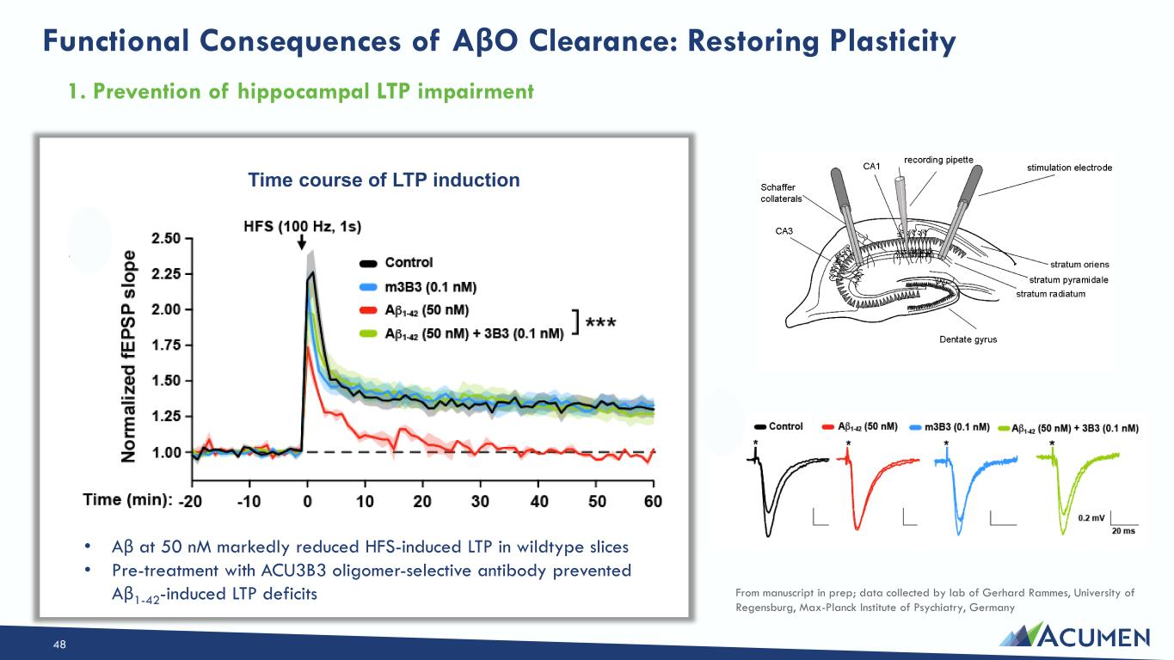
1. Prevention of hippocampal LTP impairment Functional Consequences of AβO Clearance: Restoring Plasticity 48 • Aβ at 50 nM markedly reduced HFS-induced LTP in wildtype slices • Pre-treatment with ACU3B3 oligomer-selective antibody prevented Aβ1-42-induced LTP deficits Time course of LTP induction From manuscript in prep; data collected by lab of Gerhard Rammes, University of Regensburg, Max-Planck Institute of Psychiatry, Germany

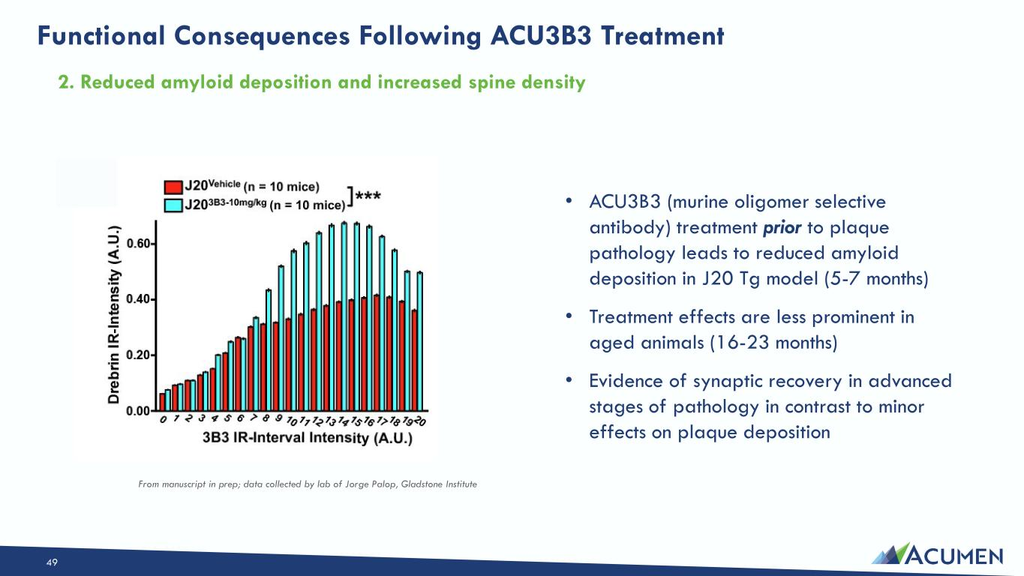
Functional Consequences Following ACU3B3 Treatment 49 • ACU3B3 (murine oligomer selective antibody) treatment prior to plaque pathology leads to reduced amyloid deposition in J20 Tg model (5-7 months) • Treatment effects are less prominent in aged animals (16-23 months) • Evidence of synaptic recovery in advanced stages of pathology in contrast to minor effects on plaque deposition From manuscript in prep; data collected by lab of Jorge Palop, Gladstone Institute 2. Reduced amyloid deposition and increased spine density

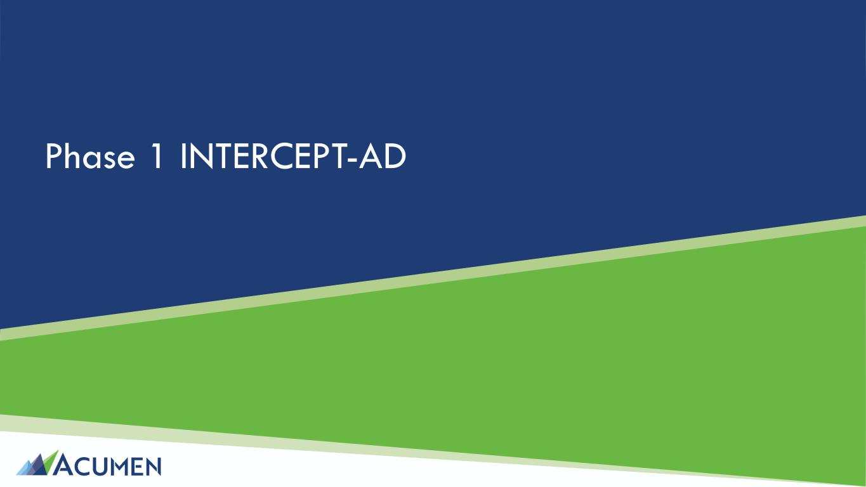
Phase 1 INTERCEPT-AD

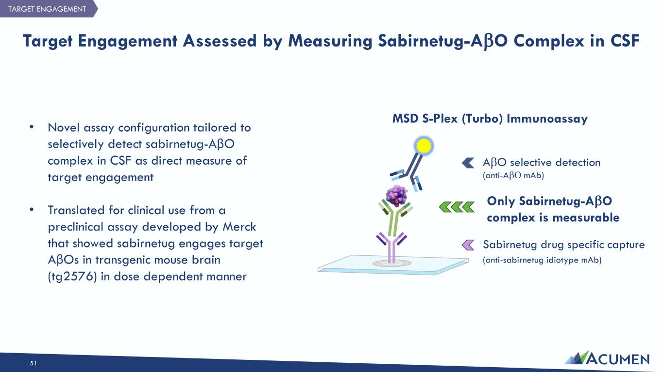
Sabirnetug drug specific capture (anti-sabirnetug idiotype mAb) 51 Target Engagement Assessed by Measuring Sabirnetug-AβO Complex in CSF AβO selective detection (anti-AβΟ mAb) Only Sabirnetug-AβO complex is measurable • Novel assay configuration tailored to selectively detect sabirnetug-AβO complex in CSF as direct measure of target engagement • Translated for clinical use from a preclinical assay developed by Merck that showed sabirnetug engages target AβOs in transgenic mouse brain (tg2576) in dose dependent manner MSD S-Plex (Turbo) Immunoassay TARGET ENGAGEMENT

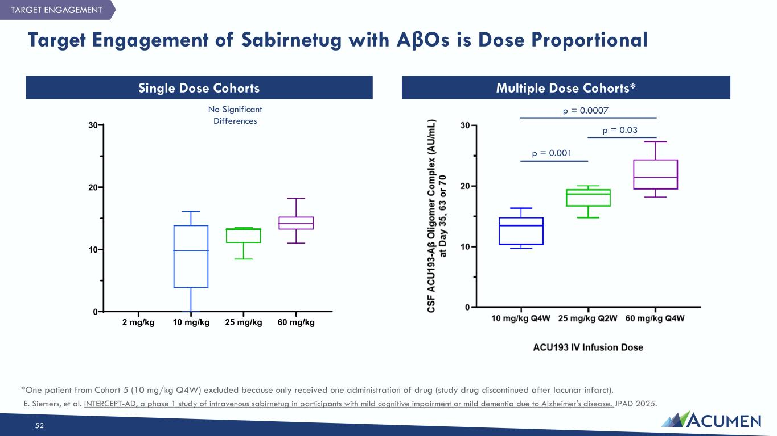
Target Engagement of Sabirnetug with AβOs is Dose Proportional 52 Single Dose Cohorts Multiple Dose Cohorts* 2 mg/kg 10 mg/kg 25 mg/kg 60 mg/kg 0 10 20 30 *One patient from Cohort 5 (10 mg/kg Q4W) excluded because only received one administration of drug (study drug discontinued after lacunar infarct). TARGET ENGAGEMENT p = 0.001 p = 0.03 p = 0.0007No Significant Differences E. Siemers, et al. INTERCEPT-AD, a phase 1 study of intravenous sabirnetug in participants with mild cognitive impairment or mild dementia due to Alzheimer's disease. JPAD 2025.

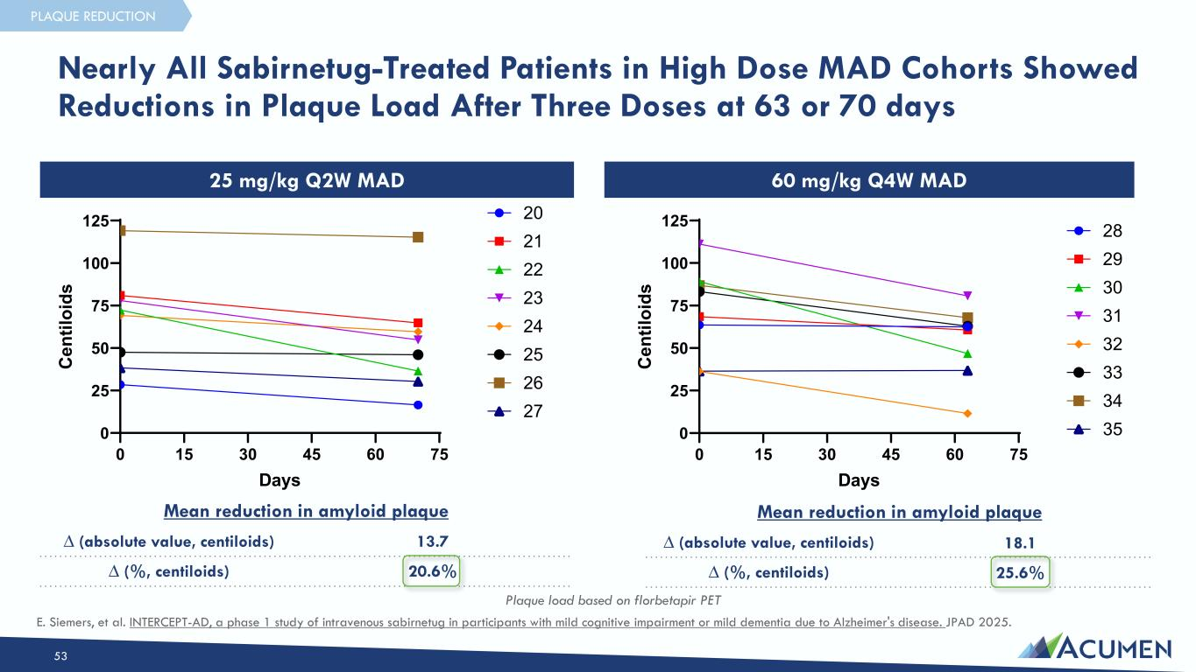
Nearly All Sabirnetug-Treated Patients in High Dose MAD Cohorts Showed Reductions in Plaque Load After Three Doses at 63 or 70 days 53 Plaque load based on florbetapir PET 0 15 30 45 60 75 0 25 50 75 100 125 25 mg/kg Q2W MAD Days C en til oi ds 20 21 22 23 24 25 26 27 0 15 30 45 60 75 0 25 50 75 100 125 60 mg/kg Q4W MAD Days C en til oi ds 28 29 30 31 32 33 34 35 25 mg/kg Q2W MAD 60 mg/kg Q4W MAD Mean reduction in amyloid plaque ∆ (absolute value, centiloids) 13.7 ∆ (%, centiloids) 20.6% Mean reduction in amyloid plaque ∆ (absolute value, centiloids) 18.1 ∆ (%, centiloids) 25.6% PLAQUE REDUCTION E. Siemers, et al. INTERCEPT-AD, a phase 1 study of intravenous sabirnetug in participants with mild cognitive impairment or mild dementia due to Alzheimer's disease. JPAD 2025.

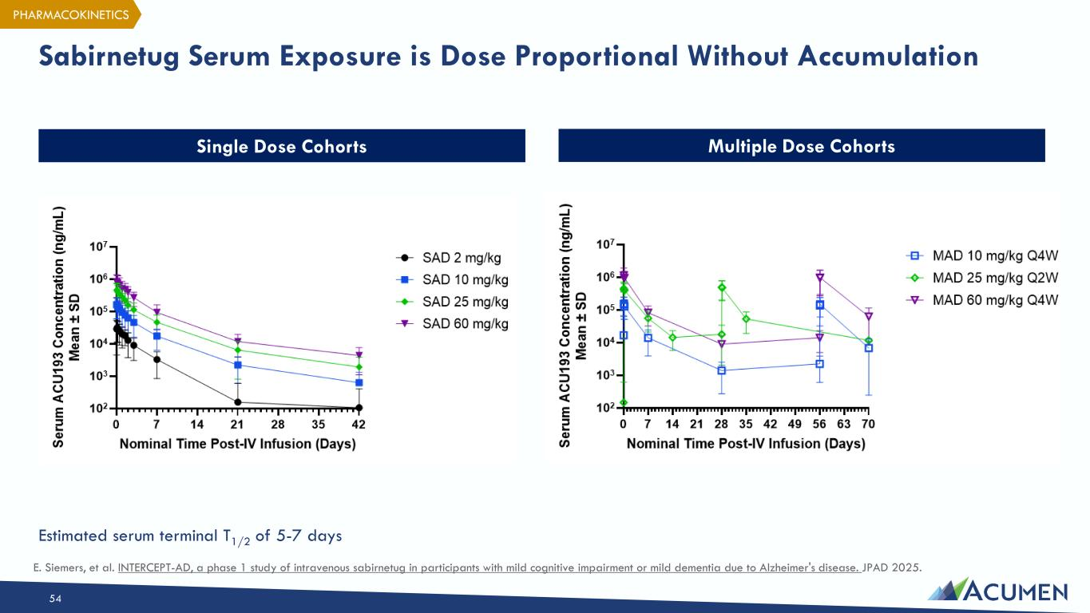
Sabirnetug Serum Exposure is Dose Proportional Without Accumulation 54 Single Dose Cohorts Multiple Dose Cohorts PHARMACOKINETICS Estimated serum terminal T1/2 of 5-7 days E. Siemers, et al. INTERCEPT-AD, a phase 1 study of intravenous sabirnetug in participants with mild cognitive impairment or mild dementia due to Alzheimer's disease. JPAD 2025.

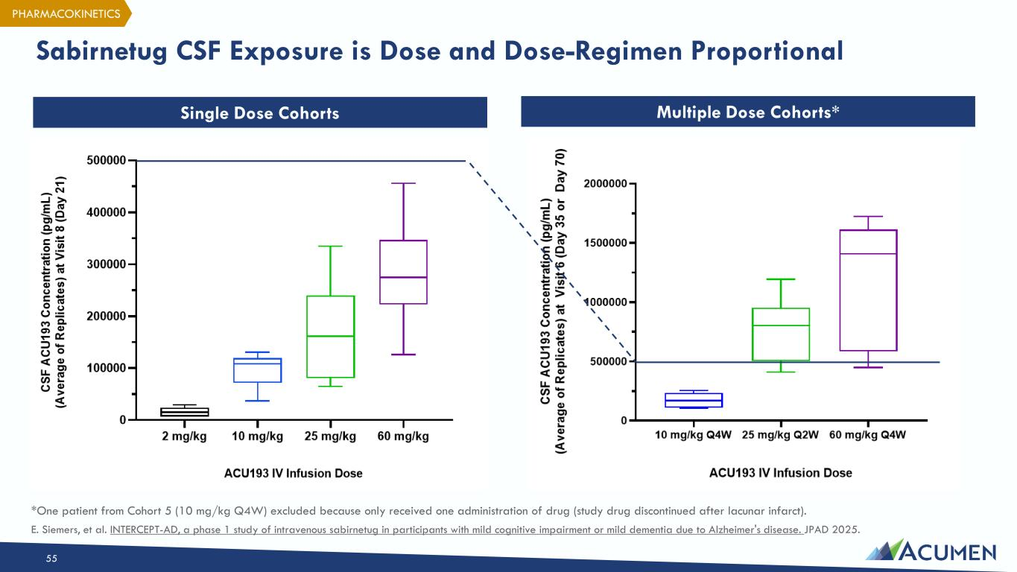
Sabirnetug CSF Exposure is Dose and Dose-Regimen Proportional 55 Single Dose Cohorts Multiple Dose Cohorts* *One patient from Cohort 5 (10 mg/kg Q4W) excluded because only received one administration of drug (study drug discontinued after lacunar infarct). PHARMACOKINETICS E. Siemers, et al. INTERCEPT-AD, a phase 1 study of intravenous sabirnetug in participants with mild cognitive impairment or mild dementia due to Alzheimer's disease. JPAD 2025.

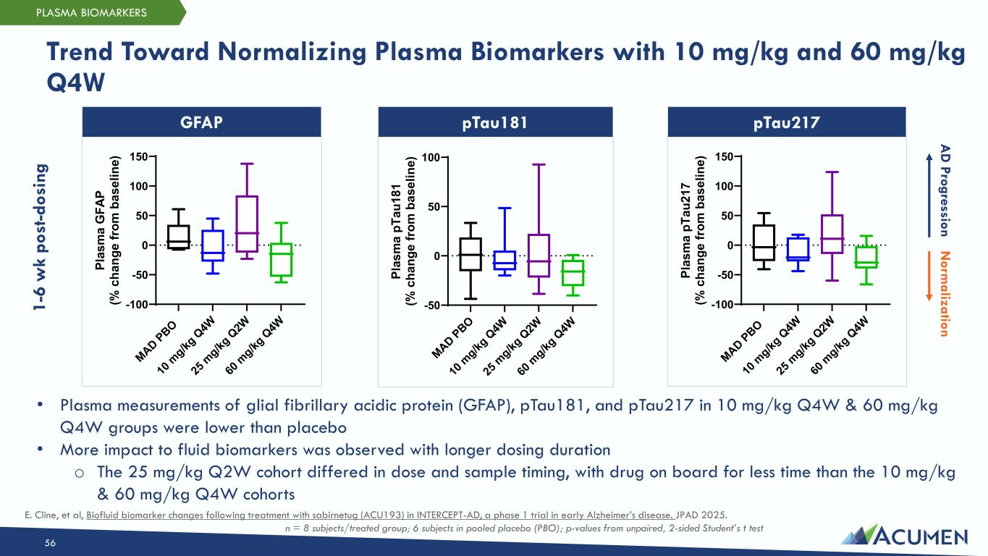
Trend Toward Normalizing Plasma Biomarkers with 10 mg/kg and 60 mg/kg Q4W 56 MAD PBO 10 m g/kg Q 4W 25 m g/kg Q 2W 60 m g/kg Q 4W -100 -50 0 50 100 150 Pl as m a G FA P (% c ha ng e fr om b as el in e) MAD PBO 10 m g/kg Q 4W 25 m g/kg Q 2W 60 m g/kg Q 4W -50 0 50 100 Pl as m a pT au 18 1 (% c ha ng e fr om b as el in e) MAD PBO 10 m g/kg Q 4W 25 m g/kg Q 2W 60 m g/kg Q 4W -100 -50 0 50 100 150 Pl as m a pT au 21 7 (% c ha ng e fr om b as el in e) 1- 6 w k po st -d os in g • Plasma measurements of glial fibrillary acidic protein (GFAP), pTau181, and pTau217 in 10 mg/kg Q4W & 60 mg/kg Q4W groups were lower than placebo • More impact to fluid biomarkers was observed with longer dosing duration o The 25 mg/kg Q2W cohort differed in dose and sample timing, with drug on board for less time than the 10 mg/kg & 60 mg/kg Q4W cohorts PLASMA BIOMARKERS pTau181GFAP pTau217 A D Progression N orm alization n = 8 subjects/treated group; 6 subjects in pooled placebo (PBO); p-values from unpaired, 2-sided Student’s t test E. Cline, et al, Biofluid biomarker changes following treatment with sabirnetug (ACU193) in INTERCEPT-AD, a phase 1 trial in early Alzheimer’s disease. JPAD 2025.

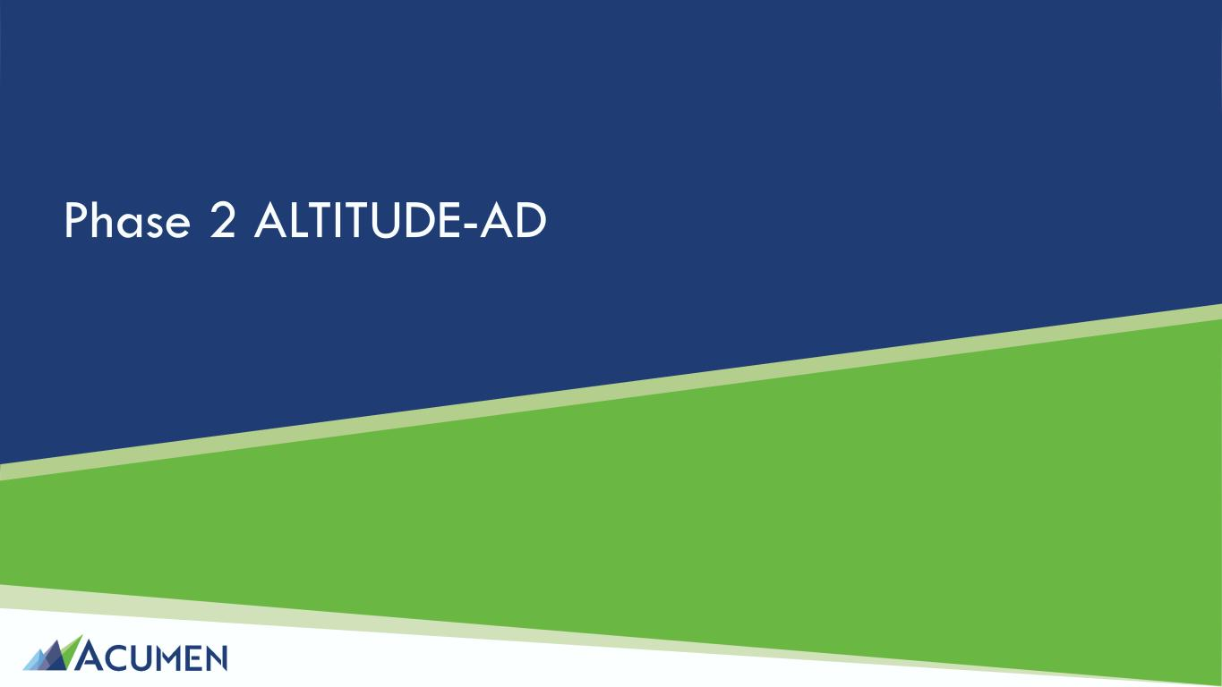
Phase 2 ALTITUDE-AD

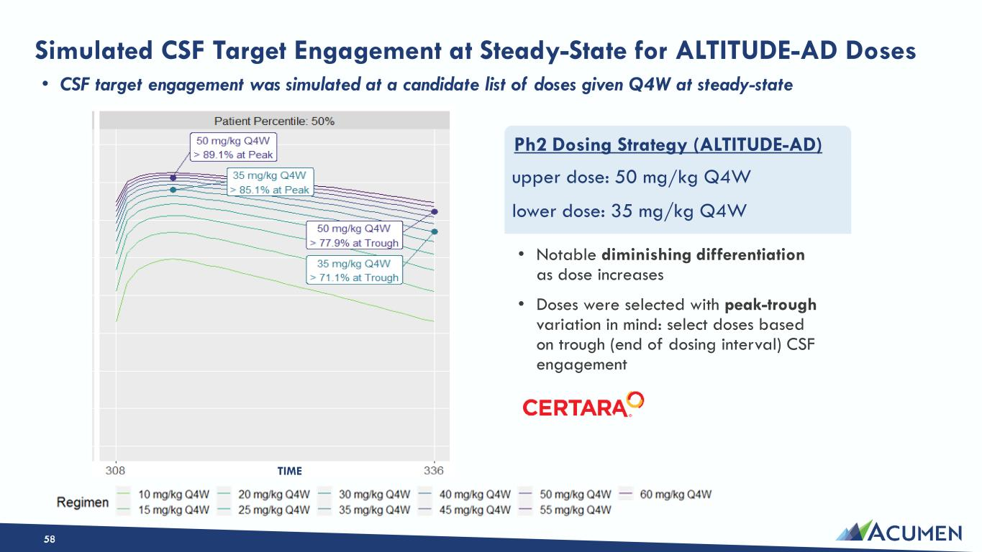
Simulated CSF Target Engagement at Steady-State for ALTITUDE-AD Doses • CSF target engagement was simulated at a candidate list of doses given Q4W at steady-state • Notable diminishing differentiation as dose increases • Doses were selected with peak-trough variation in mind: select doses based on trough (end of dosing interval) CSF engagement upper dose: 50 mg/kg Q4W lower dose: 35 mg/kg Q4W Ph2 Dosing Strategy (ALTITUDE-AD) TIME 58

