UNITED STATES
SECURITIES AND EXCHANGE COMMISSION
WASHINGTON, D.C. 20549
FORM 8-K
CURRENT REPORT

Pursuant to Section 13 or 15(d)
of the Securities Exchange Act of 1934
Date of Report (Date of earliest event reported): September 16, 2026

Acumen Pharmaceuticals, Inc.
(Exact name of Registrant as Specified in Its Charter)
____________________________
Delaware |  |  | 001-40551 |  |  | 36-4108129
(State or Other Jurisdiction  of Incorporation) |  |  | (Commission  File Number) |  |  | (IRS Employer  Identification No.)
1210-1220 Washington Street, Suite 210  Newton, Massachusetts |  |  | 02465
(Address of Principal Executive Offices) |  |  | (Zip Code)
Registrant’s Telephone Number, Including Area Code: (617) 344-4190

(Former Name or Former Address, if Changed Since Last Report)

Check the appropriate box below if the Form 8-K filing is intended to simultaneously satisfy the filing obligation of the registrant under any of the following provisions (see General Instructions A.2. below):
o |  |  | Written communications pursuant to Rule 425 under the Securities Act (17 CFR 230.425)
o |  |  | Soliciting material pursuant to Rule 14a-12 under the Exchange Act (17 CFR 240.14a-12)
o |  |  | Pre-commencement communications pursuant to Rule 14d-2(b) under the Exchange Act (17 CFR 240.14d-2(b))
o |  |  | Pre-commencement communications pursuant to Rule 13e-4(c) under the Exchange Act (17 CFR 240.13e-4(c))
Securities registered pursuant to Section 12(b) of the Act:
Title of each class |  |  |  |  |  | Trading  Symbol(s) |  |  |  |  |  | Name of each exchange  on which registered
Common Stock, $0.0001 par value |  |  |  |  |  | ABOS |  |  |  |  |  | The Nasdaq Global Select Market
Indicate by check mark whether the registrant is an emerging growth company as defined in Rule 405 of the Securities Act of 1933 (§230.405 of this chapter) or Rule 12b-2 of the Securities Exchange Act of 1934 (§240.12b-2 of this chapter).
Emerging growth company x
If an emerging growth company, indicate by check mark if the registrant has elected not to use the extended transition period for complying with any new or revised financial accounting standards provided pursuant to Section 13(a) of the Exchange Act. o

Item 7.01 Regulation FD Disclosure.
On September 16, 2026, the Company will host an Investor Day beginning at 10:00 a.m. Eastern Time, which will be live-webcast. Following the conclusion of the Investor Day, the webcast and corresponding slide presentation that will be used by members of the Company’s executive team at the Investor Day will be posted on the Company’s investor relations website. In addition, a copy of this presentation is attached as Exhibit 99.1 to this Current Report on Form 8-K (this “Report”).
The information in this Item 7.01 of this Report (including Exhibit 99.1), is being furnished and shall not be deemed “filed” for purposes of Section 18 of the Securities Exchange Act of 1934, as amended (the “Exchange Act”), or otherwise subject to the liabilities of that Section, nor shall it be deemed incorporated by reference in any filing under the Securities Act of 1933, as amended, or the Exchange Act, except as expressly set forth by specific reference in such filing. The Company’s submission of this Report shall not be deemed an admission as to the materiality of any information required to be disclosed solely to satisfy the requirements of Regulation FD.

Item 9.01 Financial Statements and Exhibits.
(d).Exhibits

Exhibit No. |  |  |  |  |  | Description
99.1 |  |  |  |  |  | Investor Day Presentation, dated September 16, 2026
104 |  |  |  |  |  | Cover Page Interactive Data File (embedded within the Inline XBRL document)

SIGNATURES
Pursuant to the requirements of the Securities Exchange Act of 1934, as amended, the Company has duly caused this report to be signed on its behalf by the undersigned hereunto duly authorized.
 |  |  | Acumen Pharmaceuticals, Inc.
Dated: September 16, 2026 |  |  | By: |  |  | /s/ Matthew Zuga
Matthew Zuga
Chief Financial Officer and Chief Business Officer


Investor Day September 2026

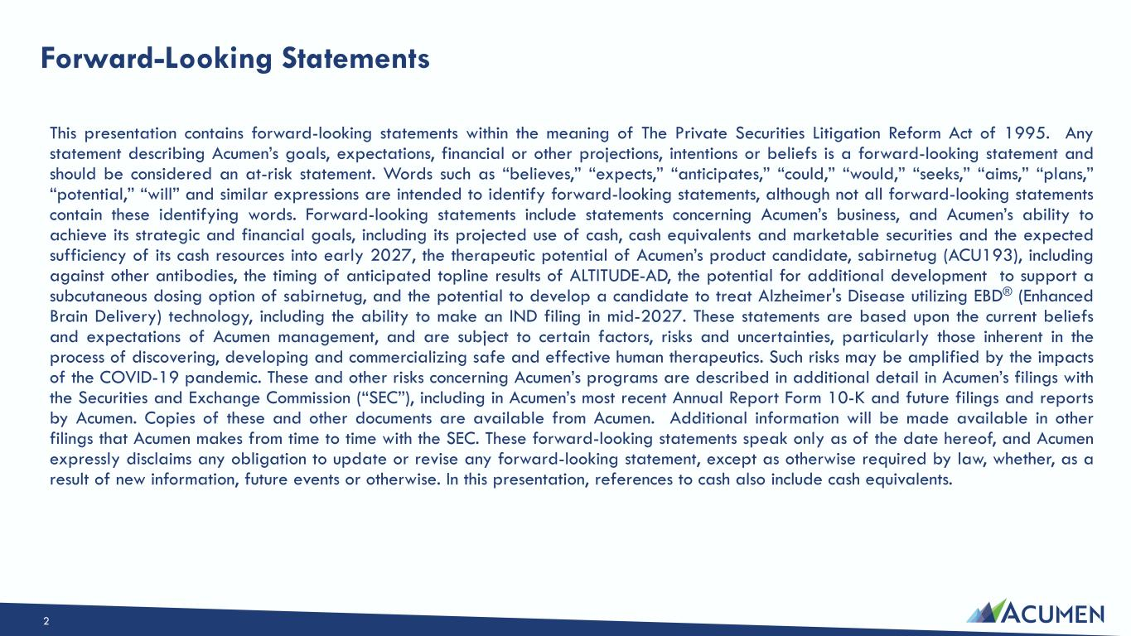
Forward-Looking Statements This presentation contains forward-looking statements within the meaning of The Private Securities Litigation Reform Act of 1995. Any statement describing Acumen’s goals, expectations, financial or other projections, intentions or beliefs is a forward-looking statement and should be considered an at-risk statement. Words such as “believes,” “expects,” “anticipates,” “could,” “would,” “seeks,” “aims,” “plans,” “potential,” “will” and similar expressions are intended to identify forward-looking statements, although not all forward-looking statements contain these identifying words. Forward-looking statements include statements concerning Acumen’s business, and Acumen’s ability to achieve its strategic and financial goals, including its projected use of cash, cash equivalents and marketable securities and the expected sufficiency of its cash resources into early 2027, the therapeutic potential of Acumen’s product candidate, sabirnetug (ACU193), including against other antibodies, the timing of anticipated topline results of ALTITUDE-AD, the potential for additional development to support a subcutaneous dosing option of sabirnetug, and the potential to develop a candidate to treat Alzheimer's Disease utilizing EBD® (Enhanced Brain Delivery) technology, including the ability to make an IND filing in mid-2027. These statements are based upon the current beliefs and expectations of Acumen management, and are subject to certain factors, risks and uncertainties, particularly those inherent in the process of discovering, developing and commercializing safe and effective human therapeutics. Such risks may be amplified by the impacts of the COVID-19 pandemic. These and other risks concerning Acumen’s programs are described in additional detail in Acumen’s filings with the Securities and Exchange Commission (“SEC”), including in Acumen’s most recent Annual Report Form 10-K and future filings and reports by Acumen. Copies of these and other documents are available from Acumen. Additional information will be made available in other filings that Acumen makes from time to time with the SEC. These forward-looking statements speak only as of the date hereof, and Acumen expressly disclaims any obligation to update or revise any forward-looking statement, except as otherwise required by law, whether, as a result of new information, future events or otherwise. In this presentation, references to cash also include cash equivalents. 2

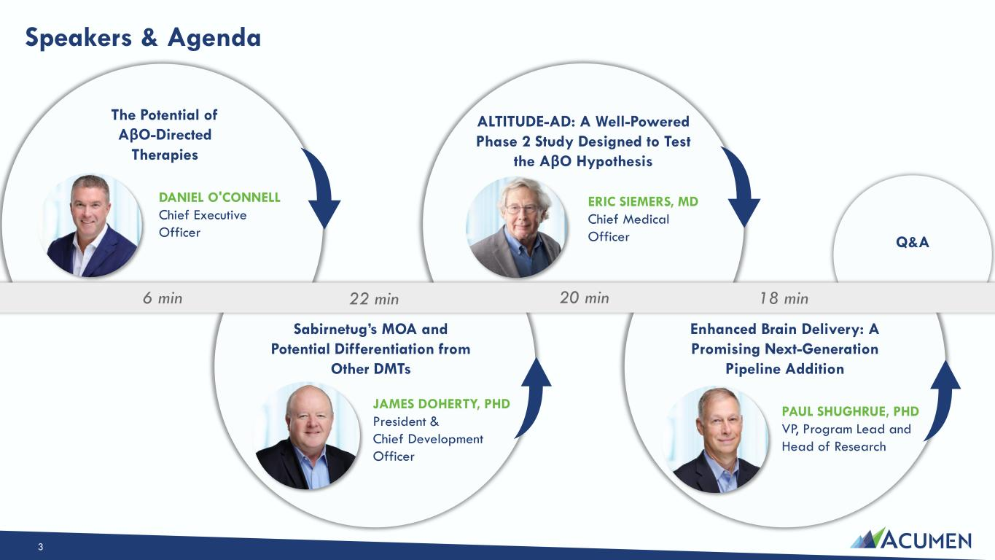
Speakers & Agenda ERIC SIEMERS, MD Chief Medical Officer DANIEL O'CONNELL Chief Executive Officer JAMES DOHERTY, PHD President & Chief Development Officer PAUL SHUGHRUE, PHD VP, Program Lead and Head of Research The Potential of AβO-Directed Therapies Sabirnetug’s MOA and Potential Differentiation from Other DMTs ALTITUDE-AD: A Well-Powered Phase 2 Study Designed to Test the AβO Hypothesis Enhanced Brain Delivery: A Promising Next-Generation Pipeline Addition Q&A 6 min 22 min 20 min 18 min 3

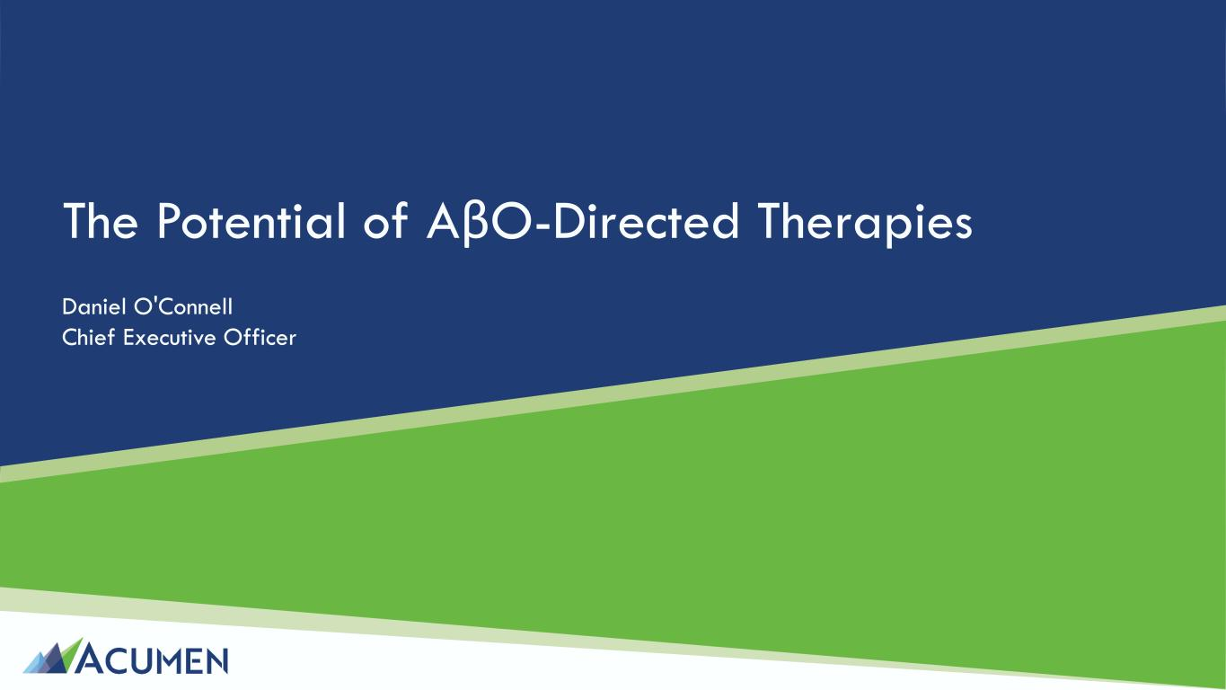
The Potential of AβO-Directed Therapies Daniel O'Connell Chief Executive Officer

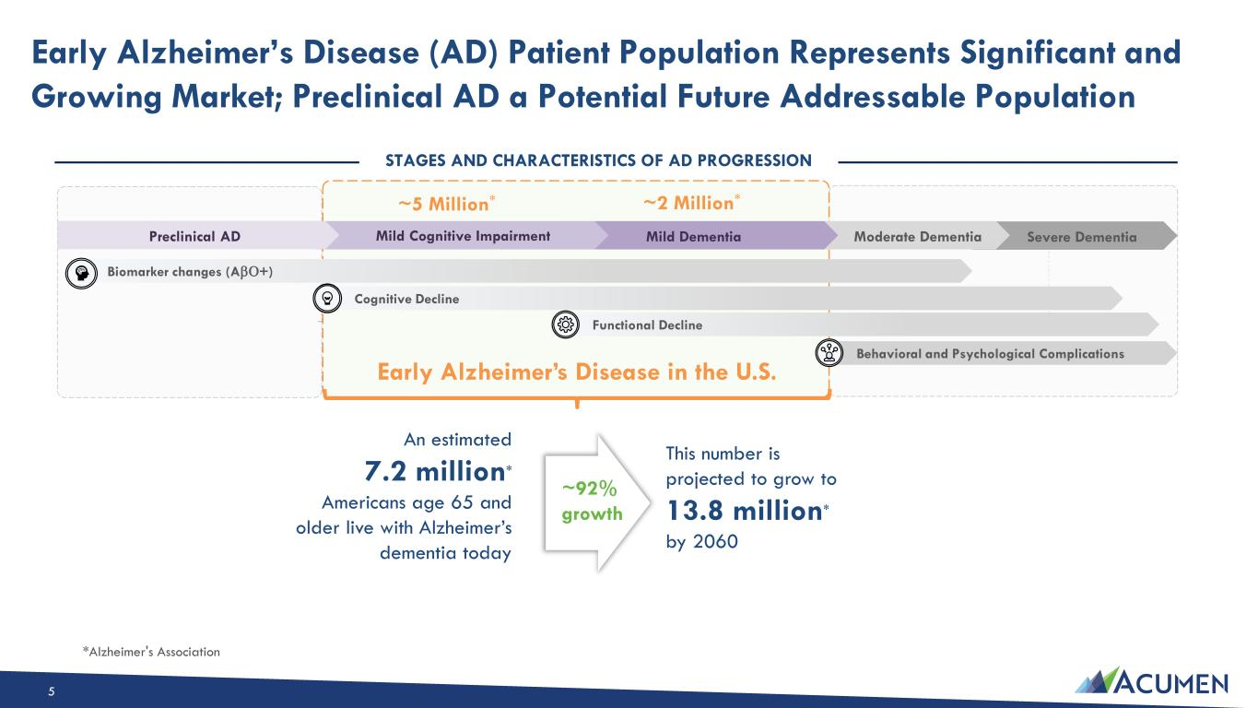
Early Alzheimer’s Disease (AD) Patient Population Represents Significant and Growing Market; Preclinical AD a Potential Future Addressable Population *Alzheimer's Association An estimated 7.2 million* Americans age 65 and older live with Alzheimer’s dementia today STAGES AND CHARACTERISTICS OF AD PROGRESSION Severe DementiaModerate DementiaMild DementiaMild Cognitive ImpairmentPreclinical AD ~5 Million* ~2 Million* Early Alzheimer’s Disease in the U.S. Cognitive Decline Behavioral and Psychological Complications Functional Decline This number is projected to grow to 13.8 million* by 2060 ~92% growth Biomarker changes (A+) 5

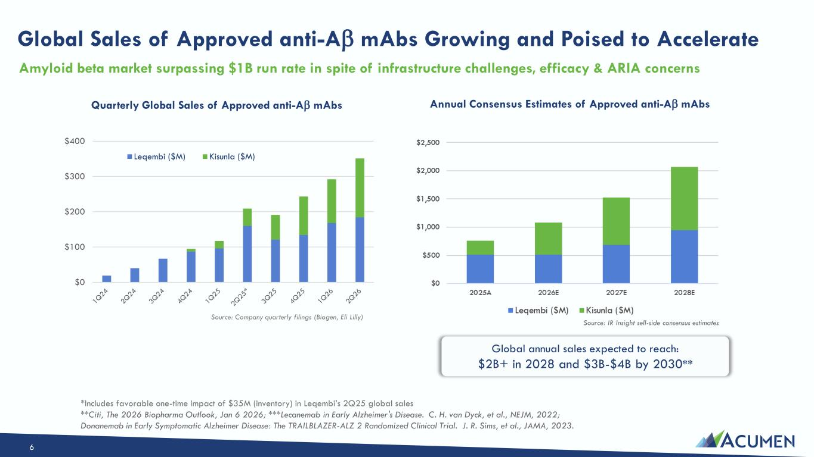
Global Sales of Approved anti-A mAbs Growing and Poised to Accelerate $0 $100 $200 $300 $400 Quarterly Global Sales of Approved anti-A mAbs Leqembi ($M) Kisunla ($M) Global annual sales expected to reach: $2B+ in 2028 and $3B-$4B by 2030** Amyloid beta market surpassing $1B run rate in spite of infrastructure challenges, efficacy & ARIA concerns *Includes favorable one-time impact of $35M (inventory) in Leqembi’s 2Q25 global sales **Citi, The 2026 Biopharma Outlook, Jan 6 2026; ***Lecanemab in Early Alzheimer's Disease. C. H. van Dyck, et al., NEJM, 2022; Donanemab in Early Symptomatic Alzheimer Disease: The TRAILBLAZER-ALZ 2 Randomized Clinical Trial. J. R. Sims, et al., JAMA, 2023. Source: Company quarterly filings (Biogen, Eli Lilly) Source: IR Insight sell-side consensus estimates Annual Consensus Estimates of Approved anti-A mAbs 6

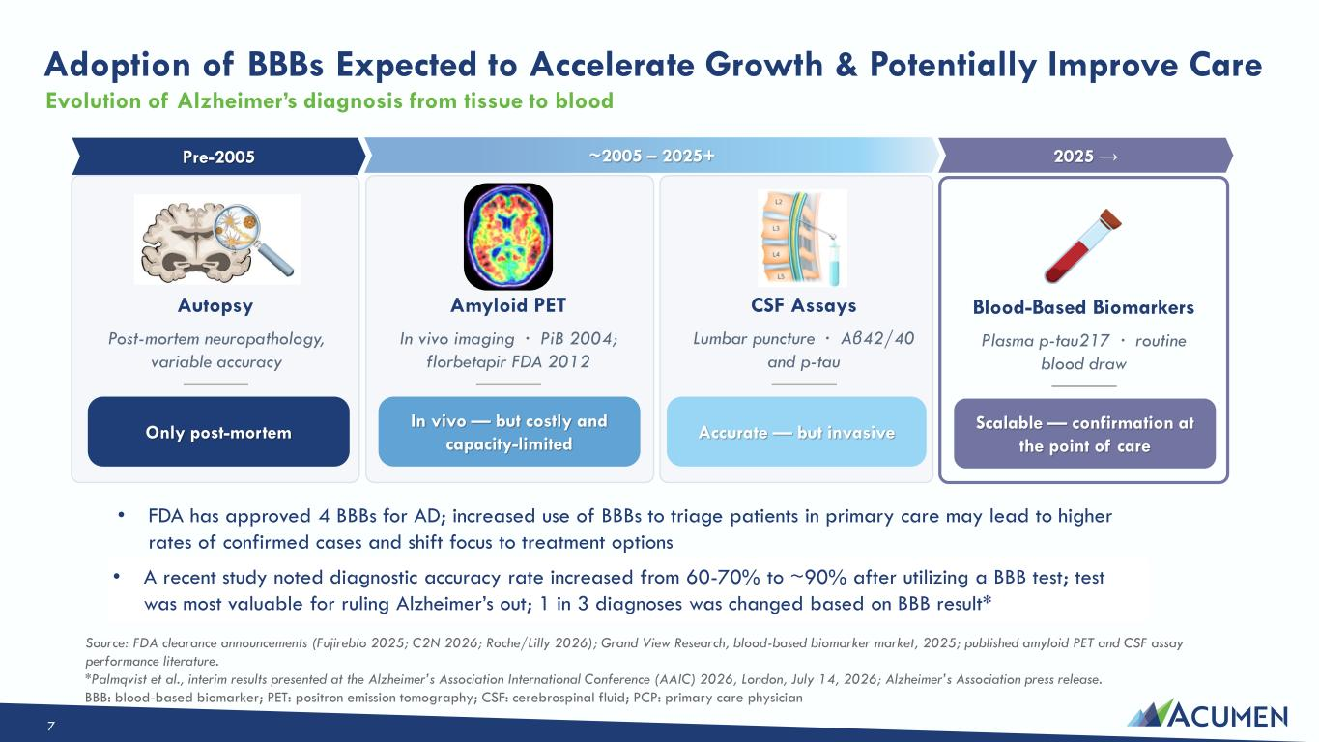
Adoption of BBBs Expected to Accelerate Growth & Potentially Improve Care Pre-2005 Autopsy Post-mortem neuropathology, variable accuracy ~2005 – 2025+ Amyloid PET In vivo imaging · PiB 2004; florbetapir FDA 2012 In vivo — but costly and capacity-limited CSF Assays Lumbar puncture · Aβ42/40 and p-tau Accurate — but invasive 2025 → Blood-Based Biomarkers Plasma p-tau217 · routine blood draw Scalable — confirmation at the point of care Source: FDA clearance announcements (Fujirebio 2025; C2N 2026; Roche/Lilly 2026); Grand View Research, blood-based biomarker market, 2025; published amyloid PET and CSF assay performance literature. Only post-mortem • FDA has approved 4 BBBs for AD; increased use of BBBs to triage patients in primary care may lead to higher rates of confirmed cases and shift focus to treatment options • A recent study noted diagnostic accuracy rate increased from 60-70% to ~90% after utilizing a BBB test; test was most valuable for ruling Alzheimer’s out; 1 in 3 diagnoses was changed based on BBB result* Evolution of Alzheimer’s diagnosis from tissue to blood *Palmqvist et al., interim results presented at the Alzheimer’s Association International Conference (AAIC) 2026, London, July 14, 2026; Alzheimer’s Association press release. BBB: blood-based biomarker; PET: positron emission tomography; CSF: cerebrospinal fluid; PCP: primary care physician 7

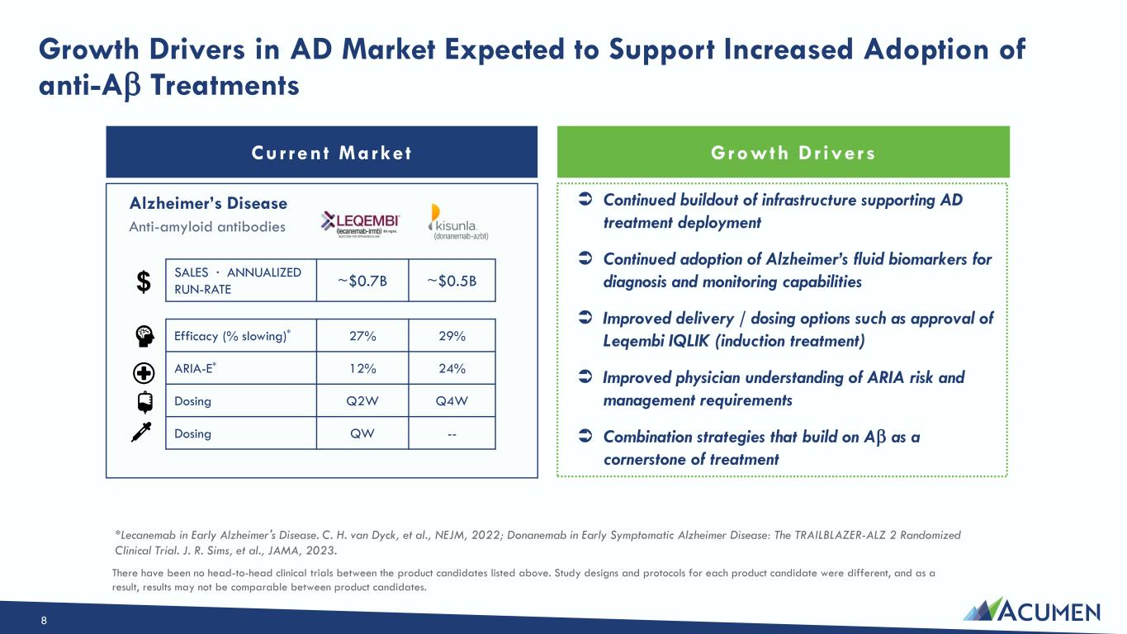
Growth Drivers in AD Market Expected to Support Increased Adoption of anti-A Treatments Current Marke t Alzheimer’s Disease Anti-amyloid antibodies  Continued buildout of infrastructure supporting AD treatment deployment  Continued adoption of Alzheimer’s fluid biomarkers for diagnosis and monitoring capabilities  Improved delivery / dosing options such as approval of Leqembi IQLIK (induction treatment)  Improved physician understanding of ARIA risk and management requirements  Combination strategies that build on A as a cornerstone of treatment Efficacy (% slowing)* 27% 29% ARIA-E* 12% 24% Dosing Q2W Q4W Dosing QW -- SALES · ANNUALIZED RUN-RATE ~$0.7B ~$0.5B Growth Dr ivers *Lecanemab in Early Alzheimer's Disease. C. H. van Dyck, et al., NEJM, 2022; Donanemab in Early Symptomatic Alzheimer Disease: The TRAILBLAZER-ALZ 2 Randomized Clinical Trial. J. R. Sims, et al., JAMA, 2023. There have been no head-to-head clinical trials between the product candidates listed above. Study designs and protocols for each product candidate were different, and as a result, results may not be comparable between product candidates. 8

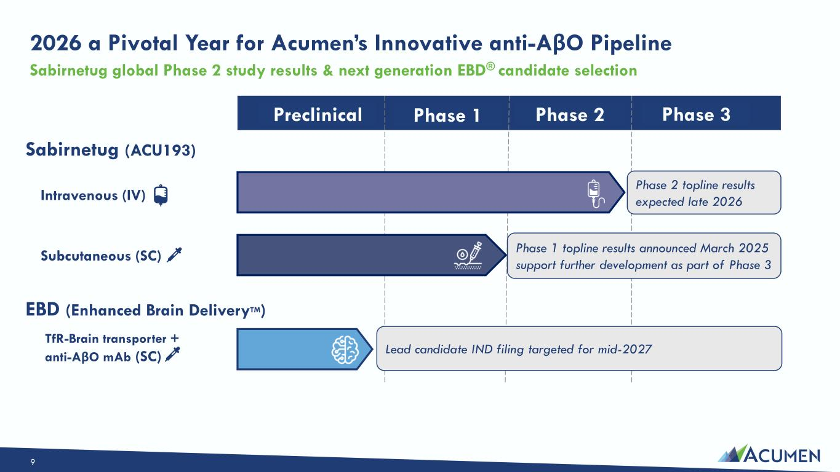
Phase 1 Phase 2 Phase 3Preclinical Intravenous (IV) Subcutaneous (SC) Phase 2 topline results expected late 2026 Phase 1 topline results announced March 2025 support further development as part of Phase 3 TfR-Brain transporter + anti-AβO mAb (SC) Lead candidate IND filing targeted for mid-2027 Sabirnetug (ACU193) EBD (Enhanced Brain DeliveryTM) 2026 a Pivotal Year for Acumen’s Innovative anti-AβO Pipeline Sabirnetug global Phase 2 study results & next generation EBD® candidate selection 9

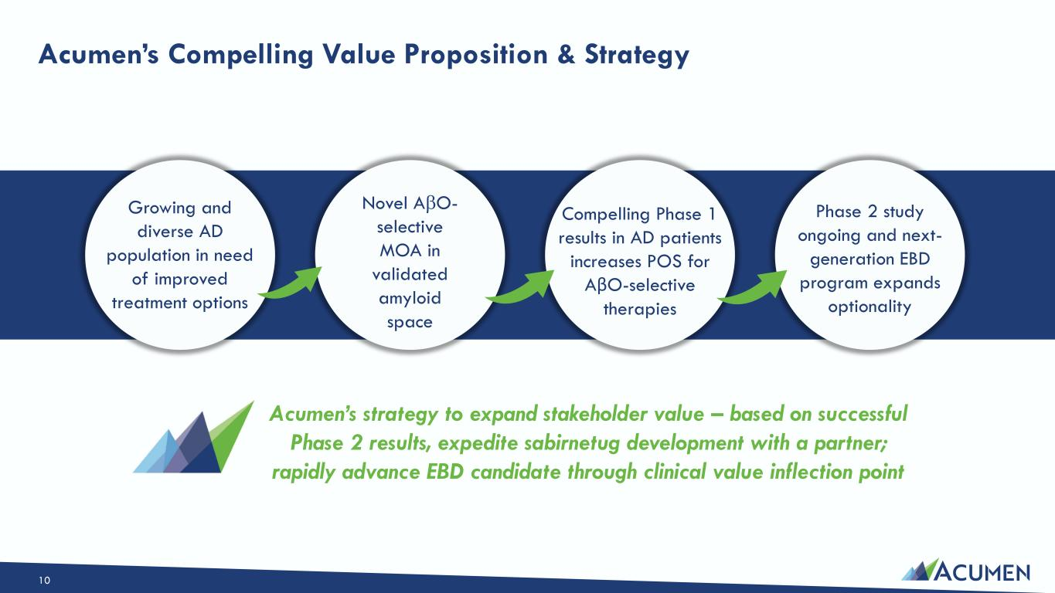
Acumen’s Compelling Value Proposition & Strategy Novel AO- selective MOA in validated amyloid space Growing and diverse AD population in need of improved treatment options Compelling Phase 1 results in AD patients increases POS for AβO-selective therapies Phase 2 study ongoing and next- generation EBD program expands optionality Acumen’s strategy to expand stakeholder value – based on successful Phase 2 results, expedite sabirnetug development with a partner; rapidly advance EBD candidate through clinical value inflection point 10

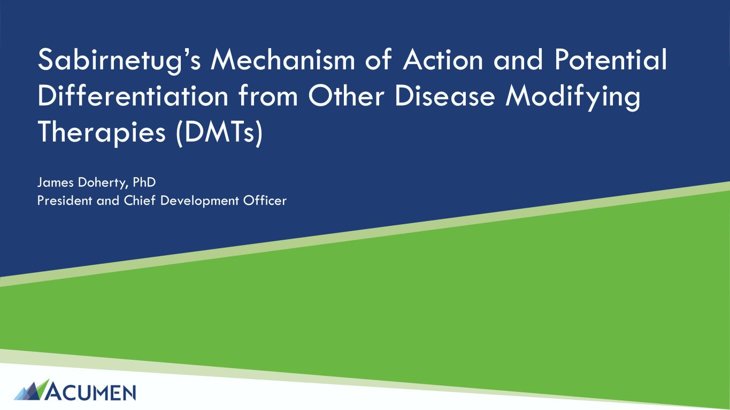
Sabirnetug’s Mechanism of Action and Potential Differentiation from Other Disease Modifying Therapies (DMTs) James Doherty, PhD President and Chief Development Officer

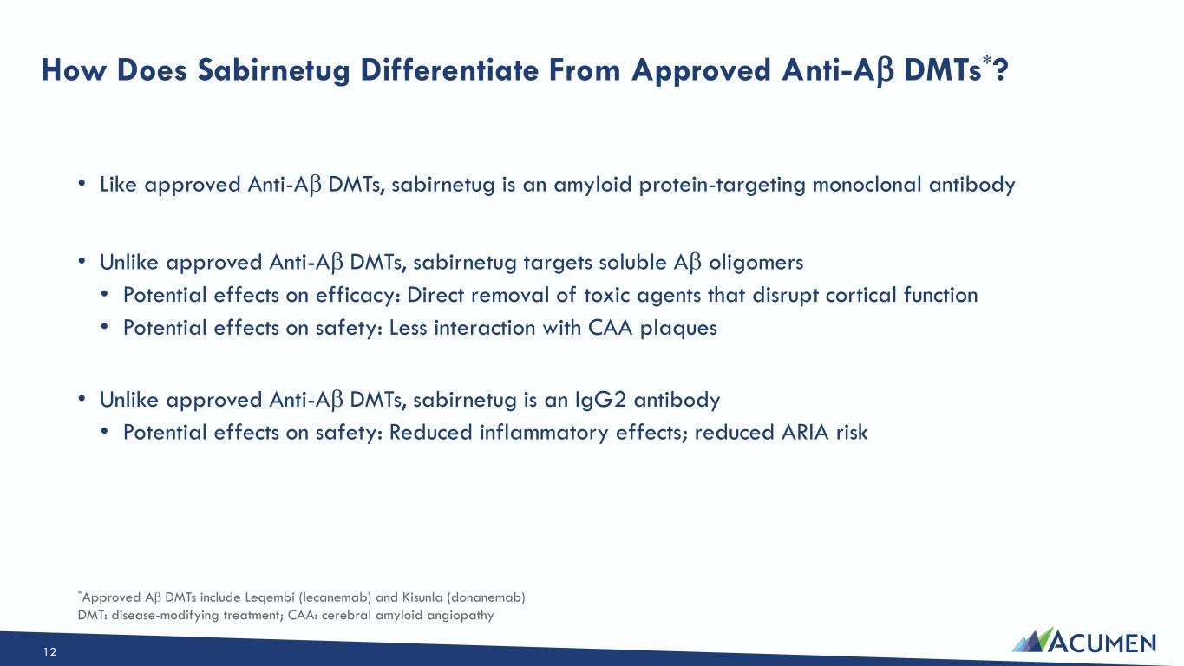
How Does Sabirnetug Differentiate From Approved Anti-A DMTs*? • Like approved Anti-A DMTs, sabirnetug is an amyloid protein-targeting monoclonal antibody • Unlike approved Anti-A DMTs, sabirnetug targets soluble A oligomers • Potential effects on efficacy: Direct removal of toxic agents that disrupt cortical function • Potential effects on safety: Less interaction with CAA plaques • Unlike approved Anti-A DMTs, sabirnetug is an IgG2 antibody • Potential effects on safety: Reduced inflammatory effects; reduced ARIA risk *Approved A DMTs include Leqembi (lecanemab) and Kisunla (donanemab) DMT: disease-modifying treatment; CAA: cerebral amyloid angiopathy 12

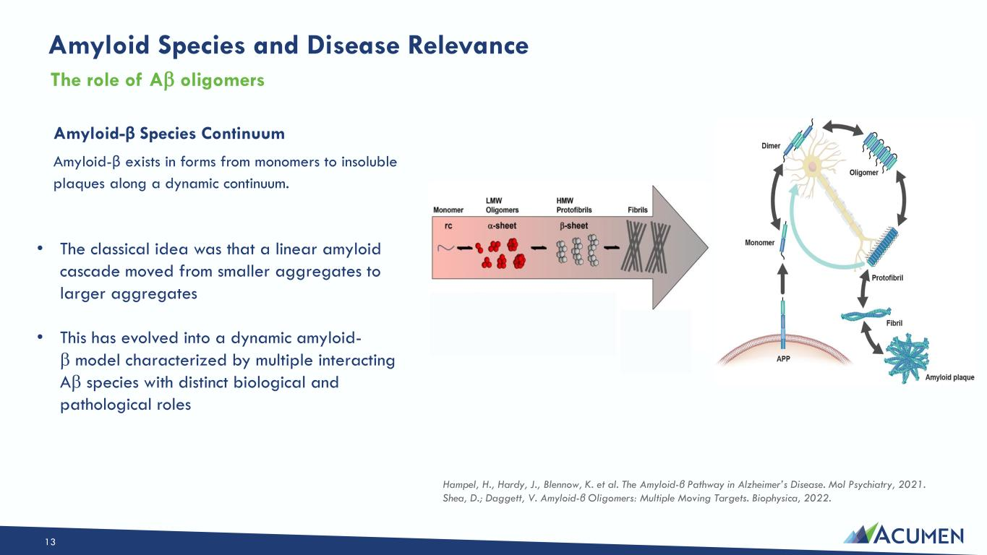
Amyloid Species and Disease Relevance Amyloid-β Species Continuum Amyloid-β exists in forms from monomers to insoluble plaques along a dynamic continuum. The role of A oligomers Hampel, H., Hardy, J., Blennow, K. et al. The Amyloid-β Pathway in Alzheimer’s Disease. Mol Psychiatry, 2021. Shea, D.; Daggett, V. Amyloid-β Oligomers: Multiple Moving Targets. Biophysica, 2022. • The classical idea was that a linear amyloid cascade moved from smaller aggregates to larger aggregates • This has evolved into a dynamic amyloid-  model characterized by multiple interacting A species with distinct biological and pathological roles 13

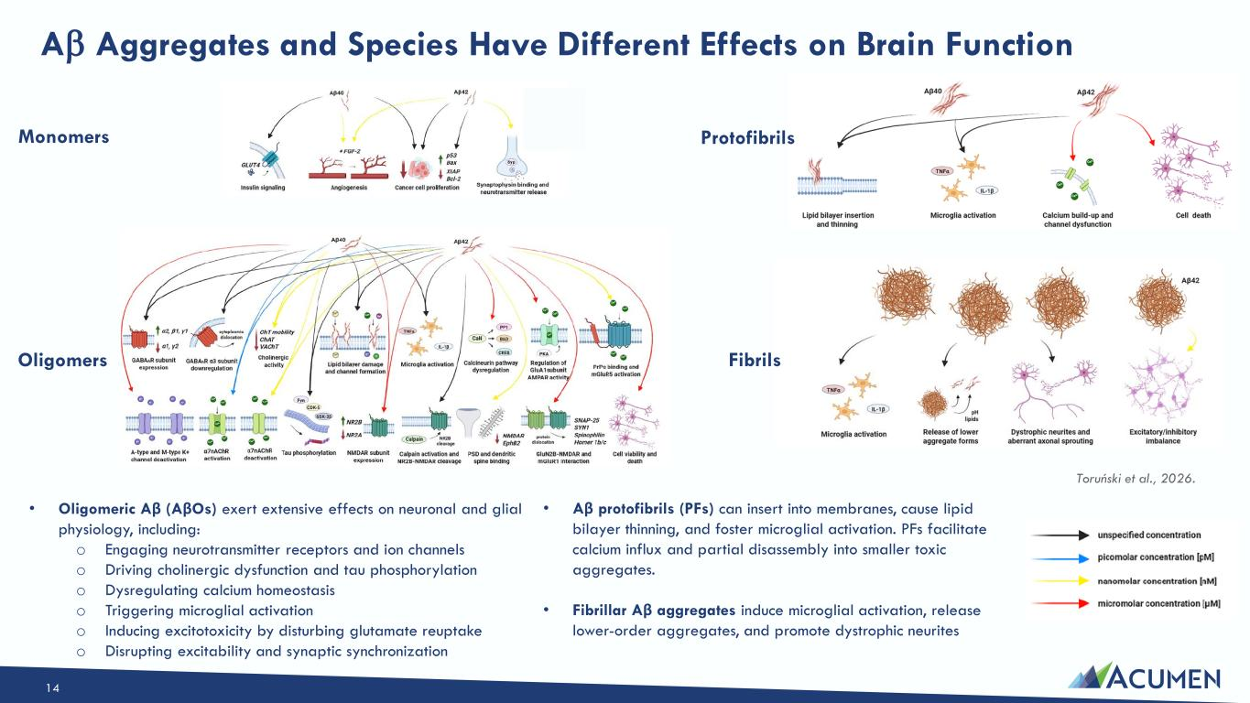
A Aggregates and Species Have Different Effects on Brain Function Toruński et al., 2026. • Oligomeric Aβ (AβOs) exert extensive effects on neuronal and glial physiology, including: o Engaging neurotransmitter receptors and ion channels o Driving cholinergic dysfunction and tau phosphorylation o Dysregulating calcium homeostasis o Triggering microglial activation o Inducing excitotoxicity by disturbing glutamate reuptake o Disrupting excitability and synaptic synchronization • Aβ protofibrils (PFs) can insert into membranes, cause lipid bilayer thinning, and foster microglial activation. PFs facilitate calcium influx and partial disassembly into smaller toxic aggregates. • Fibrillar Aβ aggregates induce microglial activation, release lower-order aggregates, and promote dystrophic neurites Monomers Oligomers Protofibrils Fibrils 14

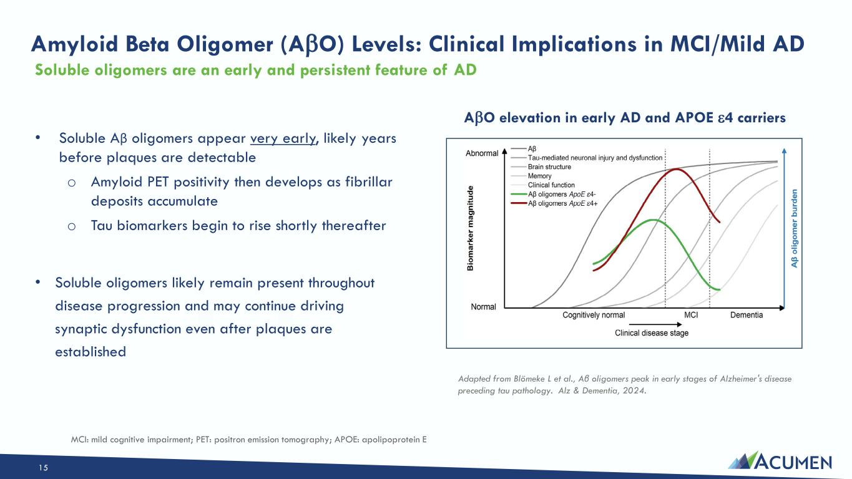
Amyloid Beta Oligomer (AO) Levels: Clinical Implications in MCI/Mild AD Soluble oligomers are an early and persistent feature of AD Adapted from Blömeke L et al., Aβ oligomers peak in early stages of Alzheimer's disease preceding tau pathology. Alz & Dementia, 2024. AO elevation in early AD and APOE 4 carriers • Soluble Aβ oligomers appear very early, likely years before plaques are detectable o Amyloid PET positivity then develops as fibrillar deposits accumulate o Tau biomarkers begin to rise shortly thereafter • Soluble oligomers likely remain present throughout disease progression and may continue driving synaptic dysfunction even after plaques are established MCI: mild cognitive impairment; PET: positron emission tomography; APOE: apolipoprotein E 15

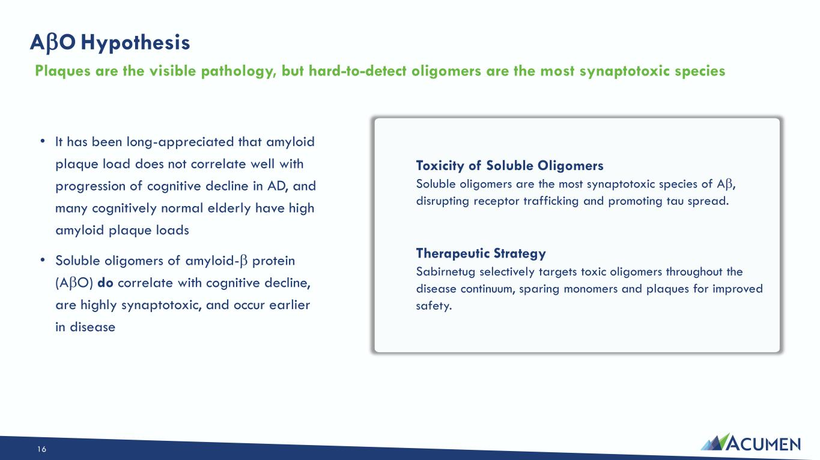
AO Hypothesis • It has been long-appreciated that amyloid plaque load does not correlate well with progression of cognitive decline in AD, and many cognitively normal elderly have high amyloid plaque loads • Soluble oligomers of amyloid- protein (AO) do correlate with cognitive decline, are highly synaptotoxic, and occur earlier in disease Plaques are the visible pathology, but hard-to-detect oligomers are the most synaptotoxic species Toxicity of Soluble Oligomers Soluble oligomers are the most synaptotoxic species of A, disrupting receptor trafficking and promoting tau spread. Therapeutic Strategy Sabirnetug selectively targets toxic oligomers throughout the disease continuum, sparing monomers and plaques for improved safety. 16

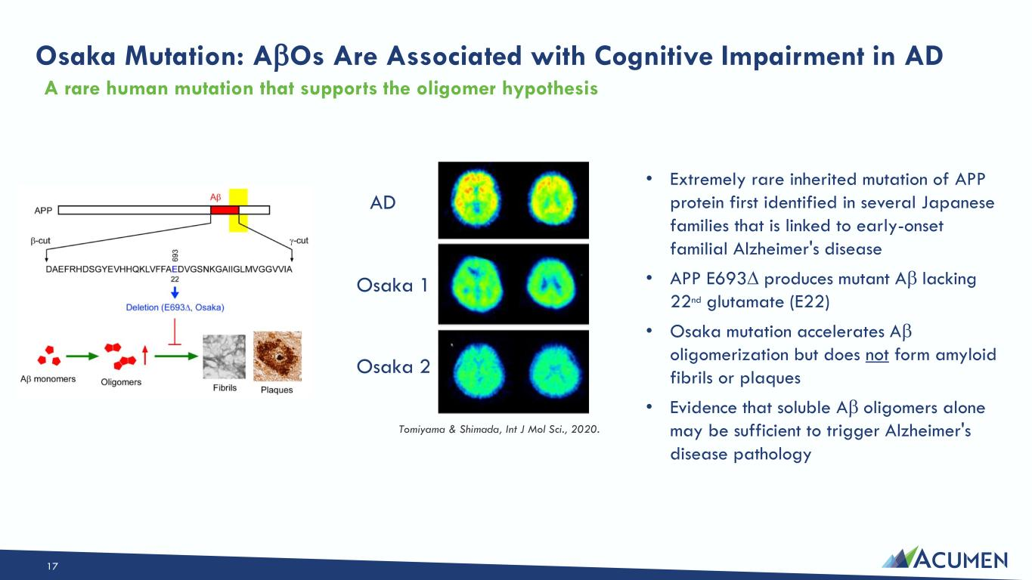
Osaka Mutation: AOs Are Associated with Cognitive Impairment in AD • Extremely rare inherited mutation of APP protein first identified in several Japanese families that is linked to early-onset familial Alzheimer's disease • APP E693 produces mutant A lacking 22nd glutamate (E22) • Osaka mutation accelerates A oligomerization but does not form amyloid fibrils or plaques • Evidence that soluble A oligomers alone may be sufficient to trigger Alzheimer's disease pathology A rare human mutation that supports the oligomer hypothesis Tomiyama & Shimada, Int J Mol Sci., 2020. Osaka 1 Osaka 2 AD 17

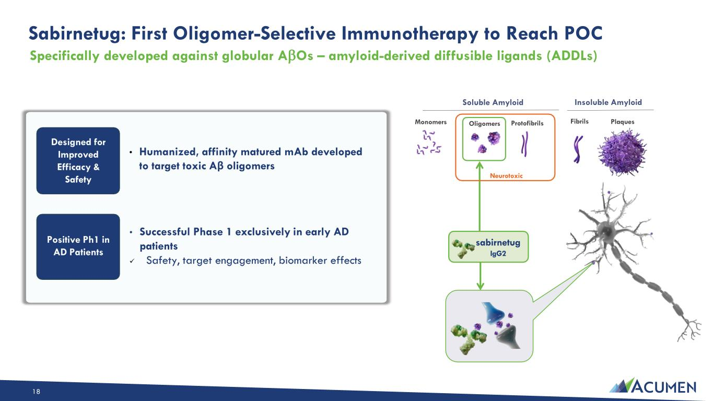
Sabirnetug: First Oligomer-Selective Immunotherapy to Reach POC Sabirnetug: First Oligomer-Selective Immunotherapy to Reach POC • Humanized, affinity matured mAb developed to target toxic Aβ oligomers Designed for Improved Efficacy & Safety Positive Ph1 in AD Patients • Successful Phase 1 exclusively in early AD patients ✓ Safety, target engagement, biomarker effects Monomers Soluble Amyloid Oligomers Protofibrils Insoluble Amyloid Fibrils Plaques sabirnetug IgG2 Neurotoxic Specifically developed against globular AOs – amyloid-derived diffusible ligands (ADDLs) 18

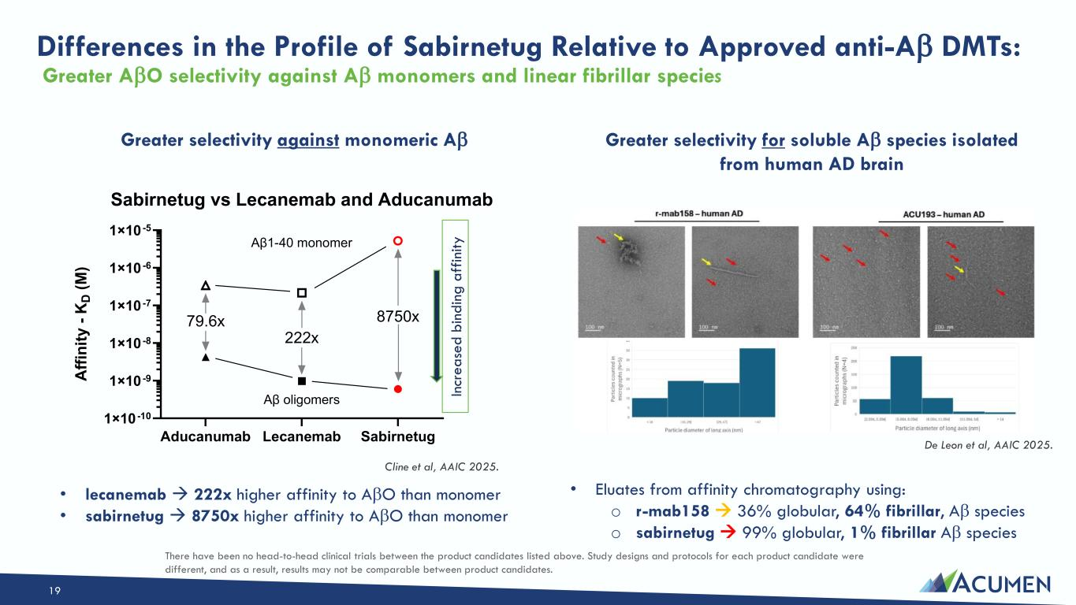
Differences in the Profile of Sabirnetug Relative to Approved anti-A DMTs: Greater AO selectivity against A monomers and linear fibrillar species Aducanumab Lecanemab Sabirnetug 1×10 -10 1×10 -9 1×10 -8 1×10 -7 1×10 -6 1×10 -5 Sabirnetug vs Lecanemab and Aducanumab A ff in it y - K D ( M ) Aβ1-40 monomer Aβ oligomers 8750x 222x 79.6x In cr e a se d b in d in g a ff in it y Greater selectivity for soluble A species isolated from human AD brain Greater selectivity against monomeric A Cline et al, AAIC 2025. • Eluates from affinity chromatography using: o r-mab158 → 36% globular, 64% fibrillar, A species o sabirnetug → 99% globular, 1% fibrillar A species • lecanemab → 222x higher affinity to AO than monomer • sabirnetug → 8750x higher affinity to AO than monomer De Leon et al, AAIC 2025. There have been no head-to-head clinical trials between the product candidates listed above. Study designs and protocols for each product candidate were different, and as a result, results may not be comparable between product candidates. 19

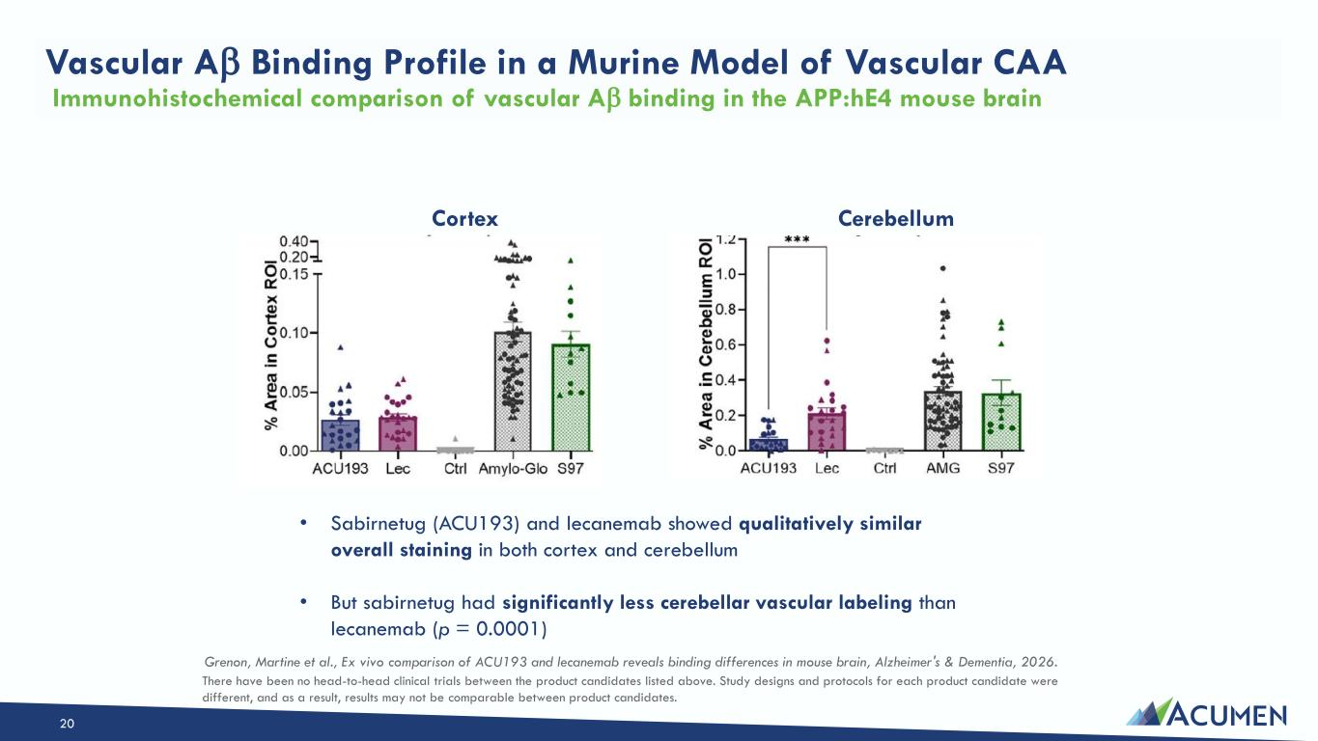
Vascular A Binding Profile in a Murine Model of Vascular CAA Immunohistochemical comparison of vascular A binding in the APP:hE4 mouse brain • Sabirnetug (ACU193) and lecanemab showed qualitatively similar overall staining in both cortex and cerebellum • But sabirnetug had significantly less cerebellar vascular labeling than lecanemab (p = 0.0001) Cortex Cerebellum Grenon, Martine et al., Ex vivo comparison of ACU193 and lecanemab reveals binding differences in mouse brain, Alzheimer's & Dementia, 2026. There have been no head-to-head clinical trials between the product candidates listed above. Study designs and protocols for each product candidate were different, and as a result, results may not be comparable between product candidates. 20

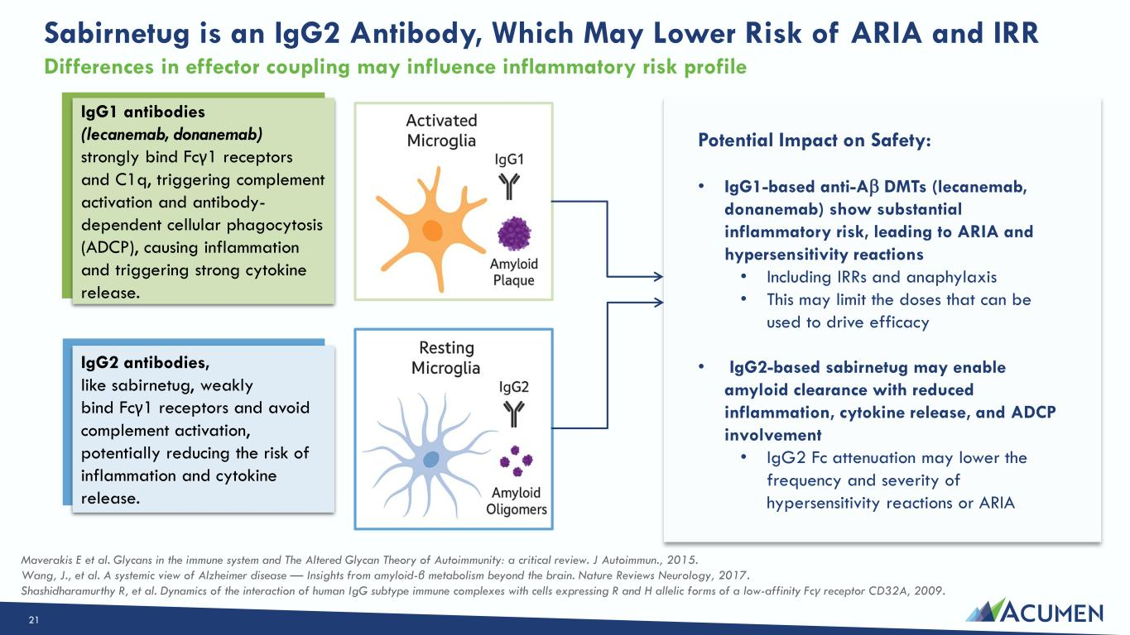
Sabirnetug is an IgG2 Antibody, Which May Lower Risk of ARIA and IRR IgG1 antibodies (lecanemab, donanemab) strongly bind Fcγ1 receptors and C1q, triggering complement activation and antibody- dependent cellular phagocytosis (ADCP), causing inflammation and triggering strong cytokine release. IgG2 antibodies, like sabirnetug, weakly bind Fcγ1 receptors and avoid complement activation, potentially reducing the risk of inflammation and cytokine release. Maverakis E et al. Glycans in the immune system and The Altered Glycan Theory of Autoimmunity: a critical review. J Autoimmun., 2015. Wang, J., et al. A systemic view of Alzheimer disease — Insights from amyloid-β metabolism beyond the brain. Nature Reviews Neurology, 2017. Shashidharamurthy R, et al. Dynamics of the interaction of human IgG subtype immune complexes with cells expressing R and H allelic forms of a low-affinity Fcγ receptor CD32A, 2009. Potential Impact on Safety: • IgG1-based anti-A DMTs (lecanemab, donanemab) show substantial inflammatory risk, leading to ARIA and hypersensitivity reactions • Including IRRs and anaphylaxis • This may limit the doses that can be used to drive efficacy • IgG2-based sabirnetug may enable amyloid clearance with reduced inflammation, cytokine release, and ADCP involvement • IgG2 Fc attenuation may lower the frequency and severity of hypersensitivity reactions or ARIA Differences in effector coupling may influence inflammatory risk profile 21

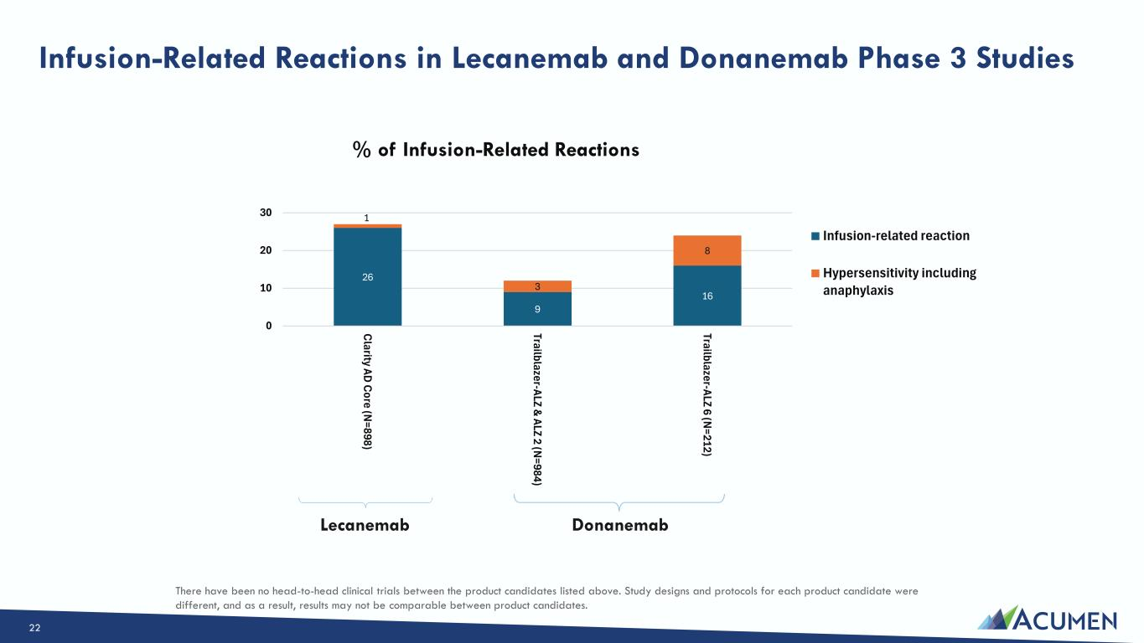
Infusion-Related Reactions in Lecanemab and Donanemab Phase 3 Studies 22 26 9 16 1 3 8 0 10 20 30 C larity AD C ore (N =898) Trailblazer-ALZ & ALZ 2 (N =984) Trailblazer-ALZ 6 (N =212) % of Infusion-Related Reactions Infusion-related reaction Hypersensitivity including anaphylaxis Lecanemab Donanemab There have been no head-to-head clinical trials between the product candidates listed above. Study designs and protocols for each product candidate were different, and as a result, results may not be comparable between product candidates.

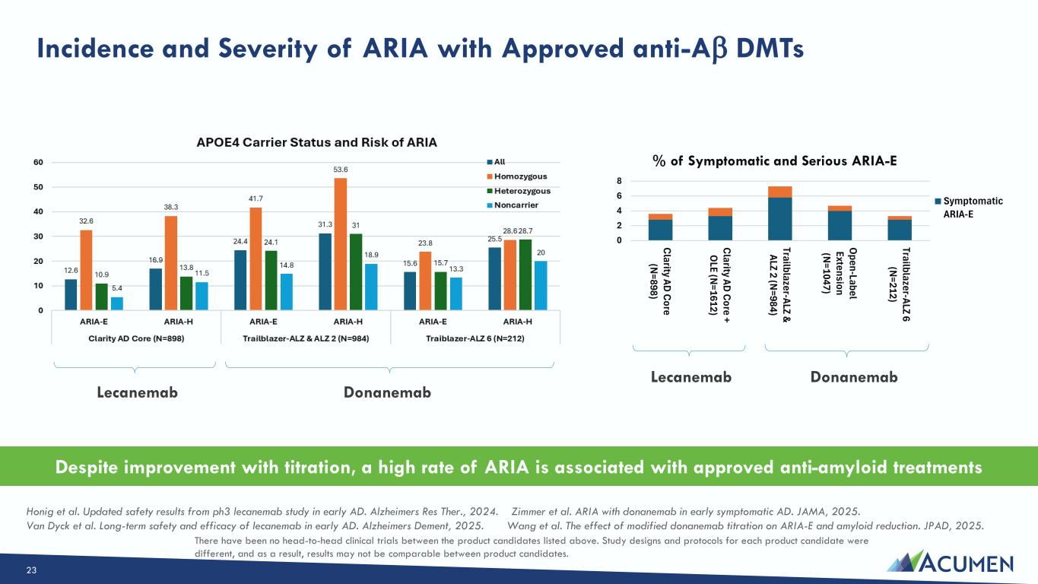
Incidence and Severity of ARIA with Approved anti-A DMTs Lecanemab Donanemab Despite improvement with titration, a high rate of ARIA is associated with approved anti-amyloid treatments Honig et al. Updated safety results from ph3 lecanemab study in early AD. Alzheimers Res Ther., 2024. Zimmer et al. ARIA with donanemab in early symptomatic AD. JAMA, 2025. Van Dyck et al. Long-term safety and efficacy of lecanemab in early AD. Alzheimers Dement, 2025. Wang et al. The effect of modified donanemab titration on ARIA-E and amyloid reduction. JPAD, 2025. Lecanemab Donanemab 0 2 4 6 8 C larity AD C ore (N =898) C larity AD C ore + O LE (N =1612) Trailblazer-ALZ & ALZ 2 (N =984) O pen-Label Extension (N =1047) Trailblazer-ALZ 6 (N =212) % of Symptomatic and Serious ARIA-E Symptomatic ARIA-E There have been no head-to-head clinical trials between the product candidates listed above. Study designs and protocols for each product candidate were different, and as a result, results may not be comparable between product candidates. 23

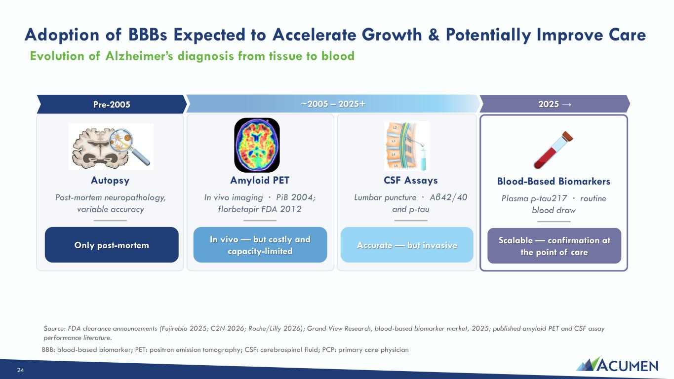
Adoption of BBBs Expected to Accelerate Growth & Potentially Improve Care Pre-2005 Autopsy Post-mortem neuropathology, variable accuracy ~2005 – 2025+ Amyloid PET In vivo imaging · PiB 2004; florbetapir FDA 2012 In vivo — but costly and capacity-limited CSF Assays Lumbar puncture · Aβ42/40 and p-tau Accurate — but invasive 2025 → Blood-Based Biomarkers Plasma p-tau217 · routine blood draw Scalable — confirmation at the point of care Source: FDA clearance announcements (Fujirebio 2025; C2N 2026; Roche/Lilly 2026); Grand View Research, blood-based biomarker market, 2025; published amyloid PET and CSF assay performance literature. Only post-mortem Evolution of Alzheimer’s diagnosis from tissue to blood BBB: blood-based biomarker; PET: positron emission tomography; CSF: cerebrospinal fluid; PCP: primary care physician 24

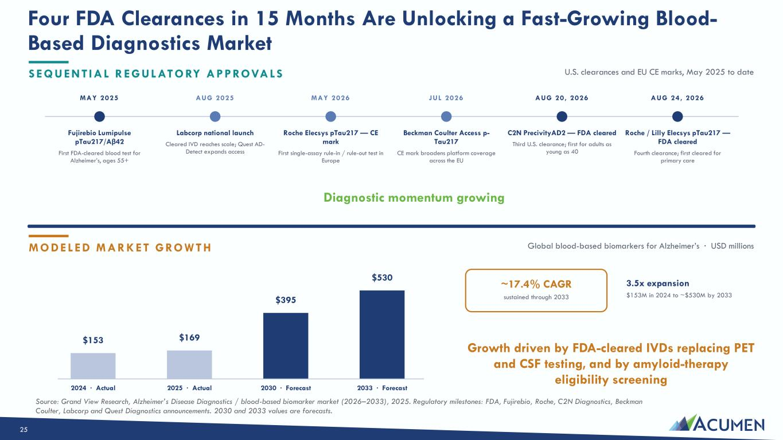
Four FDA Clearances in 15 Months Are Unlocking a Fast-Growing Blood- Based Diagnostics Market S E Q UEN T IA L R E G ULATO RY A PPROVA LS U.S. clearances and EU CE marks, May 2025 to date MAY 2025 Fujirebio Lumipulse pTau217/Aβ42 First FDA-cleared blood test for Alzheimer’s, ages 55+ AUG 2025 Labcorp national launch Cleared IVD reaches scale; Quest AD- Detect expands access MAY 2026 Roche Elecsys pTau217 — CE mark First single-assay rule-in / rule-out test in Europe JUL 2026 Beckman Coulter Access p- Tau217 CE mark broadens platform coverage across the EU AUG 20, 2026 C2N PrecivityAD2 — FDA cleared Third U.S. clearance; first for adults as young as 40 AUG 24, 2026 Roche / Lilly Elecsys pTau217 — FDA cleared Fourth clearance; first cleared for primary care Diagnostic momentum growing M O DE LE D M A R KE T G ROW T H Global blood-based biomarkers for Alzheimer’s · USD millions $153 2024 · Actual $169 2025 · Actual $395 2030 · Forecast $530 2033 · Forecast ~17.4% CAGR sustained through 2033 3.5x expansion $153M in 2024 to ~$530M by 2033 Growth driven by FDA-cleared IVDs replacing PET and CSF testing, and by amyloid-therapy eligibility screening Source: Grand View Research, Alzheimer’s Disease Diagnostics / blood-based biomarker market (2026–2033), 2025. Regulatory milestones: FDA, Fujirebio, Roche, C2N Diagnostics, Beckman Coulter, Labcorp and Quest Diagnostics announcements. 2030 and 2033 values are forecasts. 25

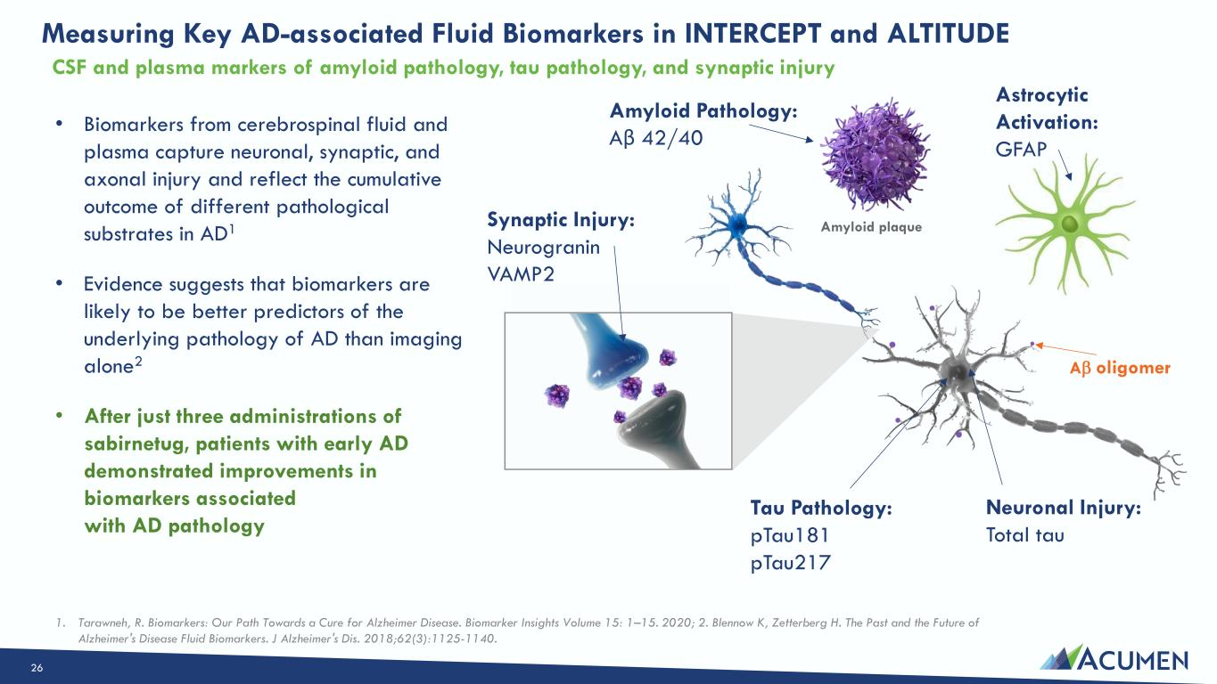
Measuring Key AD-associated Fluid Biomarkers in INTERCEPT and ALTITUDE Tau Pathology: pTau181 pTau217 Neuronal Injury: Total tau Synaptic Injury: Neurogranin VAMP2 Amyloid Pathology: Aβ 42/40 Astrocytic Activation: GFAP • Biomarkers from cerebrospinal fluid and plasma capture neuronal, synaptic, and axonal injury and reflect the cumulative outcome of different pathological substrates in AD1 • Evidence suggests that biomarkers are likely to be better predictors of the underlying pathology of AD than imaging alone2 • After just three administrations of sabirnetug, patients with early AD demonstrated improvements in biomarkers associated with AD pathology 1. Tarawneh, R. Biomarkers: Our Path Towards a Cure for Alzheimer Disease. Biomarker Insights Volume 15: 1–15. 2020; 2. Blennow K, Zetterberg H. The Past and the Future of Alzheimer's Disease Fluid Biomarkers. J Alzheimer's Dis. 2018;62(3):1125-1140. A oligomer Amyloid plaque CSF and plasma markers of amyloid pathology, tau pathology, and synaptic injury 26

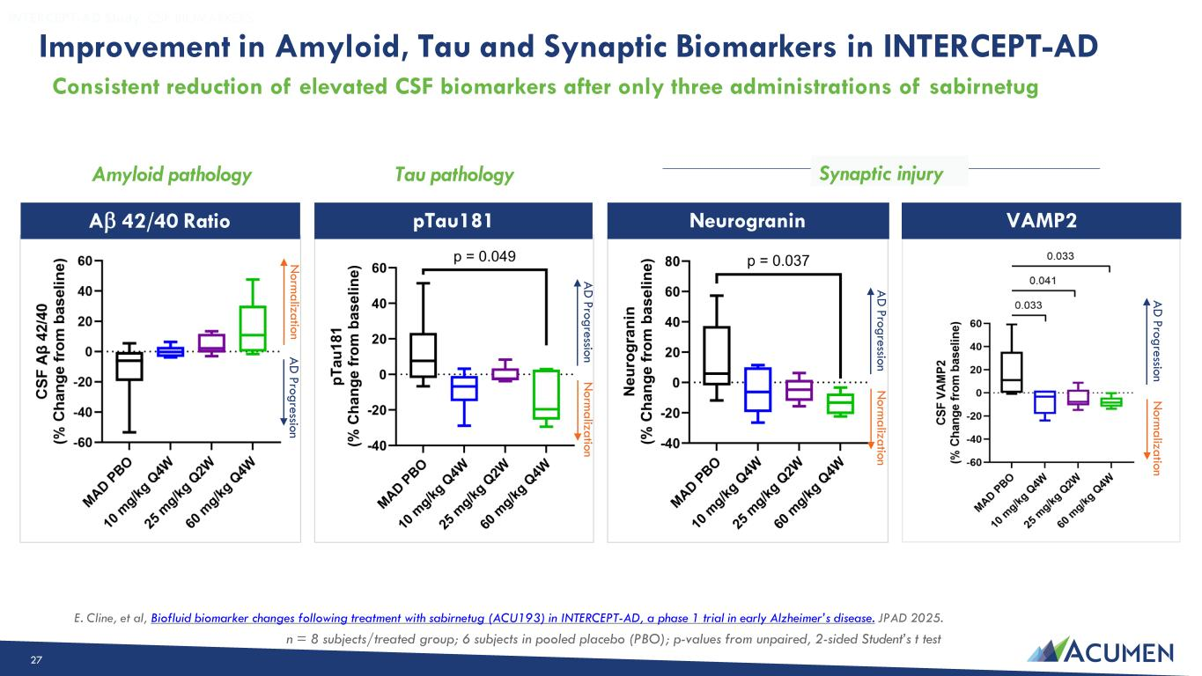
Improvement in Amyloid, Tau and Synaptic Biomarkers in INTERCEPT-AD Improvement in Amyloid, Tau and Synaptic Biomarkers in INTERCEPT-AD INTERCEPT-AD Study: CSF BIOMARKERS pTau181 NeurograninA 42/40 Ratio VAMP2 Amyloid pathology Tau pathology Synaptic injury E. Cline, et al, Biofluid biomarker changes following treatment with sabirnetug (ACU193) in INTERCEPT-AD, a phase 1 trial in early Alzheimer’s disease. JPAD 2025. n = 8 subjects/treated group; 6 subjects in pooled placebo (PBO); p-values from unpaired, 2-sided Student’s t test N o rm a liza tio n A D P ro g re ssio n N o rm a liza tio n A D P ro g re ssio n N o rm a liza tio n A D P ro g re ssio n N o rm a liza tio n A D P ro g re ssio n Consistent reduction of elevated CSF biomarkers after only three administrations of sabirnetug 27

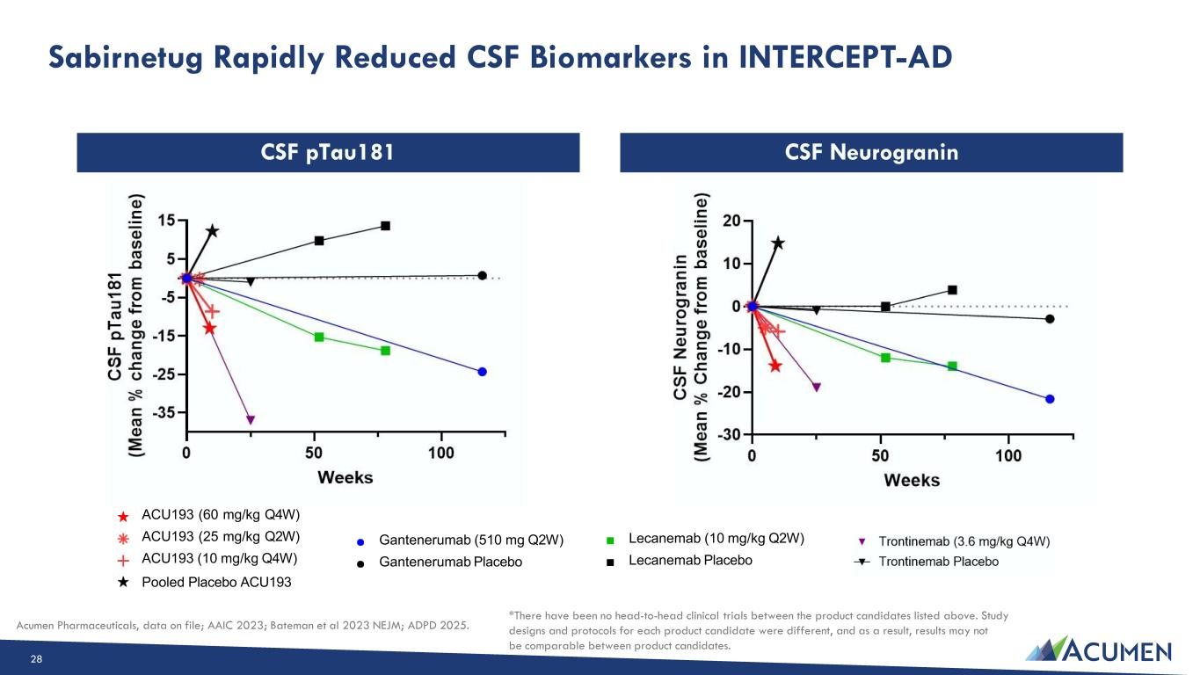
CSF NeurograninCSF pTau181 ACU193 (60 mg/kg Q4W) ACU193 (25 mg/kg Q2W) ACU193 (10 mg/kg Q4W) Pooled Placebo ACU193 Gantenerumab (510 mg Q2W) Gantenerumab Placebo Lecanemab (10 mg/kg Q2W) Lecanemab Placebo *There have been no head-to-head clinical trials between the product candidates listed above. Study designs and protocols for each product candidate were different, and as a result, results may not be comparable between product candidates. Acumen Pharmaceuticals, data on file; AAIC 2023; Bateman et al 2023 NEJM; ADPD 2025. Sabirnetug Rapidly Reduced CSF Biomarkers in INTERCEPT-AD 28

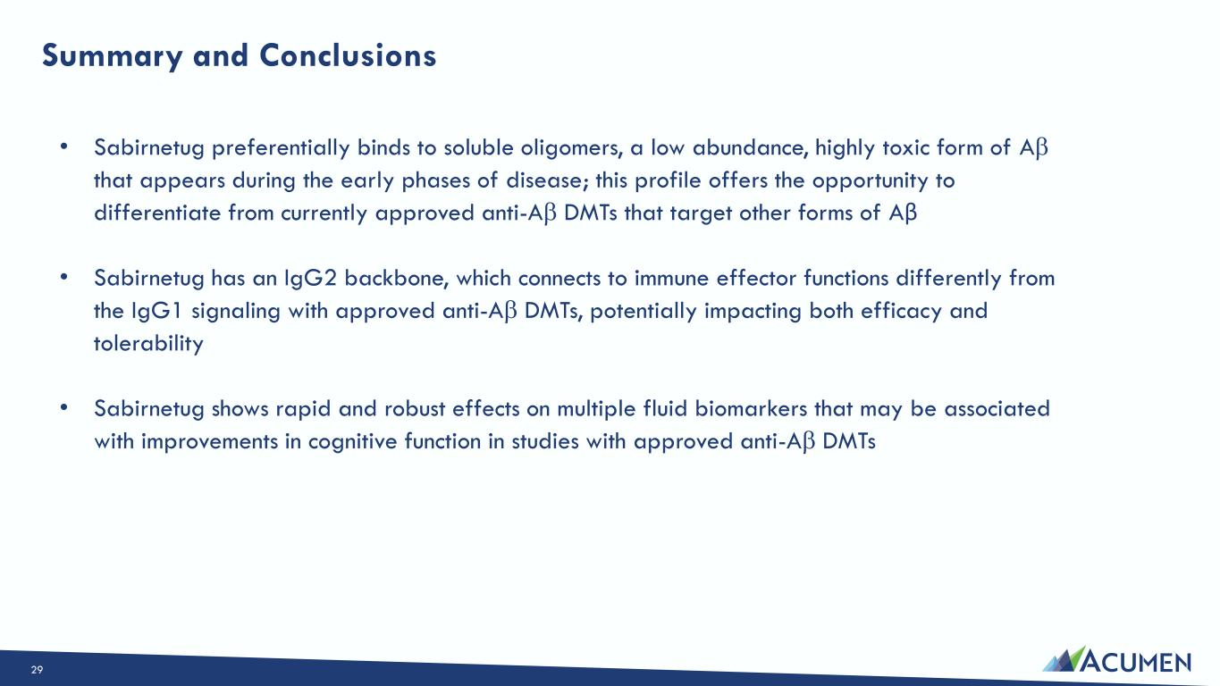
Summary and Conclusions • Sabirnetug preferentially binds to soluble oligomers, a low abundance, highly toxic form of A that appears during the early phases of disease; this profile offers the opportunity to differentiate from currently approved anti-A DMTs that target other forms of Aβ • Sabirnetug has an IgG2 backbone, which connects to immune effector functions differently from the IgG1 signaling with approved anti-A DMTs, potentially impacting both efficacy and tolerability • Sabirnetug shows rapid and robust effects on multiple fluid biomarkers that may be associated with improvements in cognitive function in studies with approved anti-A DMTs 29

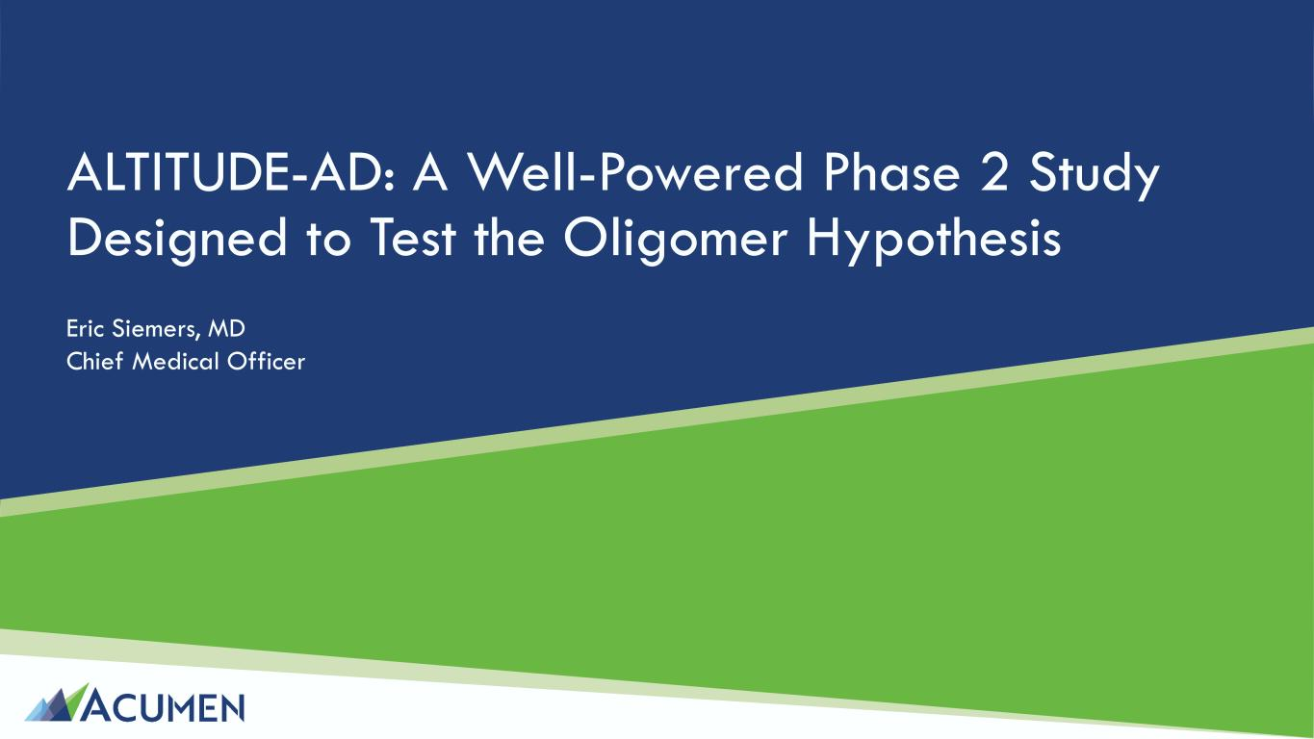
ALTITUDE-AD: A Well-Powered Phase 2 Study Designed to Test the Oligomer Hypothesis Eric Siemers, MD Chief Medical Officer

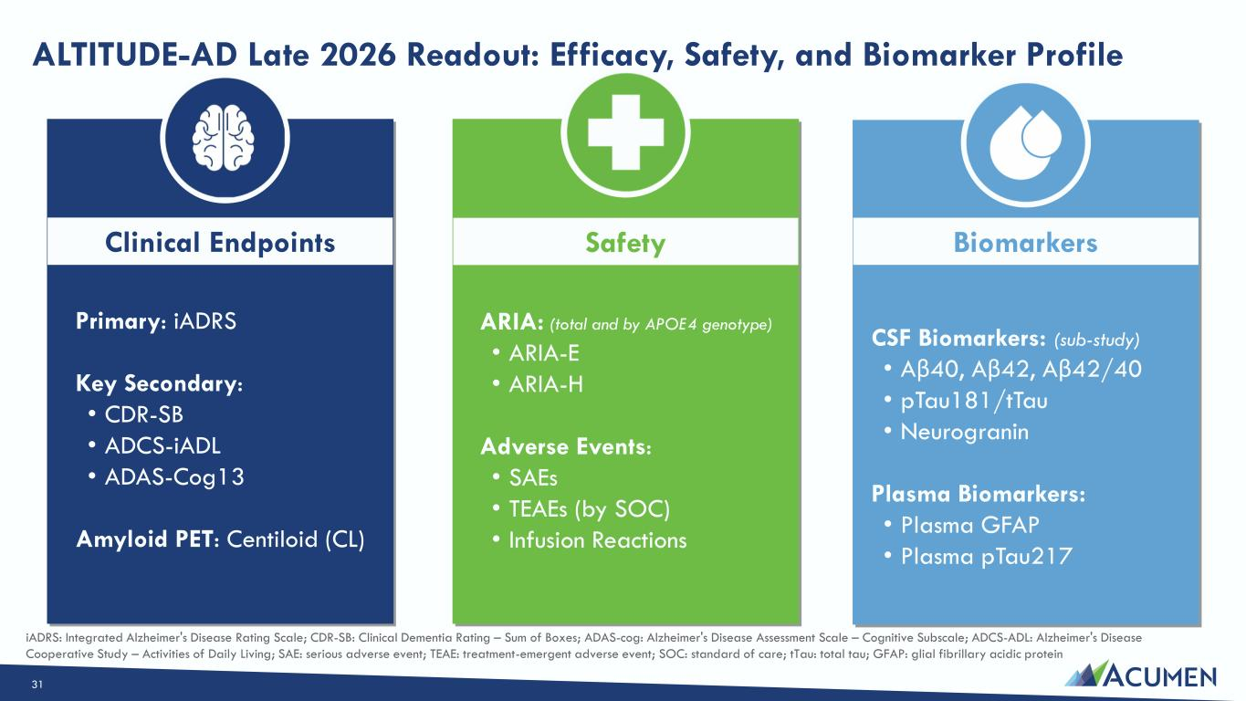
ALTITUDE-AD Late 2026 Readout: Efficacy, Safety, and Biomarker Profile (2) safety endpoints (ARIA rate, Symptomatic ARIA rate) across ApoE4 homozygotes, ApoE4 heterozygotes, non-carriers (3) biomarkers Clinical Endpoints Safety Biomarkers Primary: iADRS Key Secondary: • CDR-SB • ADCS-iADL • ADAS-Cog13 Amyloid PET: Centiloid (CL) ARIA: (total and by APOE4 genotype) • ARIA-E • ARIA-H Adverse Events: • SAEs • TEAEs (by SOC) • Infusion Reactions CSF Biomarkers: (sub-study) • Aβ40, Aβ42, Aβ42/40 • pTau181/tTau • Neurogranin Plasma Biomarkers: • Plasma GFAP • Plasma pTau217 iADRS: Integrated Alzheimer's Disease Rating Scale; CDR-SB: Clinical Dementia Rating – Sum of Boxes; ADAS-cog: Alzheimer's Disease Assessment Scale – Cognitive Subscale; ADCS-ADL: Alzheimer's Disease Cooperative Study – Activities of Daily Living; SAE: serious adverse event; TEAE: treatment-emergent adverse event; SOC: standard of care; tTau: total tau; GFAP: glial fibrillary acidic protein 31

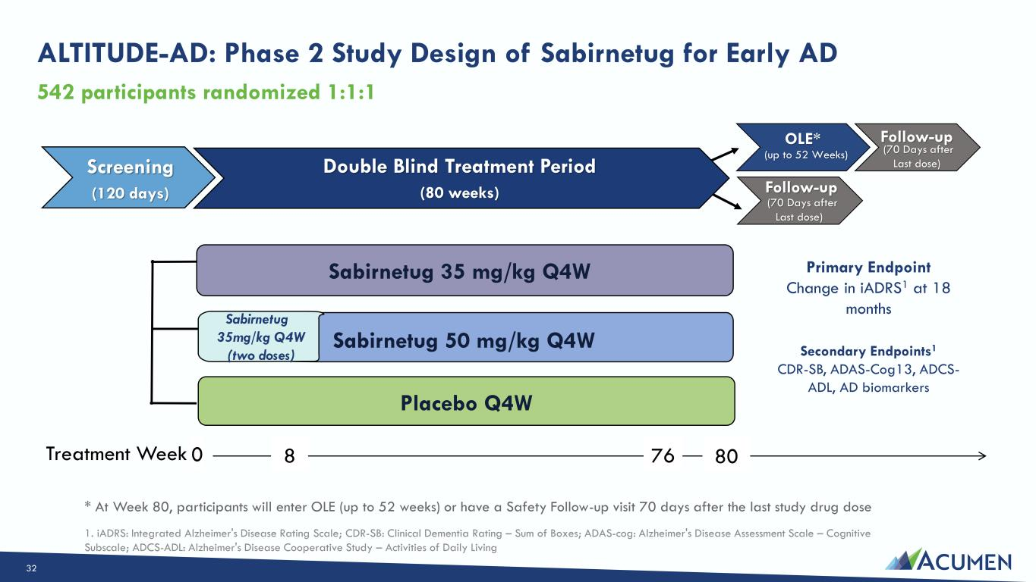
ALTITUDE-AD: Phase 2 Study Design of Sabirnetug for Early AD 542 participants randomized 1:1:1 Screening (120 days) Double Blind Treatment Period (80 weeks) Sabirnetug 35 mg/kg Q4W Sabirnetug 35mg/kg Q4W (two doses) Sabirnetug 50 mg/kg Q4W Placebo Q4W Treatment Week 0 8 8076 * At Week 80, participants will enter OLE (up to 52 weeks) or have a Safety Follow-up visit 70 days after the last study drug dose 1. iADRS: Integrated Alzheimer's Disease Rating Scale; CDR-SB: Clinical Dementia Rating – Sum of Boxes; ADAS-cog: Alzheimer's Disease Assessment Scale – Cognitive Subscale; ADCS-ADL: Alzheimer's Disease Cooperative Study – Activities of Daily Living OLE* (up to 52 Weeks) Follow-up (70 Days after Last dose) Follow-up (70 Days after Last dose) Primary Endpoint Change in iADRS1 at 18 months Secondary Endpoints1 CDR-SB, ADAS-Cog13, ADCS- ADL, AD biomarkers 32

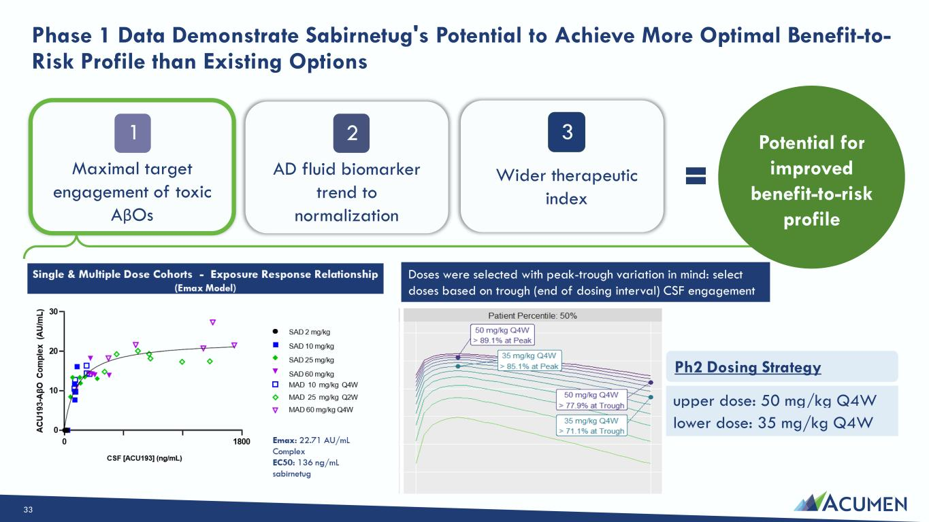
Phase 1 Data Demonstrate Sabirnetug's Potential to Achieve More Optimal Benefit-to- Risk Profile than Existing Options Maximal target engagement of toxic AβOs AD fluid biomarker trend to normalization Wider therapeutic index 1 2 3 Potential for improved benefit-to-risk profile Doses were selected with peak-trough variation in mind: select doses based on trough (end of dosing interval) CSF engagement upper dose: 50 mg/kg Q4W lower dose: 35 mg/kg Q4W Ph2 Dosing Strategy Potential for improved benefit-to-risk profile Potential for improved benefit-to-risk profile 33

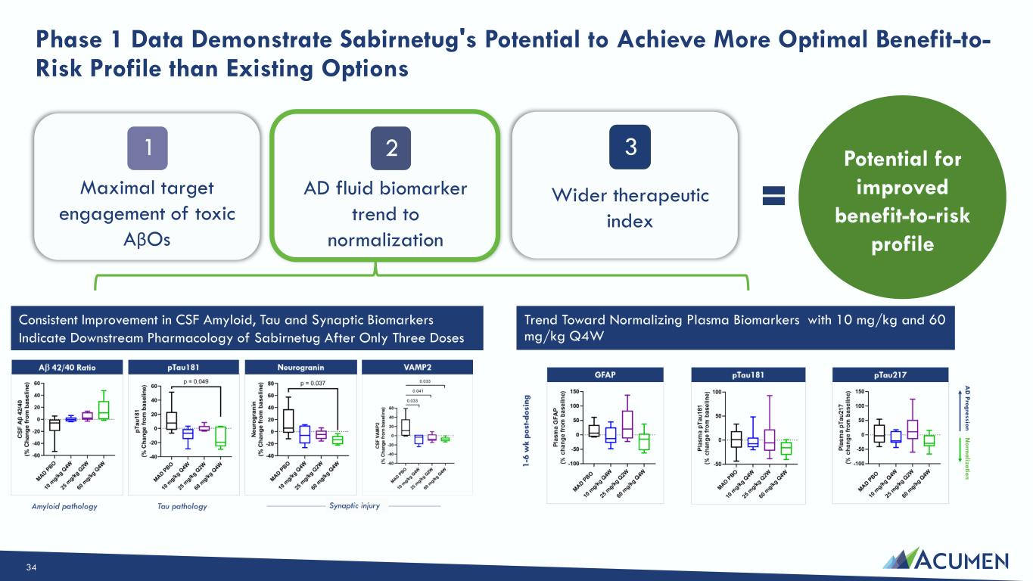
Phase 1 Data Demonstrate Sabirnetug's Potential to Achieve More Optimal Benefit-to- Risk Profile than Existing Options Maximal target engagement of toxic AβOs AD fluid biomarker trend to normalization Wider therapeutic index 1 2 3 Potential for improved benefit-to-risk profile Consistent Improvement in CSF Amyloid, Tau and Synaptic Biomarkers Indicate Downstream Pharmacology of Sabirnetug After Only Three Doses Trend Toward Normalizing Plasma Biomarkers with 10 mg/kg and 60 mg/kg Q4W Potential for improved benefit-to-risk profile 34

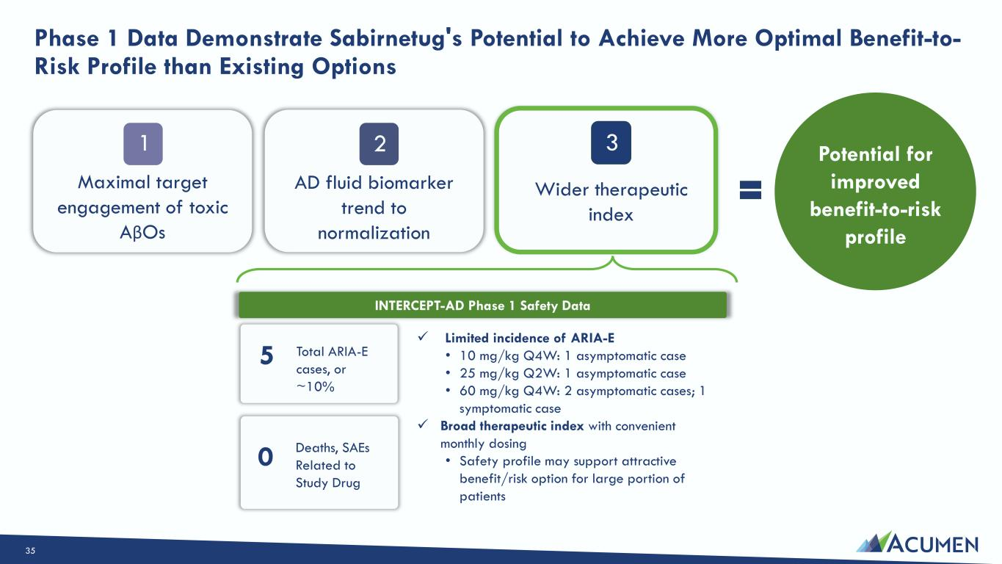
Phase 1 Data Demonstrate Sabirnetug's Potential to Achieve More Optimal Benefit-to- Risk Profile than Existing Options ✓ Limited incidence of ARIA-E • 10 mg/kg Q4W: 1 asymptomatic case • 25 mg/kg Q2W: 1 asymptomatic case • 60 mg/kg Q4W: 2 asymptomatic cases; 1 symptomatic case ✓ Broad therapeutic index with convenient monthly dosing • Safety profile may support attractive benefit/risk option for large portion of patients 5 Total ARIA-E cases, or ~10% 0 Deaths, SAEs Related to Study Drug INTERCEPT-AD Phase 1 Safety Data Potential for improved benefit-to-risk profile Maximal target engagement of toxic AβOs AD fluid biomarker trend to normalization Wider therapeutic index 1 2 3 35

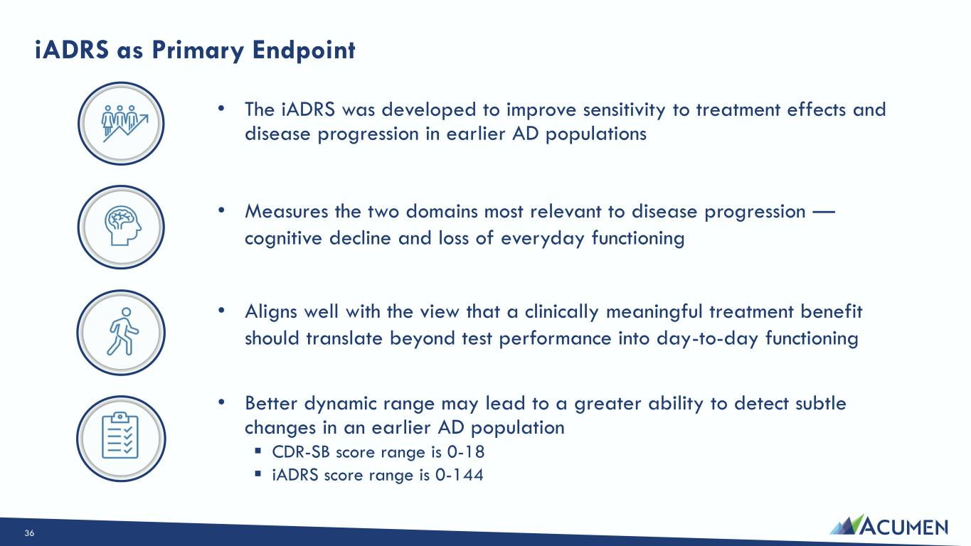
iADRS as Primary Endpoint • The iADRS was developed to improve sensitivity to treatment effects and disease progression in earlier AD populations • Better dynamic range may lead to a greater ability to detect subtle changes in an earlier AD population ▪ CDR-SB score range is 0-18 ▪ iADRS score range is 0-144 • Aligns well with the view that a clinically meaningful treatment benefit should translate beyond test performance into day-to-day functioning • Measures the two domains most relevant to disease progression — cognitive decline and loss of everyday functioning 36

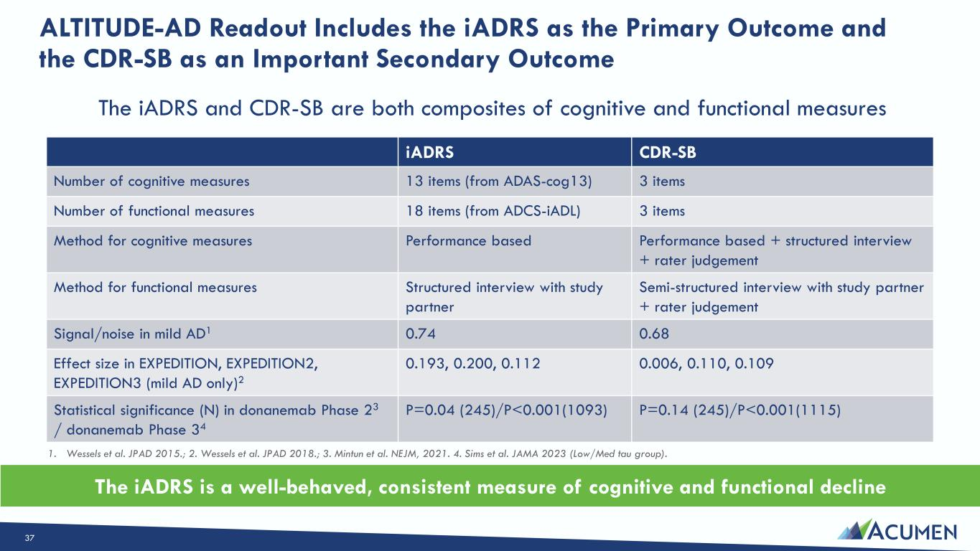
ALTITUDE-AD Readout Includes the iADRS as the Primary Outcome and the CDR-SB as an Important Secondary Outcome The iADRS and CDR-SB are both composites of cognitive and functional measures iADRS CDR-SB Number of cognitive measures 13 items (from ADAS-cog13) 3 items Number of functional measures 18 items (from ADCS-iADL) 3 items Method for cognitive measures Performance based Performance based + structured interview + rater judgement Method for functional measures Structured interview with study partner Semi-structured interview with study partner + rater judgement Signal/noise in mild AD1 0.74 0.68 Effect size in EXPEDITION, EXPEDITION2, EXPEDITION3 (mild AD only)2 0.193, 0.200, 0.112 0.006, 0.110, 0.109 Statistical significance (N) in donanemab Phase 23 / donanemab Phase 34 P=0.04 (245)/P<0.001(1093) P=0.14 (245)/P<0.001(1115) 1. Wessels et al. JPAD 2015.; 2. Wessels et al. JPAD 2018.; 3. Mintun et al. NEJM, 2021. 4. Sims et al. JAMA 2023 (Low/Med tau group). The iADRS is a well-behaved, consistent measure of cognitive and functional decline 37

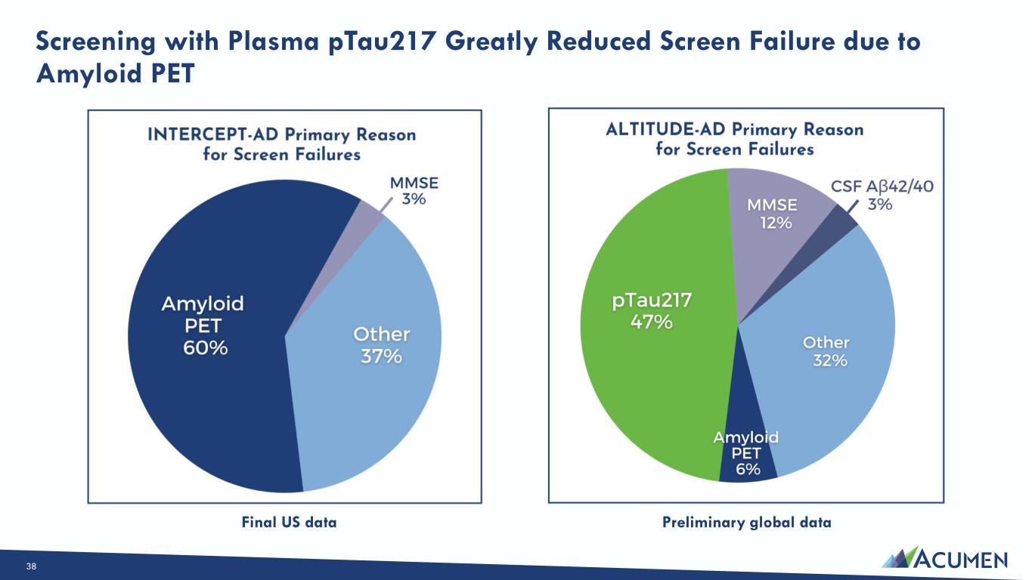
Screening with Plasma pTau217 Greatly Reduced Screen Failure due to Amyloid PET Preliminary global dataFinal US data 38

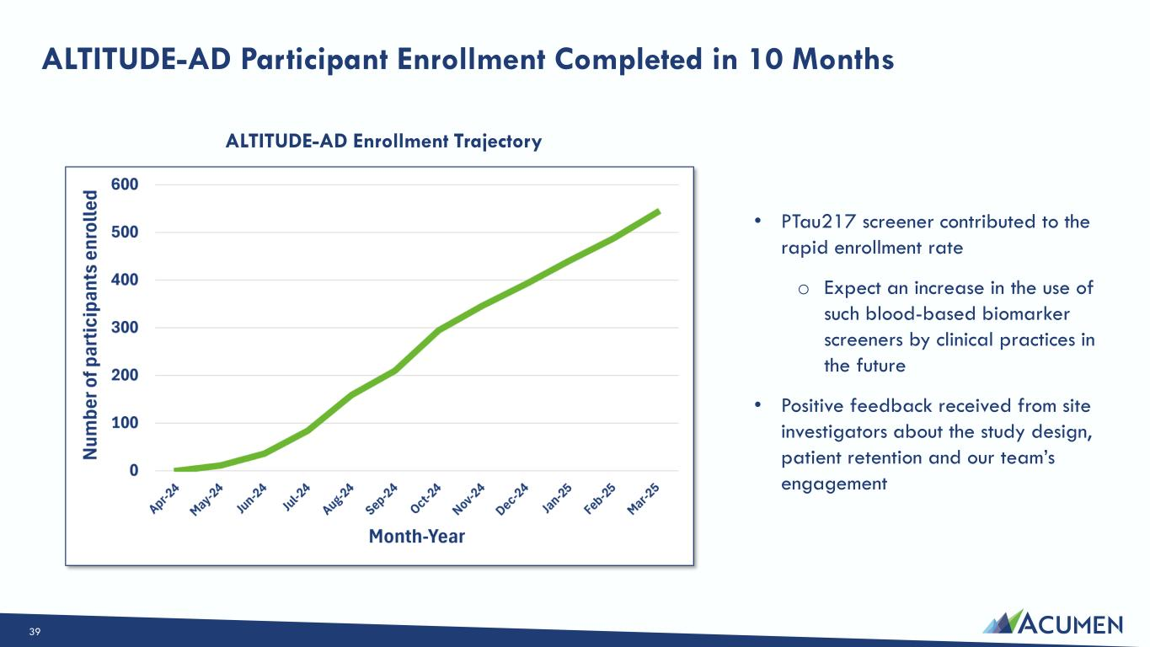
ALTITUDE-AD Participant Enrollment Completed in 10 Months • PTau217 screener contributed to the rapid enrollment rate o Expect an increase in the use of such blood-based biomarker screeners by clinical practices in the future • Positive feedback received from site investigators about the study design, patient retention and our team’s engagement ALTITUDE-AD Enrollment Trajectory 39

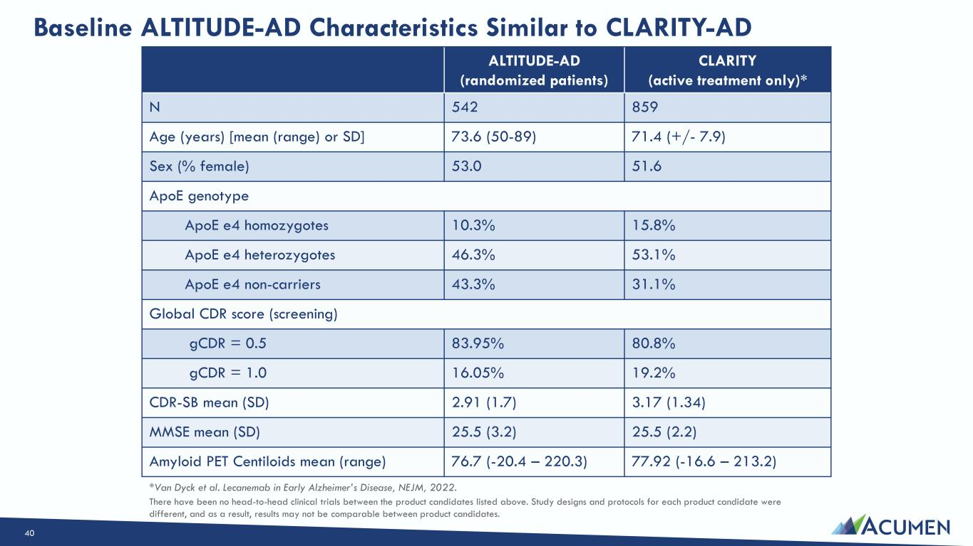
Baseline ALTITUDE-AD Characteristics Similar to CLARITY-AD ALTITUDE-AD (randomized patients) CLARITY (active treatment only)* N 542 859 Age (years) [mean (range) or SD] 73.6 (50-89) 71.4 (+/- 7.9) Sex (% female) 53.0 51.6 ApoE genotype ApoE e4 homozygotes 10.3% 15.8% ApoE e4 heterozygotes 46.3% 53.1% ApoE e4 non-carriers 43.3% 31.1% Global CDR score (screening) gCDR = 0.5 83.95% 80.8% gCDR = 1.0 16.05% 19.2% CDR-SB mean (SD) 2.91 (1.7) 3.17 (1.34) MMSE mean (SD) 25.5 (3.2) 25.5 (2.2) Amyloid PET Centiloids mean (range) 76.7 (-20.4 – 220.3) 77.92 (-16.6 – 213.2) *Van Dyck et al. Lecanemab in Early Alzheimer’s Disease, NEJM, 2022. There have been no head-to-head clinical trials between the product candidates listed above. Study designs and protocols for each product candidate were different, and as a result, results may not be comparable between product candidates. 40

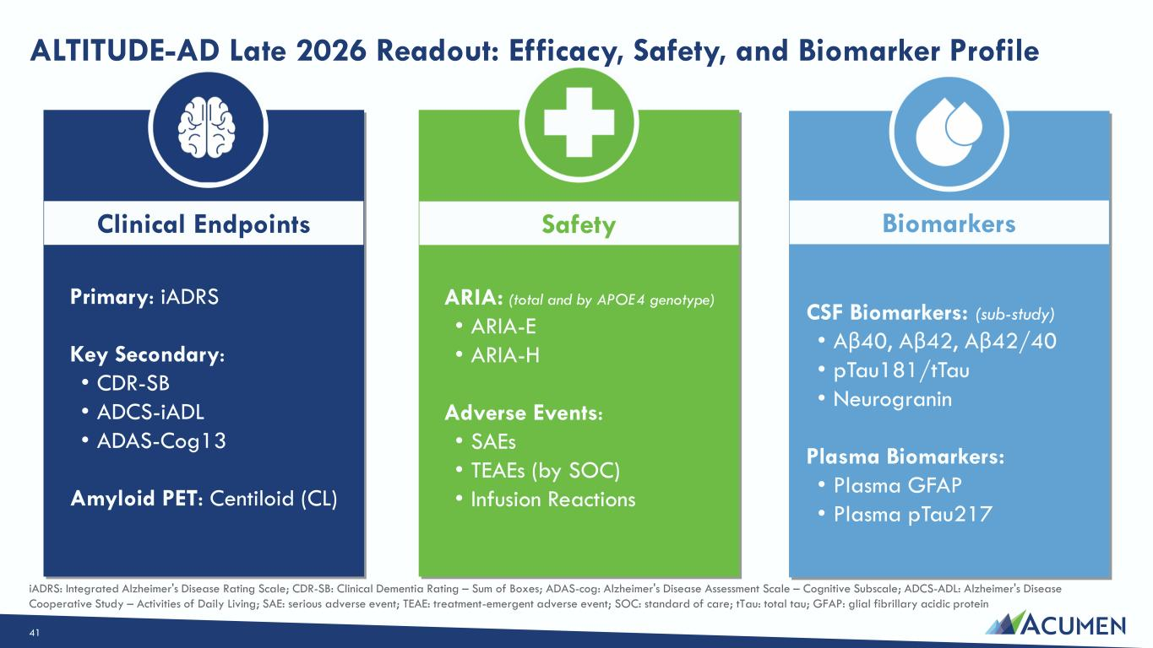
ALTITUDE-AD Late 2026 Readout: Efficacy, Safety, and Biomarker Profile (2) safety endpoints (ARIA rate, Symptomatic ARIA rate) across ApoE4 homozygotes, ApoE4 heterozygotes, non-carriers (3) biomarkers Clinical Endpoints Safety Biomarkers Primary: iADRS Key Secondary: • CDR-SB • ADCS-iADL • ADAS-Cog13 Amyloid PET: Centiloid (CL) ARIA: (total and by APOE4 genotype) • ARIA-E • ARIA-H Adverse Events: • SAEs • TEAEs (by SOC) • Infusion Reactions CSF Biomarkers: (sub-study) • Aβ40, Aβ42, Aβ42/40 • pTau181/tTau • Neurogranin Plasma Biomarkers: • Plasma GFAP • Plasma pTau217 iADRS: Integrated Alzheimer's Disease Rating Scale; CDR-SB: Clinical Dementia Rating – Sum of Boxes; ADAS-cog: Alzheimer's Disease Assessment Scale – Cognitive Subscale; ADCS-ADL: Alzheimer's Disease Cooperative Study – Activities of Daily Living; SAE: serious adverse event; TEAE: treatment-emergent adverse event; SOC: standard of care; tTau: total tau; GFAP: glial fibrillary acidic protein 41

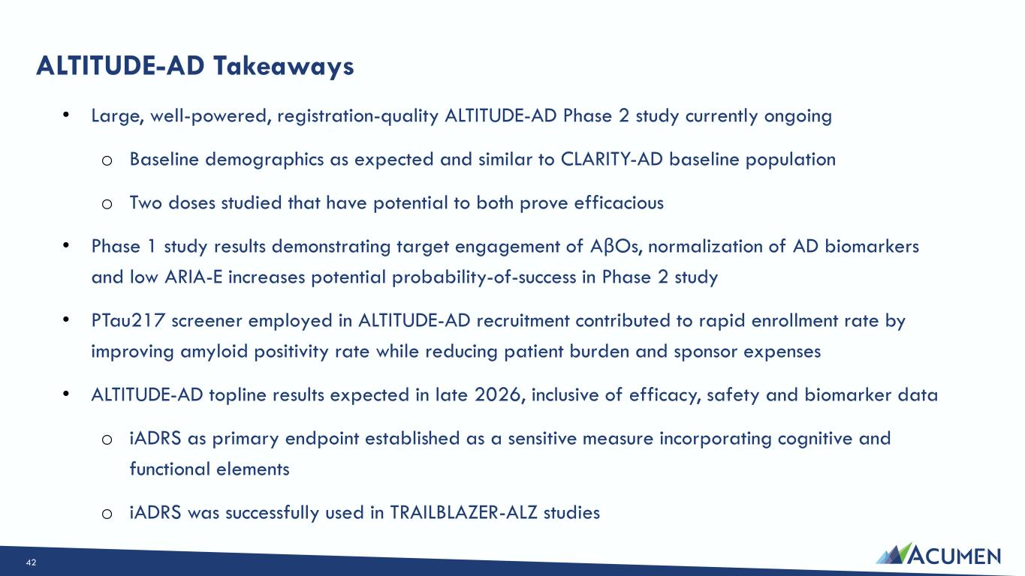
ALTITUDE-AD Takeaways • Large, well-powered, registration-quality ALTITUDE-AD Phase 2 study currently ongoing o Baseline demographics as expected and similar to CLARITY-AD baseline population o Two doses studied that have potential to both prove efficacious • Phase 1 study results demonstrating target engagement of AβOs, normalization of AD biomarkers and low ARIA-E increases potential probability-of-success in Phase 2 study • PTau217 screener employed in ALTITUDE-AD recruitment contributed to rapid enrollment rate by improving amyloid positivity rate while reducing patient burden and sponsor expenses • ALTITUDE-AD topline results expected in late 2026, inclusive of efficacy, safety and biomarker data o iADRS as primary endpoint established as a sensitive measure incorporating cognitive and functional elements o iADRS was successfully used in TRAILBLAZER-ALZ studies 42

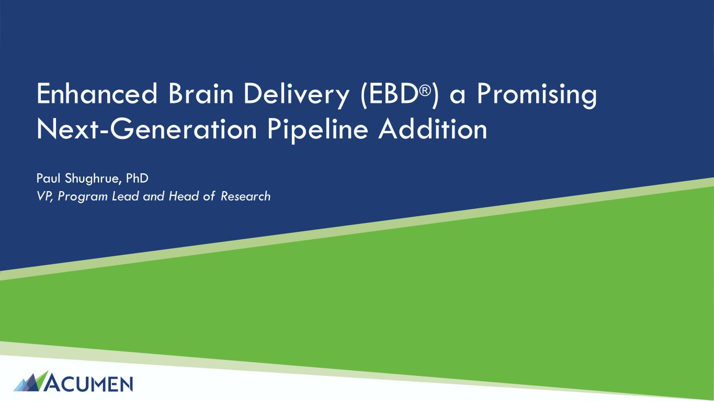
Enhanced Brain Delivery (EBD®) a Promising Next-Generation Pipeline Addition Paul Shughrue, PhD VP, Program Lead and Head of Research

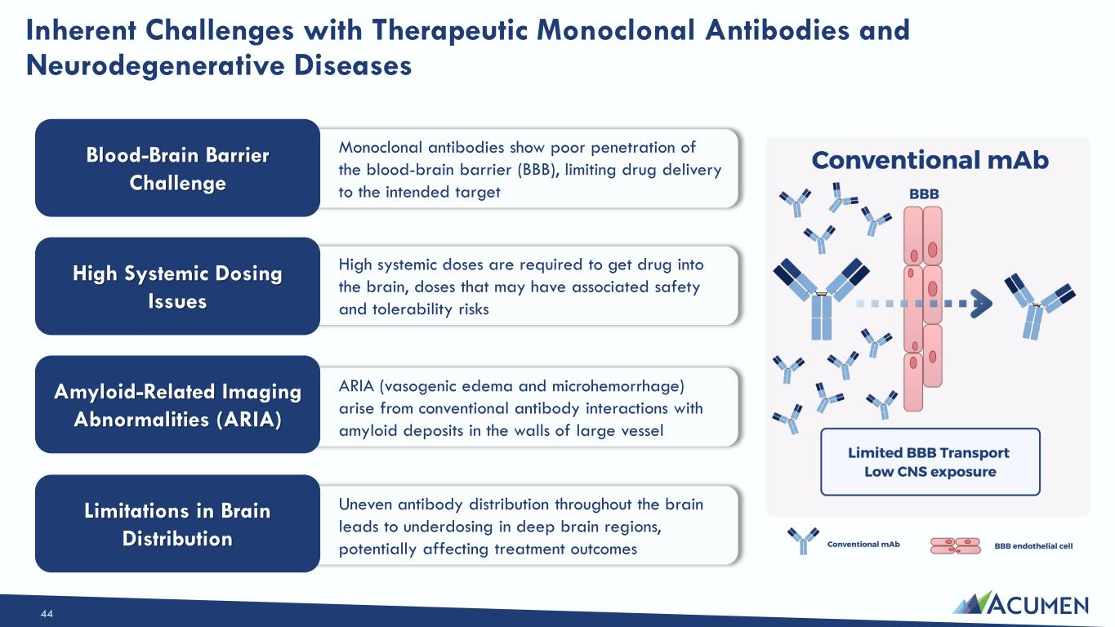
Inherent Challenges with Therapeutic Monoclonal Antibodies and Neurodegenerative Diseases Monoclonal antibodies show poor penetration of the blood-brain barrier (BBB), limiting drug delivery to the intended target Blood-Brain Barrier Challenge High systemic doses are required to get drug into the brain, doses that may have associated safety and tolerability risks ARIA (vasogenic edema and microhemorrhage) arise from conventional antibody interactions with amyloid deposits in the walls of large vessel Uneven antibody distribution throughout the brain leads to underdosing in deep brain regions, potentially affecting treatment outcomes High Systemic Dosing Issues Amyloid-Related Imaging Abnormalities (ARIA) Limitations in Brain Distribution 44

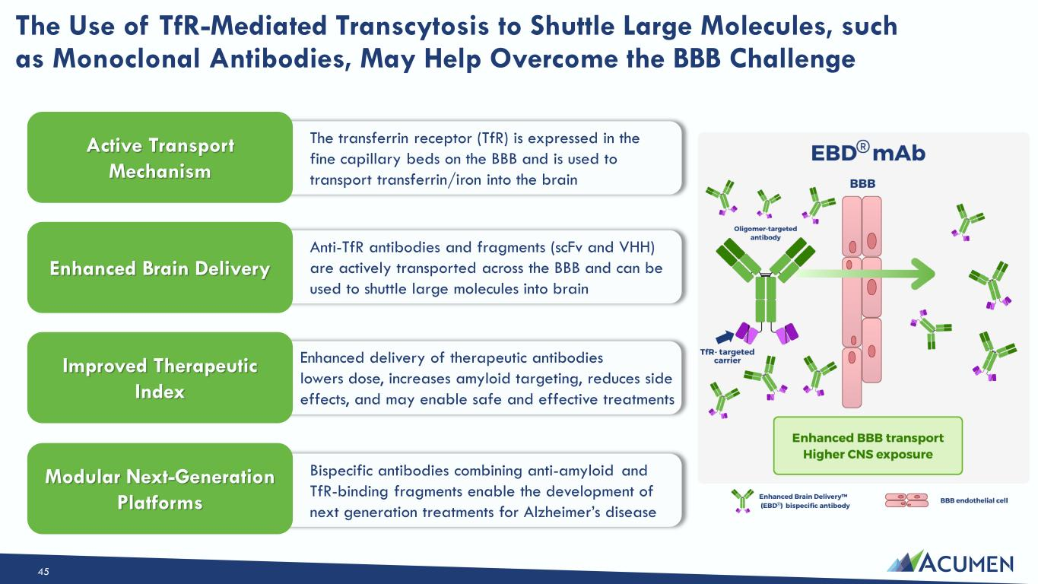
The Use of TfR-Mediated Transcytosis to Shuttle Large Molecules, such as Monoclonal Antibodies, May Help Overcome the BBB Challenge The transferrin receptor (TfR) is expressed in the fine capillary beds on the BBB and is used to transport transferrin/iron into the brain Active Transport Mechanism Anti-TfR antibodies and fragments (scFv and VHH) are actively transported across the BBB and can be used to shuttle large molecules into brain Bispecific antibodies combining anti-amyloid and TfR-binding fragments enable the development of next generation treatments for Alzheimer’s disease Enhanced Brain Delivery Improved Therapeutic Index Modular Next-Generation Platforms Enhanced delivery of therapeutic antibodies lowers dose, increases amyloid targeting, reduces side effects, and may enable safe and effective treatments 45

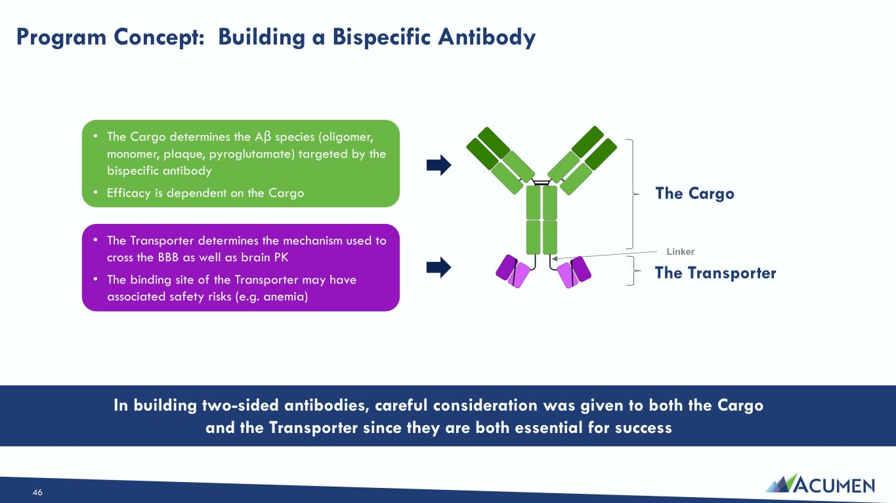
Program Concept: Building a Bispecific Antibody • The Cargo determines the Aβ species (oligomer, monomer, plaque, pyroglutamate) targeted by the bispecific antibody • Efficacy is dependent on the Cargo • The Transporter determines the mechanism used to cross the BBB as well as brain PK • The binding site of the Transporter may have associated safety risks (e.g. anemia) The Cargo Linker In building two-sided antibodies, careful consideration was given to both the Cargo and the Transporter since they are both essential for success The Transporter 46

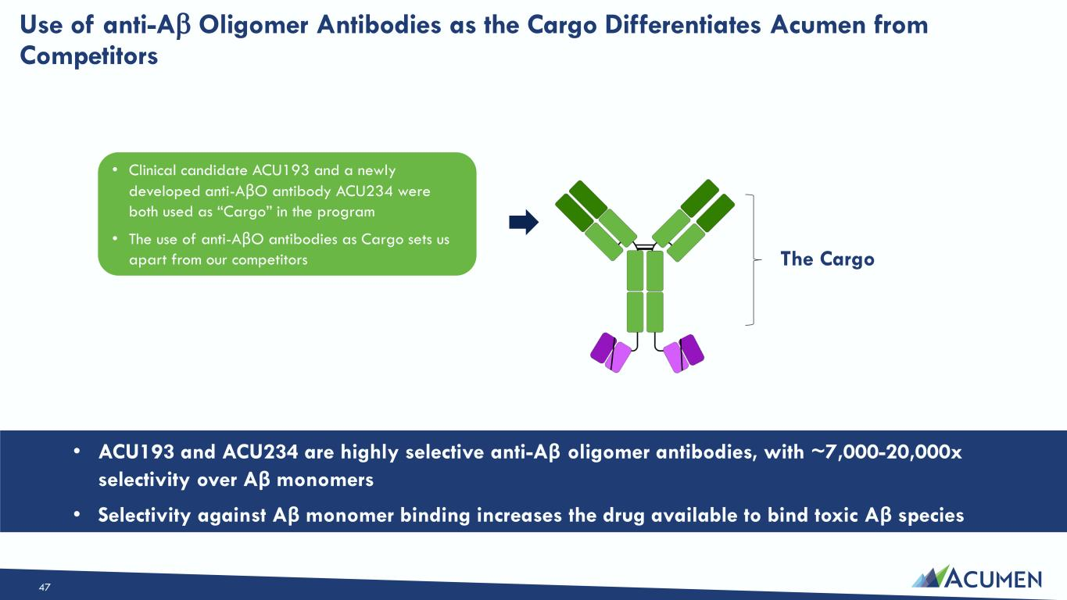
Use of anti-A Oligomer Antibodies as the Cargo Differentiates Acumen from Competitors • Clinical candidate ACU193 and a newly developed anti-AβO antibody ACU234 were both used as “Cargo” in the program • The use of anti-AβO antibodies as Cargo sets us apart from our competitors • ACU193 and ACU234 are highly selective anti-Aβ oligomer antibodies, with ~7,000-20,000x selectivity over Aβ monomers • Selectivity against Aβ monomer binding increases the drug available to bind toxic Aβ species The Cargo 47

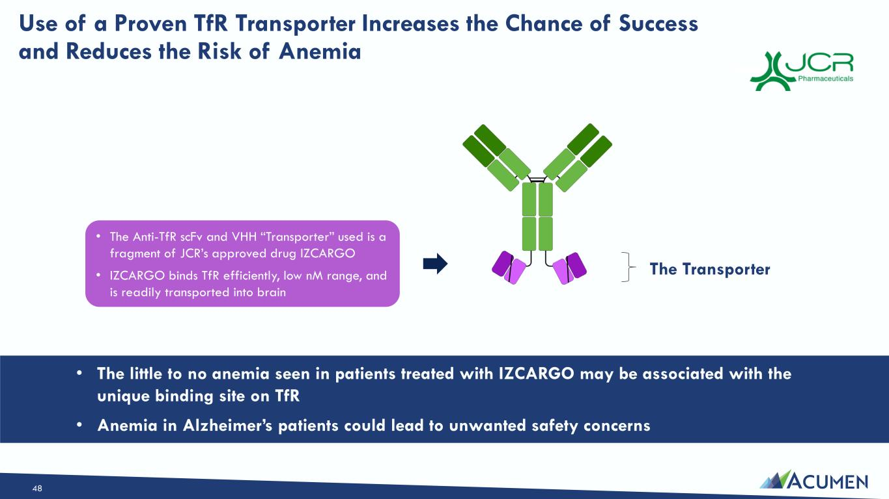
Use of a Proven TfR Transporter Increases the Chance of Success and Reduces the Risk of Anemia • The Anti-TfR scFv and VHH “Transporter” used is a fragment of JCR’s approved drug IZCARGO • IZCARGO binds TfR efficiently, low nM range, and is readily transported into brain • The little to no anemia seen in patients treated with IZCARGO may be associated with the unique binding site on TfR • Anemia in Alzheimer’s patients could lead to unwanted safety concerns The Transporter 48

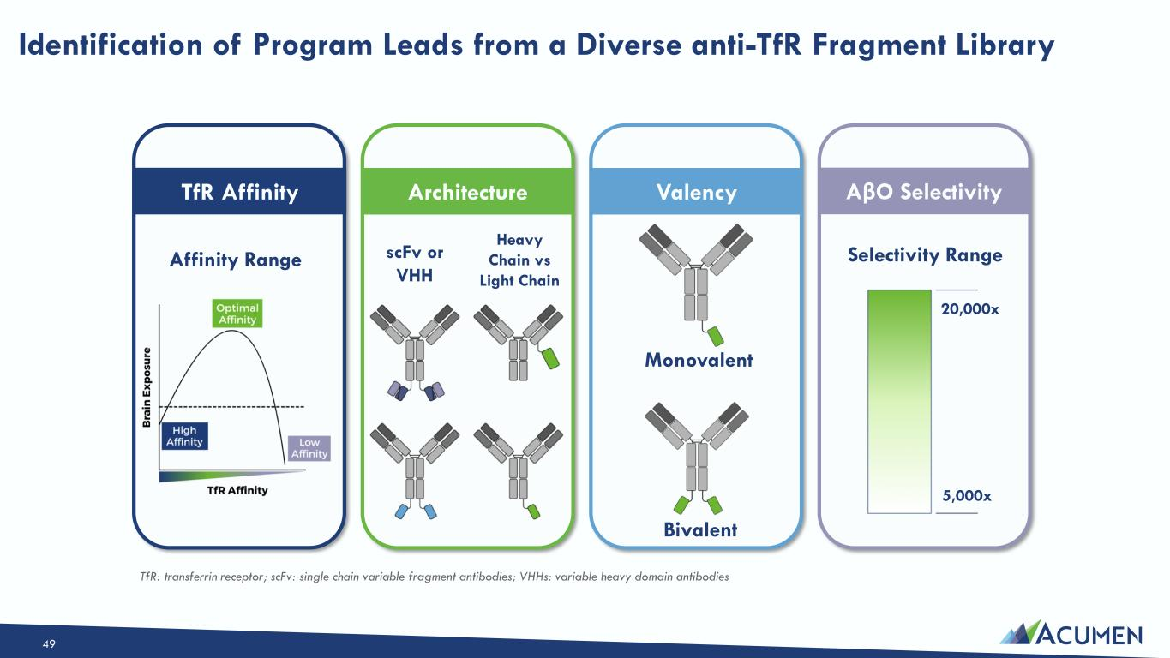
Identification of Program Leads from a Diverse anti-TfR Fragment Library TfR Affinity Architecture Valency AβO Selectivity scFv or VHH Heavy Chain vs Light Chain Monovalent Bivalent Affinity Range Selectivity Range 20,000x 5,000x TfR: transferrin receptor; scFv: single chain variable fragment antibodies; VHHs: variable heavy domain antibodies 49

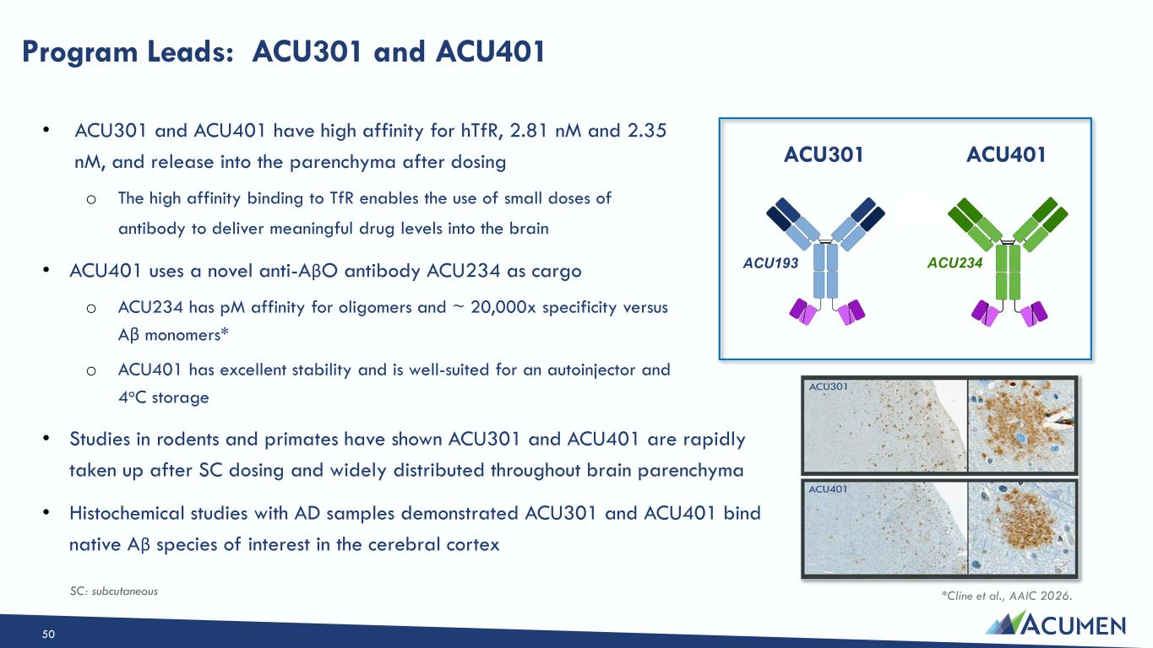
Program Leads: ACU301 and ACU401 ACU401 • ACU301 and ACU401 have high affinity for hTfR, 2.81 nM and 2.35 nM, and release into the parenchyma after dosing o The high affinity binding to TfR enables the use of small doses of antibody to deliver meaningful drug levels into the brain • ACU401 uses a novel anti-AβO antibody ACU234 as cargo o ACU234 has pM affinity for oligomers and ~ 20,000x specificity versus Aβ monomers* o ACU401 has excellent stability and is well-suited for an autoinjector and 4oC storage • Studies in rodents and primates have shown ACU301 and ACU401 are rapidly taken up after SC dosing and widely distributed throughout brain parenchyma • Histochemical studies with AD samples demonstrated ACU301 and ACU401 bind native Aβ species of interest in the cerebral cortex ACU301 ACU193 ACU234 *Cline et al., AAIC 2026. SC: subcutaneous 50

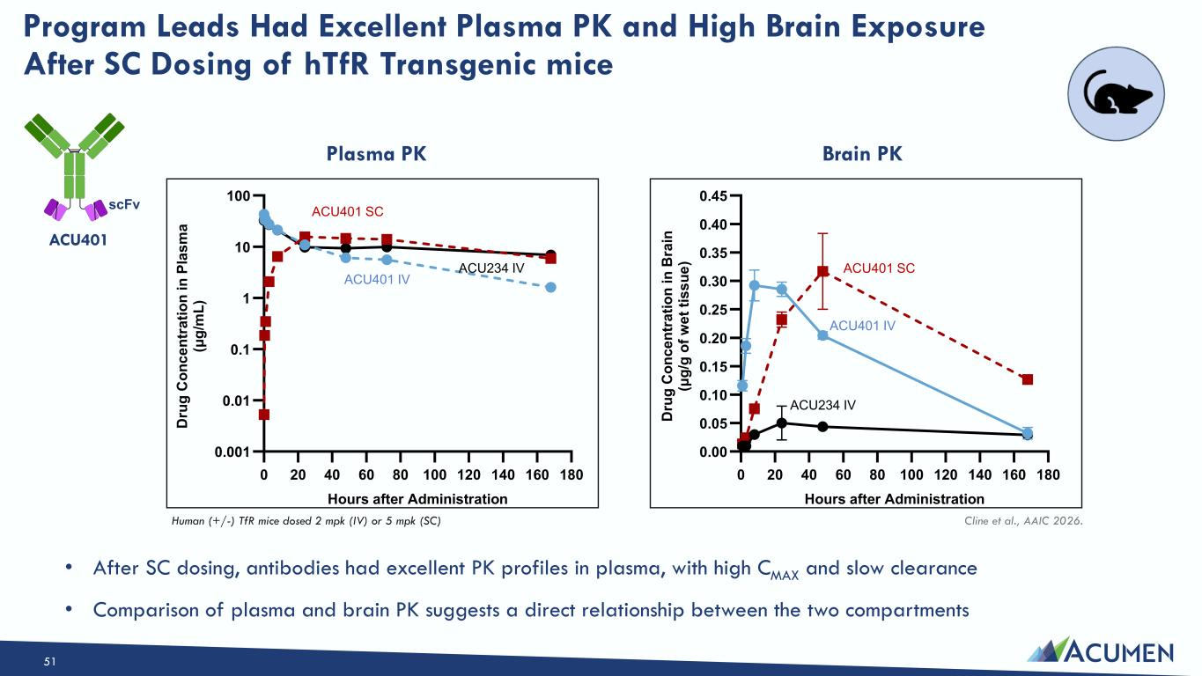
0 20 40 60 80 100 120 140 160 180 0.001 0.01 0.1 1 10 100 Hours after Administration D ru g C o n c e n tr a ti o n i n P la s m a (μ g /m L ) 0 20 40 60 80 100 120 140 160 180 0.00 0.05 0.10 0.15 0.20 0.25 0.30 0.35 0.40 0.45 Hours after Administration D ru g C o n c e n tr a ti o n i n B ra in (μ g /g o f w e t ti s s u e ) Program Leads Had Excellent Plasma PK and High Brain Exposure After SC Dosing of hTfR Transgenic mice ACU401 IV ACU401 SC ACU234 IV Brain PKPlasma PK • After SC dosing, antibodies had excellent PK profiles in plasma, with high CMAX and slow clearance • Comparison of plasma and brain PK suggests a direct relationship between the two compartments ACU401 IV ACU401 SC ACU234 IV Human (+/-) TfR mice dosed 2 mpk (IV) or 5 mpk (SC) Cline et al., AAIC 2026. ACU401 scFv 51

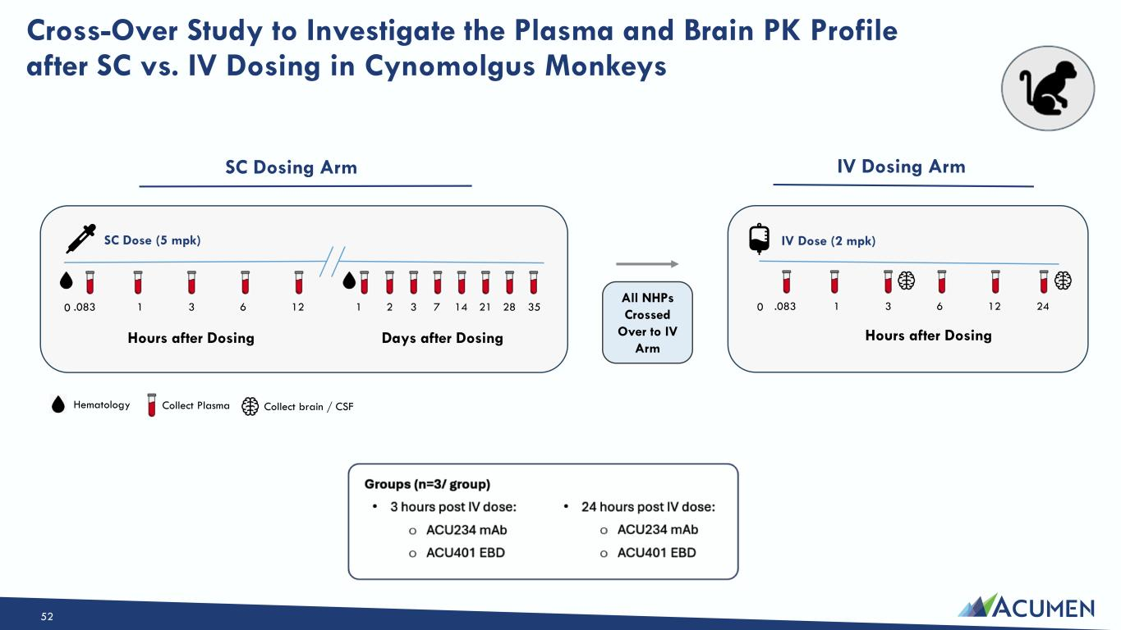
.083 1 3 6 12 1 2 Hours after Dosing SC Dosing Arm Hours after Dosing IV Dosing Arm Collect brain / CSF Cross-Over Study to Investigate the Plasma and Brain PK Profile after SC vs. IV Dosing in Cynomolgus Monkeys Collect Plasma 3 7 14 21 28 35 Hematology Days after Dosing .083 1 3 6 12 24 All NHPs Crossed Over to IV Arm 00 SC Dose (5 mpk) IV Dose (2 mpk) 52

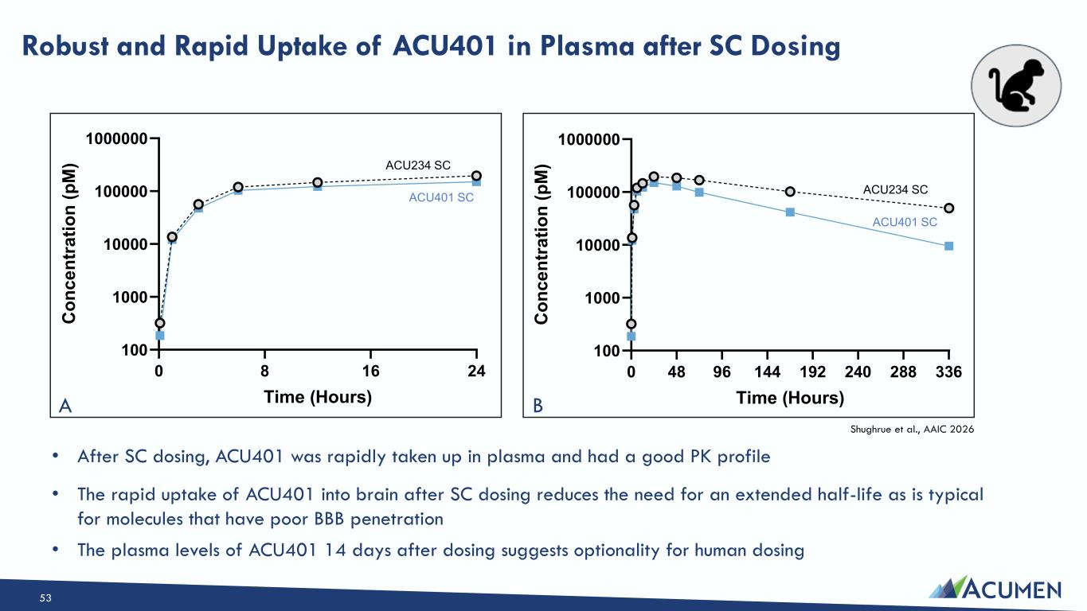
0 48 96 144 192 240 288 336 100 1000 10000 100000 1000000 Time (Hours) C o n c e n tr a ti o n ( p M ) Robust and Rapid Uptake of ACU401 in Plasma after SC Dosing • After SC dosing, ACU401 was rapidly taken up in plasma and had a good PK profile • The rapid uptake of ACU401 into brain after SC dosing reduces the need for an extended half-life as is typical for molecules that have poor BBB penetration • The plasma levels of ACU401 14 days after dosing suggests optionality for human dosing Shughrue et al., AAIC 2026 0 8 16 24 100 1000 10000 100000 1000000 Time (Hours) C o n c e n tr a ti o n ( p M ) ACU401 SC ACU234 SC ACU401 SC ACU234 SC A B 53

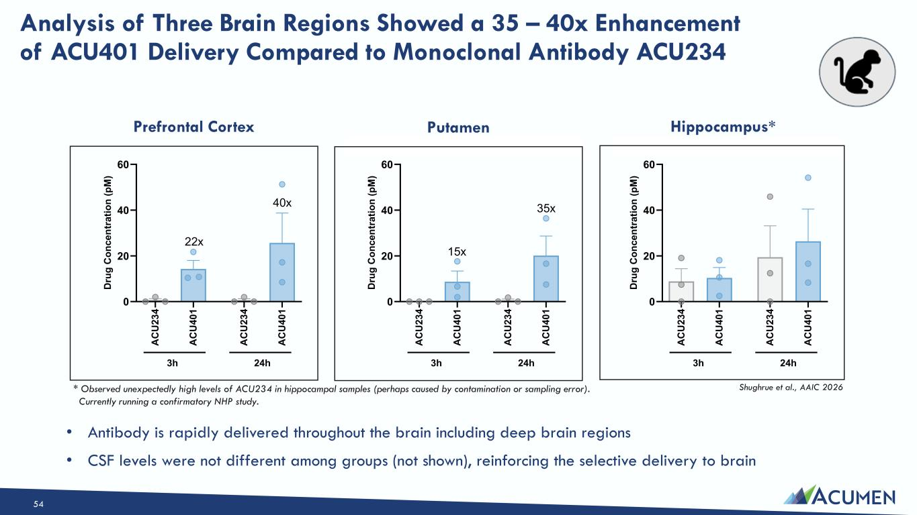
A C U 2 3 4 A C U 4 0 1 A C U 2 3 4 A C U 4 0 1 0 20 40 60 3h 24h D ru g C o n c e n tr a ti o n ( p M ) A C U 2 3 4 A C U 4 0 1 A C U 2 3 4 A C U 4 0 1 0 20 40 60 3h 24h D ru g C o n c e n tr a ti o n ( p M ) 15x 35x A C U 2 3 4 A C U 4 0 1 A C U 2 3 4 A C U 4 0 1 0 20 40 60 3h 24h D ru g C o n c e n tr a ti o n ( p M ) 22x 40x Analysis of Three Brain Regions Showed a 35 – 40x Enhancement of ACU401 Delivery Compared to Monoclonal Antibody ACU234 * Observed unexpectedly high levels of ACU234 in hippocampal samples (perhaps caused by contamination or sampling error). Currently running a confirmatory NHP study. Shughrue et al., AAIC 2026 • Antibody is rapidly delivered throughout the brain including deep brain regions • CSF levels were not different among groups (not shown), reinforcing the selective delivery to brain Prefrontal Cortex Putamen Hippocampus* 54

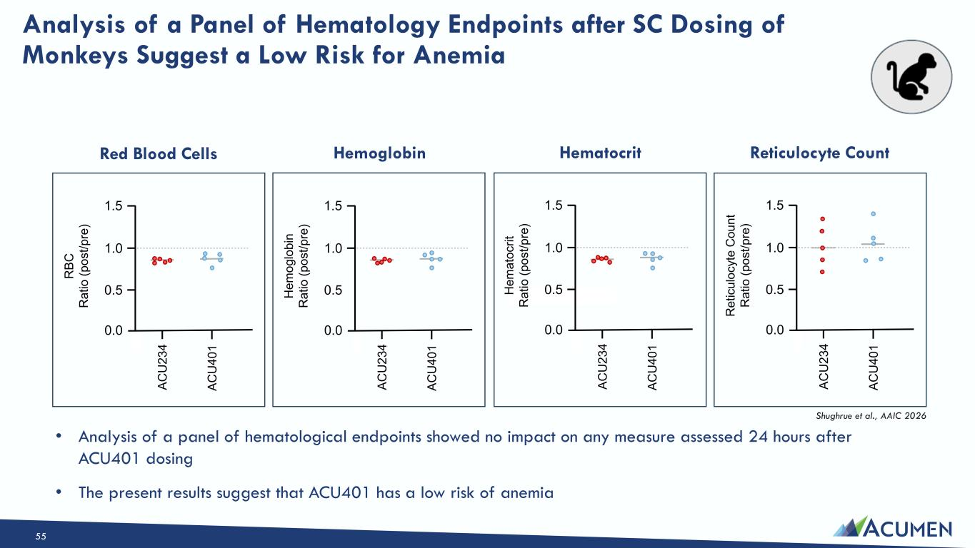
• Analysis of a panel of hematological endpoints showed no impact on any measure assessed 24 hours after ACU401 dosing • The present results suggest that ACU401 has a low risk of anemia Analysis of a Panel of Hematology Endpoints after SC Dosing of Monkeys Suggest a Low Risk for Anemia A C U 2 3 4 A C U 4 0 1 0.5 1.0 1.5 0.0 R B C R a ti o ( p o s t/ p re ) A C U 2 3 4 A C U 4 0 1 0.5 1.0 1.5 0.0 H e m o g lo b in R a ti o ( p o s t/ p re ) A C U 2 3 4 A C U 4 0 1 0.5 1.0 1.5 0.0 H e m a to c ri t R a ti o ( p o s t/ p re ) A C U 2 3 4 A C U 4 0 1 0.5 1.0 1.5 0.0 R e ti c u lo c y te C o u n t R a ti o ( p o s t/ p re ) Red Blood Cells Hemoglobin Hematocrit Reticulocyte Count Shughrue et al., AAIC 2026 55

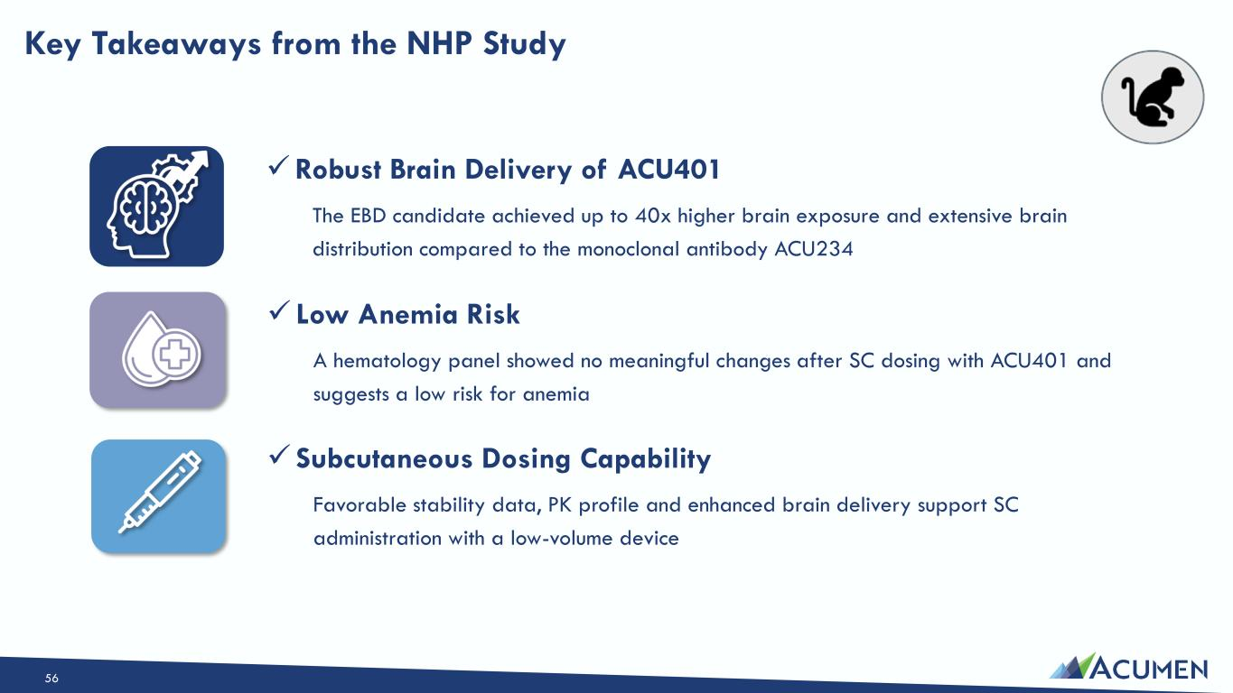
✓Robust Brain Delivery of ACU401 The EBD candidate achieved up to 40x higher brain exposure and extensive brain distribution compared to the monoclonal antibody ACU234 ✓ Subcutaneous Dosing Capability Favorable stability data, PK profile and enhanced brain delivery support SC administration with a low-volume device ✓ Low Anemia Risk A hematology panel showed no meaningful changes after SC dosing with ACU401 and suggests a low risk for anemia Key Takeaways from the NHP Study 56

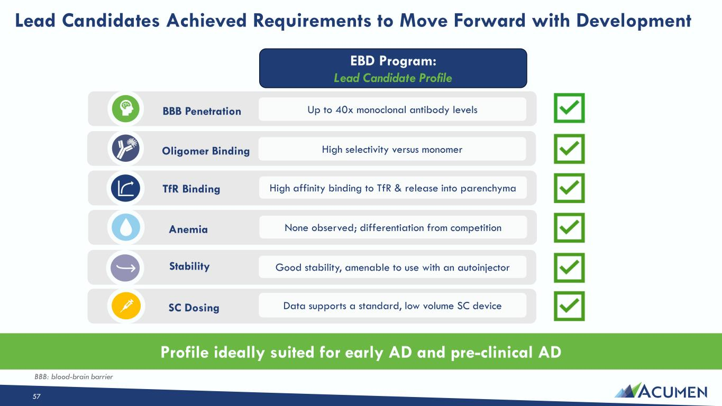
BBB Penetration Up to 40x monoclonal antibody levels None observed; differentiation from competitionAnemia Good stability, amenable to use with an autoinjectorStability Data supports a standard, low volume SC device SC Dosing Oligomer Binding High selectivity versus monomer High affinity binding to TfR & release into parenchymaTfR Binding Profile ideally suited for early AD and pre-clinical AD EBD Program: Lead Candidate Profile Lead Candidates Achieved Requirements to Move Forward with Development BBB: blood-brain barrier 57

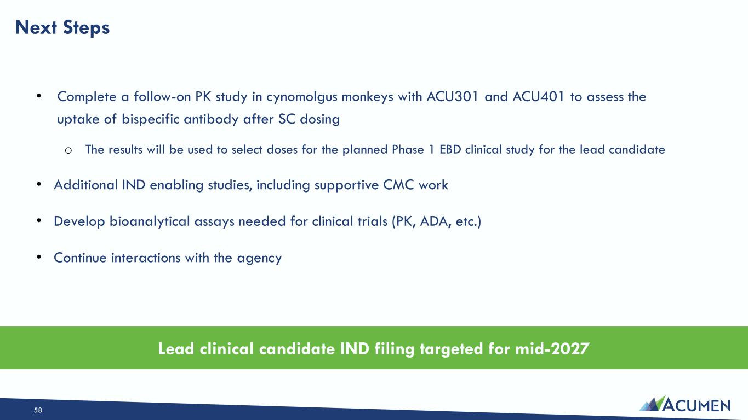
• Complete a follow-on PK study in cynomolgus monkeys with ACU301 and ACU401 to assess the uptake of bispecific antibody after SC dosing o The results will be used to select doses for the planned Phase 1 EBD clinical study for the lead candidate • Additional IND enabling studies, including supportive CMC work • Develop bioanalytical assays needed for clinical trials (PK, ADA, etc.) • Continue interactions with the agency Next Steps Lead clinical candidate IND filing targeted for mid-2027 58


Q&A

